Games for Youth
Experience has shown the effectiveness of transmitting information about climate change risks through games and exercises based on participation, role-playing, decision making and other forms of artistic expression. This type of learning, involves sensations, feelings, new behaviours and response to various stimulus through simulated actions.

Below are a few games that are used by other National Societies to work with children and youth on climate change. Read the objective to find out which games might be most suitable for your group.

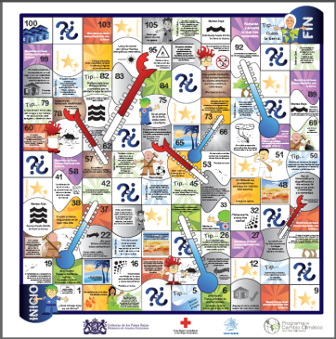  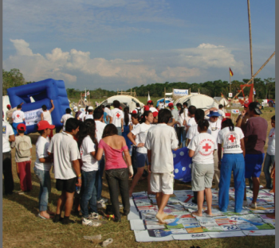  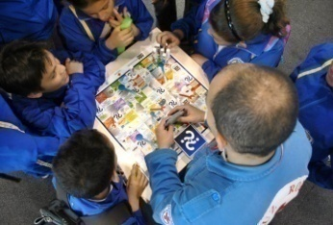 | GOOSE
AVAILABLE AT:
http://www.climatecentre.org/downloads/File/Games/game%20of%20goose%20escalera.pdf
 | DESIGNED BY: Colombian Red Cross
 | LANGUAGE: Spanish
 | SUGGESTED TARGET: Children, Youth, Adults.
 | ESTIMATED TIME: 45 minutes – 1 hour
 | OBJECTIVE: Promote a reflection about good and bad environmental habits and other tips about risk reduction in a changing climate.
DESCRIPTION
1. Players start in the first box.
2. Each player gets a turn to advance
3. Players change their position according to the number on the rolled dice.
4. The player needs to read the message in the box and then act according to the instructions: continue, go back or stay (it depends on the instruction in the box)
5. If the player falls into the question box (question mark), they will be asked a question related to climate change.
6. If the player does not answer the question, he/she will have to stay put for one turn
7. In the box "surprise" the leader may give to the player a small incentive (Example: candy)
8. The player who arrives fastest in the last box, wins.
NEEDED RESOURCES
- 1 to 6 participants
- Dice to play
- Board of game (see link)
- Book of Questions and Answers (included in folder)
- Incentives (rewards)

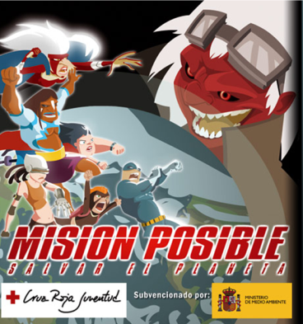 | MISSION POSSIBLE, SAVE THE PLANET
AVAILABLE IN
http://www.cruzroja.es/juego_cambio_climatico/
 | DESIGNED BY: Spanish Red Cross
 | LANGUAGE: Spanish
 | SUGGESTED TARGET: Children, Youth
 | ESTIMATED TIME : 20 minutes
 | OBJECTIVE: Increase the knowledge on climate change through questions and activities.
DESCRIPTION:
Eleven years after the rulers of the earth meet in the city of Kyoto to try to stop this process of destruction, the greenhouse gases continue being a threat to humans.
An ecological superhero team is fighting against the uncontrolled emission of gases into the atmosphere. Their mission is to mitigate this effect.
To this end, in addition to using their superpowers, they try to teach people about how to help to improve this situation. Do you want to join them on their adventures?
EXTRA INFORMATION ABOUT THE GAME:
A computer and Internet connection is required.

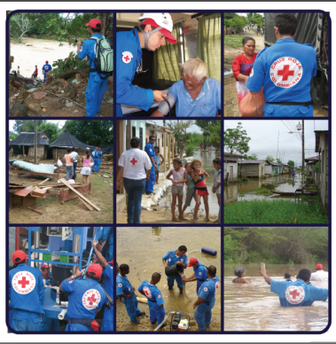  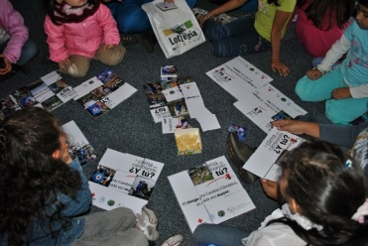 | LOTTERY
 | AVAILABLE IN: http://www.cruzrojacolombiana.org/publicaciones/pdf/manualCCFINAL_1372010_104323.pdf (Page 26)
 | DESIGNED BY: Colombian Red Cross
 | LANGUAGE: Spanish
 | SUGGESTED TARGET: Children, Youth, Adults.
 | ESTIMATED TIME: 45 minutes – 1 hour
 | OBJECTIVE: To establish the relationship between climate change, its impacts and Red Cross Red Crescent action.
DESCRIPTION
- Give one board to each player
- The leader has to put all the cards in a bag
- The leader takes a random card from the bag and describes the image (giving explanation about the content of the picture)
- The player who has the image of the card on its own board, needs to take the card and cover the board
- Who covers the entire board first wins.
NEEDED RESOURCES
- 2 Players minimum
- 10 game boards
- 100 game cards
EXTRA INFORMATION ABOUT THE GAME
The leader of the game should have sufficient knowledge about the actions of the National Society to give explanation between the images, the humanitarian action and climate change.

Disaster Masters
AVAILABLE IN: http://www.climatecentre.org/downloads/File/Youth%20docs/disaster_masters.pdf
DESIGNED BY: British Red Cross
LANGUAGE: English
SUGGESTED TARGET: Children, Youth (6-11 yrs)
ESTIMATED TIME: 3.5 hours
OBJECTIVE: To introduce young people to the work of the International Federation of Red Cross and Red Crescent Societies (IFRC), to explore various human aspects of disasters and emergencies and how these are affected by climate change.
DESCRIPTION
In detail in the PDF file.
NEEDED RESOURCES
- Risk assessment & first aid kit (plus first aider)
- IFRC film clip – Turning the Tide IFRC available from You tube (optional)
- Facilities to play the clip (DVD player and TV/ laptop, projector and speakers) (optional)
- S.O.S. cards (one per participant, in PDF)
- Name tags with Tuvalu flag for Tuvalu group or with IFRC symbol for IFRC group (one per participant, in PDF)
- Pens (one per participant)
- Funafuti map (one per group, in PDF
- Bandages (one per participant)
- Radios (one per pair if possible) or ‘pretend cut outs’ if radios are not available (in PDF)
- Three people or clothes to represent people for casualties
- Three casualty signs (reading: dead, pregnant woman, bleeding hand, unconscious, breathing, in PDF)
- River dissecting space (long strip of material or floor marked out with tape). There should be an island marked out in the middle of the river. The gap between the river bank and the island should be a few inches shorter than the long plank of wood on the Tuvaluan side and a few inches shorter than the combined length of the long plank and the short plank of wood on the other side. Look at the diagram in PDF)
- Signs indicating features of Tuvalu and devastation (school, airstrip, fast-flowing water, polluted water, cables down, etc., in PDF)
- Approximately 20 blank cards – all of one colour (Tuvaluan group, in PDF)
- Cards with short/ medium and long term needs on them, all of one colour, different to colour used for Tuvaluan cards (IFRC group, in PDF)
- Blank cards of same colour as other IFRC cards above (IFRC group, in PDF)
- Two sheets of canvas, poles, rope, tape (Tuvaluan side)
- One frame tent or equivalent (IFRC side)
- One long plank of wood (placed on Tuvaluan side)
- One piece of rope (on island)
- One bag (on island)
- Gaffer tape (on island)
- One pair of scissors (on island)
- One short plank of wood (on IFRC side)
EXTRA INFORMATION ABOUT THE GAME
The whole description of the game and some resources can be found in the PDF file.

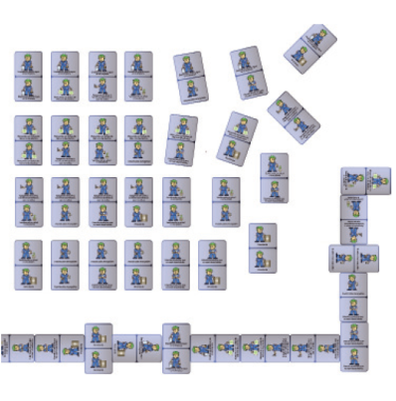 | DOMINOES
 | EXAMPLE AVAILABLE IN: http://www.climatecentre.org/downloads/File/Games/manual%20ESP.pdf (Page 28)
 | DESIGNED BY: Colombian Red Cross
 | LANGUAGE: Spanish
 | SUGGESTED TARGET: Children, Youth, Adults.
 | ESTIMATED TIME: 20 – 30 minutes
OBJECTIVE:
Raise awareness about climate change
DESCRIPTION
- 28 dominoes with text and/or pictures of 7 different actions showing awareness of climate change and its impacts. You can make them yourself or use examples from Colombian Red Cross (e.g. I save water, I use rechargeable batteries). There should be 28 different dominoes, with each domino having 2 actions (there should also be a domino with two times action nr 1, two times action nr 2 etc.).
- Each player takes 7 dominoes.
The remaining dominoes are left in 'the bank'.
The game start with a domino from 'the bank'.
- The first player has to look to its own group of dominoes and checks whether there is a domino with an identical image of the one that is on the table.
- If the player has an identical image on a domino as a domino on the table, he/she can put it on the table, by placing the identical images beside each other, creating a line. If the player does not have an identical image, he/she needs to get an additional domino from the bank (randomly selected).
- Once the domino is placed on the table, the player has to read aloud the content of the piece.
- The first player to put its last domino on the table, wins
NEEDED RESOURCES
- Dominoes with text/picture
- 2 to 4 players

