Module 3 : Youth
Exercises prepared by National Red Cross/Red Crescent Societies

Below are a large variety of exercises that can be used for inspiration to help shape your work on awareness raising in trainings, workshops, within communities, at schools or with (youth) volunteers. | 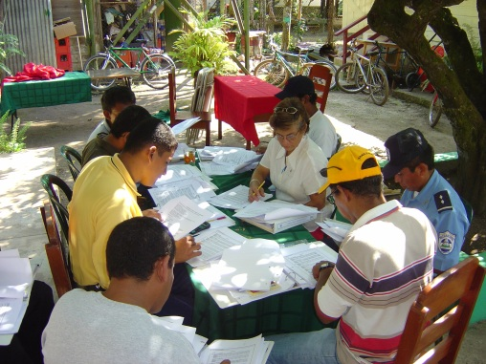  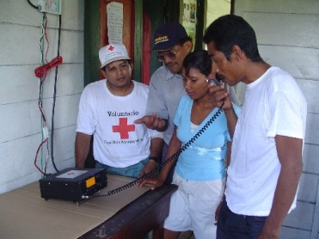

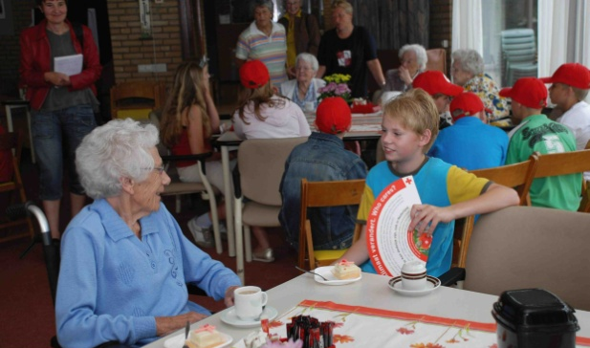  (Photo by: Cees Hamburger)  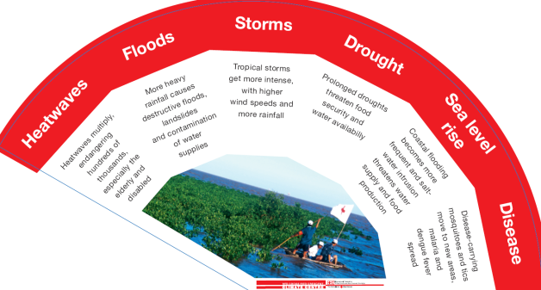t | Youth teaching the elderly
ESTIMATED TIME:
1-1,5 hours
OBJECTIVE:
Teach the elderly about health risks during heat waves and what they should and should not do during hot spells
DESCRIPTION:
- Hand out the fan to all children
- Discuss the texts on the fan so that the children understand what is written
- Visit some elderly people
- Let the children individually talk to the elderly about the fan: the health risks and dos and don’ts during a heat wave
RESOURCES NEEDED:
- Fan (English and French version included in folder Exercises)
EXTRA INFORMATION:
It would be useful to first educate the youth about climate change, particularly as it relates to heat waves (if relevant) using for example the youth presentation about climate change.

The exercise can also be an opportunity for elders in the community to share their experience of weather and climate when they were younger. Has it changed?

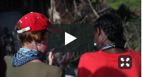 | PARTICIPATORY VIDEOS
ESTIMATED TIME:
1 week to 1 month
OBJECTIVE:
Community expresses climate change through its own perspectives, including innovative approaches that increase their way of coping with it and thereby motivate others to take similar actions.
DESCRIPTION:
- Read the document: Video-mediated approaches for community-level climate adaptation by Pablo Suarez, Fiona Ching, Gina Ziervogel, Isabelle Lemaire, Diane Turnquest, Janot Mendler de Suarez and Ben Wisner. Available here. Or, a shorter version is available at the end of the ‘recommended films’ document in this module.
- Organise a short workshop within the community to determine the content of the video. For assistance, you can contact the Climate Centre.
- In the workshop conduct a brainstorm session with the community about relevant perceptions of climate change and what can be done about to address the impacts
- Prioritise ideas
- Work with the community to produce images and interviews on selected issues.
- Video editing. Add subtitles if needed
- Share the video with the community and further afield
RESOURCES NEEDED:
- Video camera with all accessories
- Pen and paper
- People willing to show and talk about their experiences
EXTRA INFORMATION:
- See more references on participatory videos in the "Recommended films" section of this module
- Show videos of other communities and cultures in your own trainings to demonstrate that climate change is happening around the world.
- It is effective to make competitions to motivate local teams and communities making participatory videos.

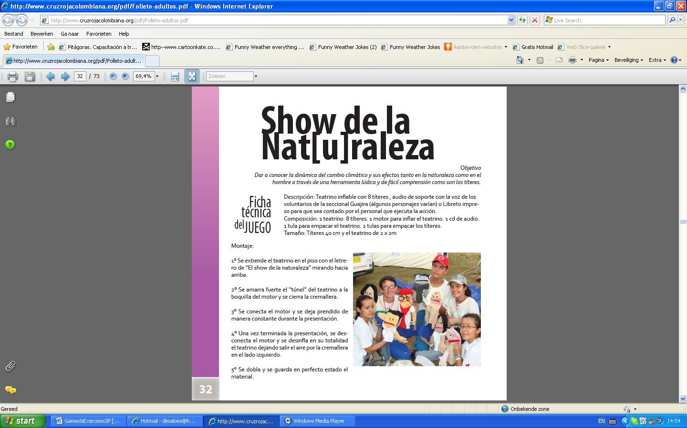 | PUPPETS
ESTIMATED TIME:
30-45 minutes
OBJECTIVE:
To tell the story of climate change through different characters (puppets) that come to life through the imagination of the volunteers and the good energy of the community.
DESCRIPTION:
The group of volunteers must write a script, giving roles to each character. Volunteers and team must take a reasonable time to prepare a rehearsal of the play. Firstly, you must verify the conditions of the place where the puppet play would be; check if the people can properly listen and see. Try to involve different people in the development of the play (e.g. schoolteachers). Make it interactive by having the puppets talk or ask questions to the public!

RESOURES NEEDED:
- Puppets (can be handmade by volunteers or school children)
- Sound system (only if necessary)
- 4 people at the very least in charge of the puppets
- 1 team leader to organize the audience
EXTRA INFORMATION:
- The original idea of puppets and climate change comes from the Colombian Red Cross. The name is "The nature show".
- Puppets can be made of recycled materials.

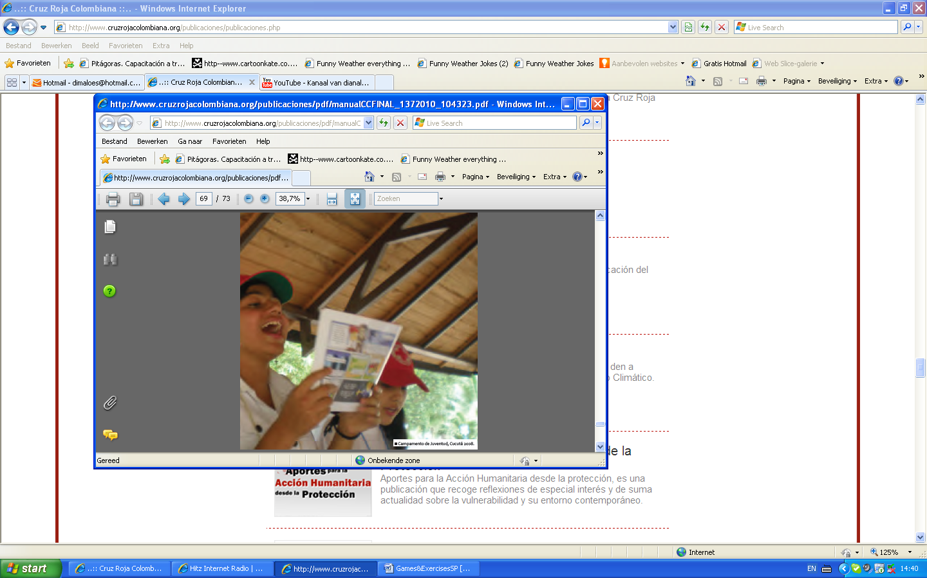 | MUSIC AND CLIMATE CHANGE
ESTIMATED TIME:
30 minutes – 1 hour
OBJECTIVE:
To memorize key messages about climate change and risk reduction through music.
DESCRIPTION:
To communicate climate change through music, it is possible to compose songs:
- First a music composition is needed (it can also be a cover using existing music as a basis)
- Fill in the text with your own lyrics
- It can even be an organized music-competition
RESOURCES NEEDED:
- Paper & pencil/pen
- Musician(s), (singer(s), guitar, etc.)
- Microphone
EXTRA INFORMATION:
- Example from Honduras Red Cross: http://www.youtube.com/watch?v=v2rfvZXhuck&feature=related (source: feliusing)
- Example from Colombian Red Cross: http://www.youtube.com/dianalondono#p/u/16/sXTT9W7SKCU (English)
http://www.youtube.com/dianalondono#p/u/15/6KxWETounp4 (Spanish)

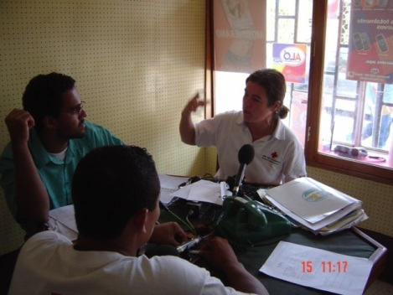 | RADIO SPOTS
ESTIMATED TIME:
It depends on the process and the dedication of the working group to the activity. It should take into account time for design, production, editing, finalizing and disseminating.
OBJECTIVE:
Use the radio to disseminate on a large scale messages related to climate change and risk reduction.
DESCRIPTION:
The radio spots can be produced by the Red Cross/Red Crescent or through a participatory process with the community. They should be short and capture the attention of the listener.
RESOURCES NEEDED:
- Script
- Cabin for recording or computer with microphone and a suitable program to work.

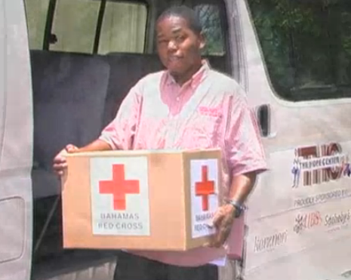 | TESTIMONIES FROM VOLUNTEERS OR COMMUNITY MEMBERS
ESTIMATED TIME:
3 - 5 days
OBJECTIVE:
To explain climate change through the vision of a volunteer who dedicates much of his/her time to humanitarian work, but at the same time is part of an at risk group (possibly being affected by the impacts of climate change). It is also recommended to find testimonies from community members as real evidence of the problems and extra motivation for donors.
DESCRIPTION:
- Draw up a list of questions that can be answered by volunteers/community members who are involved in climate change activities. Identify (a) volunteer(s) or community member(s) who have the skills to tell stories beautifully. Interview them (you can record the answers or take note).
- You can also ask general information, experiences with the Red Cross/Red Crescent, interest in humanitarian activities, personal observations of climate change impacts. Take his/her picture in different places in their community.
- Synthesize the most important parts of the interview and write a short story. Use strong quotes from the interview, add images and an attractive design for reading.
- Disseminate and share this product of communication with relevant audiences.
RESOURCES NEEDED:
- Paper & pen/pencil
- Voice recorder (optional)
- Camera
EXTRA INFORMATION: The story of a volunteer or any other Red Cross/Red Crescent member, can integrate different points of view (personal, community and institutional). It is important to remember that we are all vulnerable to climate change risks.

Strategic dissemination of this communication product allows you to recall the importance of investing in human and financial resources of your National Society to improve emergency response and health and care work.

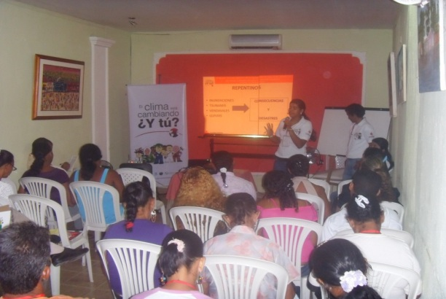 | FORUM, VIDEOFORUM AND DEBATES
 | ESTIMATED TIME: 1 – 2 hours
OBJECTIVE:
To promote discussion and reflection about changing climate risks and other related issues.
DESCRIPTION:
- Select a film or video of general interest about climate change (see list of suggestions in the ‘recommended films’ section in this communication module);
- Prepare three questions that are relevant to the information contained in the video;
- Invite a group of people to watch the video (children, young people, adults can be guests; depending on the objectives of the activity you are planning);
- Organize a session with either statements or questions at the end of the video;
- Take notes of the most important ideas and make comments that could turn into action.
RESOURCES NEEDED:
- TV/Computer
- Projector or beamer/ white wall or screen
- Facilitator
- Flipchart
EXTRA INFORMATION:
These kind of activities are useful to clarify concepts.
The effectiveness of showing videos to communities is large.
Community can become motivated to take action, based on other people’s experiences.

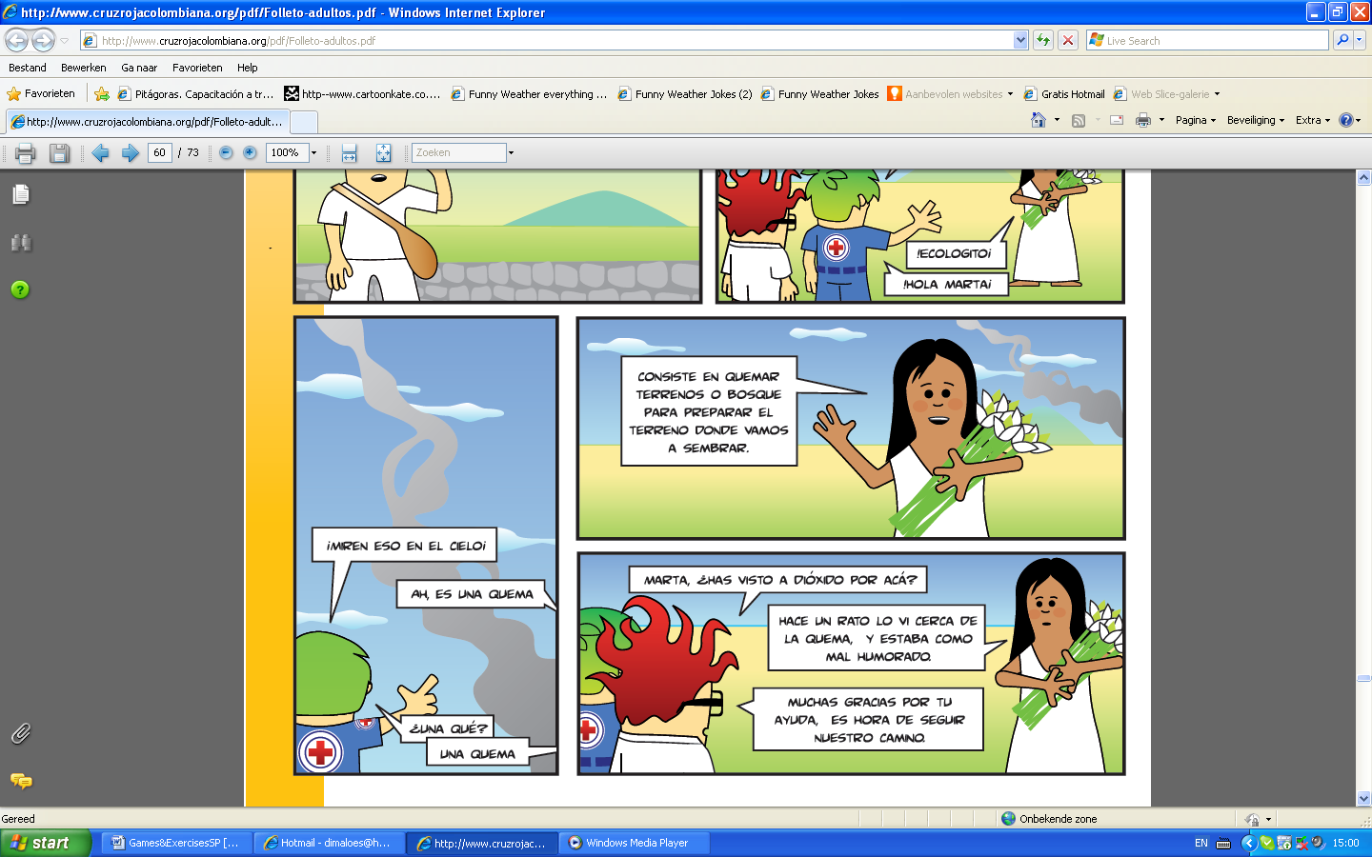 | DESIGN OF BOOKLETS, FLYERS, POSTERS, BROCHURES
ESTIMATED TIME:
1 day – 1 week or more!
OBJECTIVE:
Use the creativity of (youth) volunteers and community members to create communication products.
DESCRIPTION:
- Start the activity with an introduction of climate change and its risks. You can also carry out a playful warm-up activity.
- Split the audience into working groups and have them brainstorm on slogans and catchy lines.
- Give them the resource materials listed below.
- Ask them to draw climate change impacts, risks, or anything related to the topic.
- Ask them to put words to their drawings (if needed).
- Paste with tape on the wall all the resulting drawings.
- Ask the author of each work to explain their drawings.
- Listen carefully to the explanations provided by the participants and make sure that the concepts are clear.
- Leave this wall intact for a few days and have other staff (or volunteers) look at it and collect their feedback,
- Hopefully something useful and beautiful will come out of this!
RESOURCES NEEDED
- Colored markers/pencils, paint (and related materials), paper, tape
EXTRA INFORMATION:
- You can make an album for a local library.
- You can ask for help of professional designers to distill ideas into a publication such as a flyer or poster.
- You can repeat the activity after a period of time to review how the concepts and perceptions have changed after the trainings.
- Check the ‘relevant reading’ section of this module to see various ideas and examples of printed products and messages.

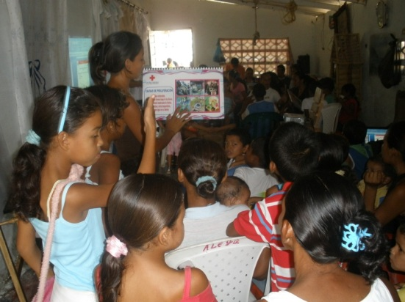 | MYTHS vs. FACTS
ESTIMATED TIME:
20 – 30 minutes
OBJECTIVE:
Busting myths and communicating relevant facts on climate change science.
DESCRIPTION:
The myths of audiences/communities about climate change can be discovered through participatory assessments, surveys and debates. Understanding traditional beliefs, convictions and knowledge are important entry points for having more in depth discussions with communities about their perceived risks. Only then certain myths can be busted and relevant facts about climate change can be communicated. You can also use quizzes or games to test statements (true or false) to check the understanding of community members or trainees.
NEEDED RESOURCES:
Local facilitators with enough knowledge on climate change.
EXTRA INFORMATION:
Some of the myths you might hear from the audience could be:
- Scientific climate models do not generate useful information about the real world.
- The climate models are so precise that scientists can zoom in and predict exactly what climate patterns we can expect for our exact location and help define our adaptation needs
- If the temperature increases only a few degrees, that’s not such a big deal
- Climate change does not exist.
- Climate change is caused by the skyscrapers with many glass windows in the cities.
- Climate change will only be a problem in the far off future and for next generations. Not for us.
- Government is responsible for climate change and the only one who can stop it.
- The effects of climate change and natural disasters are divine punishment, we cannot do anything about it.

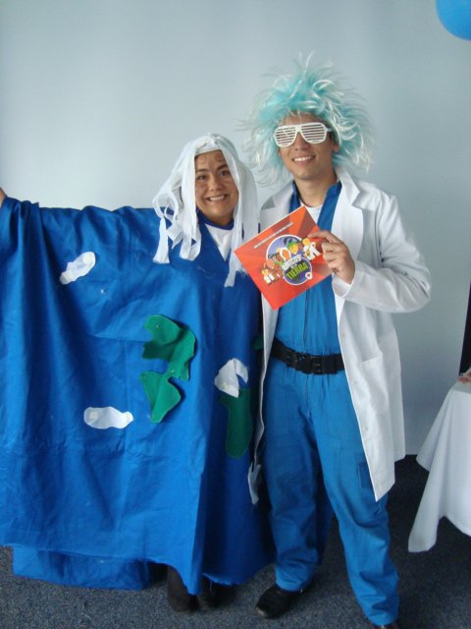 | DRAMA
ESTIMATED TIME:
2 hours
OBJECTIVE:
Those who participate in drama learn the issues by heart given the amount of time they practice. They gain confidence in public speaking, gain self esteem, youth gain healthy social skills and enhanced awareness of community needs and issues.
DESCRIPTION:
- Presenting the topic: you can use the ‘climate change basics’ section of this training kit to present some general information about climate change to participants.
- Researching the topic through brainstorming:
- Break into groups
- Each group is to brainstorm for 10 minutes on what they know about climate change (what causes climate change, what are the likely impacts of climate change, what can we do to reduce the impacts?
- Constructing a script through improvisation: this option is great to use in workshops to help participants understand the value of communicating in creative ways. It is a great energizer activity as well!
- Choose at least one answer from each of the above questions that best demonstrates a complete story e.g. a cause, an impact and a solution to adapt.
- Create a 1-2 minute role play that demonstrates the story. The role play could be a MIME (no words): you can use props from around the room if it helps.
- Give participants approximately 20 minutes to come up with their short role play that they need to perform in front of the other groups.
- Organizing outreach: after you have performed the drama to each other, perhaps you can think about performing a refined version of it more widely, for example at school, at a national day of action on climate change, in public, to adult meetings etc.

Hint: To change from one scene to the next, you can get the actors to freeze at the end of one scene, before starting the next.
RESOURCES NEEDED:
- Costumes (optional)
- Script
- Minimum of 4 actors per group
- Background music (optional)
EXTRA INFORMATION:
Adapted from Sukulu Rupeni, Institute of Applied Sciences, University of South Pacific, Fiji

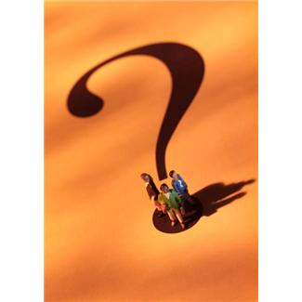 | FLASH MOB
ESTIMATED TIME:
2 Weeks for preparation / 20 minutes on implementation
OBJECTIVE:
To communicate a message through an unexpected mass performance
DESCRIPTION:
- It is a mass performance where a multitude of people gather to make some kind of action in a collective manner.
- Organize a brainstorm session with a large group of (youth) volunteers and think through what kind of activity with a dedicated crowd (e.g.. dance, song, strange movements, figures of humans) you want to make.
- Some examples:
- http://www.youtube.com/watch?v=8f1FocWHcdU (source: catch21productions)
- http://www.shock.com.co/videos/video-mujer-recibe-sorpresiva-recompensa-flashmob-ecologico (source: ParkourEntTM)
- http://www.youtube.com/watch?v=jdgX_lm1DJg (source: 891 ABC Adelaide)
RESOURCES NEEDED:
Group of people (more than 20).
EXTRA INFORMATION:
You can use this technique to spread messages about the risks of climate change and other related topics.

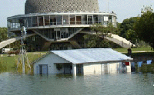 | SHOCKING ART: A HOUSE IN THE LAKE
ESTIMATED TIME:
1 week – 1 month
OBJECTIVE:
To increase consciousness about the humanitarian impacts of climate change.
DESCRIPTION:
- Installation of a house in a lake (symbolic).
- Near the place of the house, someone (a Red Cross/Red Crescent member) is giving information about floods, the need for humanitarian aid and the effects and impact of climate change.
NEEDED RESOURCE:
- Place for the exposition and permission for it to be located there
- Media (if possible),
- Information guides/ brochures,
- Volunteers to answer questions.
EXTRA INFORMATION:
Original idea of the Argentina Red Cross/ Leo Burnett. This activity was implemented for fundraising to increase preparedness work in flood affected areas.

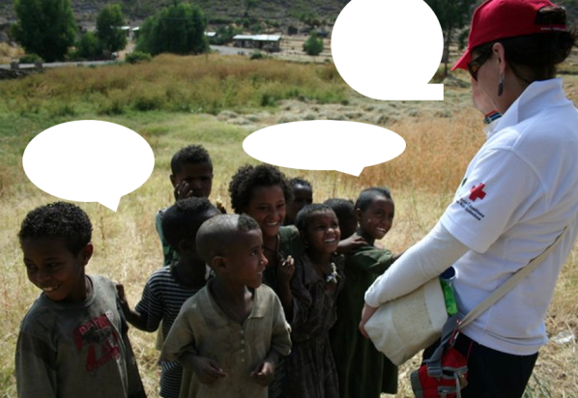 | PHOTOS AND STORIES
ESTIMATED TIME:
1 day – 1 week
OBJECTIVE:
To create awareness: photos and stories are much more likely to stick in people’s minds than facts and figures do. Telling stories and showing images shows the real face of climate change effectively
DESCRIPTION:
Collect relevant stories and integrate them into your communication/ training/advocacy efforts.
NEEDED RESOURCES:
- Camera
- Photos
EXTRA INFORMATION:
Photos can also be used for exhibitions.

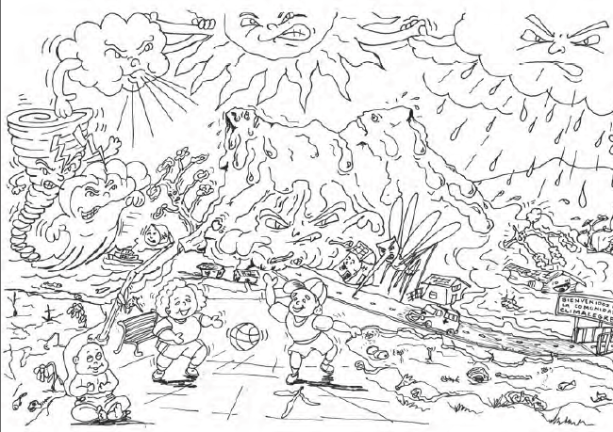 | DRAWINGS AND PAINTing
ESTIMATED TIME:
30 – 45 minutes
OBJECTIVE:
To increase the level of understanding of the community about the risks of climate change through drawing and paintings.
DESCRIPTION:
- Invite the youth volunteers/ young community members
- Provide basic information on climate change and the impacts
- Provide colors and paper to the participants
- Share all drawings at the end of the day and ask for explanations if necessary
- Put the drawings in a visible wall for a period of time
RESOURCES NEEDED:
- Paper,
- Pens/pencils
- Colour paints
- Tape.
EXTRA INFORMATION:
You can easily organize art exhibitions or drawing competitions as a result of this activity.

 |  | THE EXCHANGE OF EXPERTISE exercise
ESTIMATED TIME:
30 minutes
OBJECTIVE:
Engaging partners and increasing their understanding of each others´ expertise. This is an exercise that is useful to carry out when there are different partners involved who want to work together with your National Society.
DESCRIPTION:
- Each partner receives two green cards to write two specific approaches that he can "offer" to the other partners (for example, community risk assessments or management of water resources)
- Each partner can use two yellow cards in which specify requirements of knowledge (what they would need from others)
- The facilitator reviews the cards and matched any correspondent green and yellow cards.
- The facilitator invites partners to promote (sell) their offered expertise and have them explain why this knowledge/ skill is relevant to the programme.
- Then the facilitator looks at the yellow cards to discuss opportunities to incorporate external expertise which is lacking within the group.
RESOURCES NEEDED:
Yellow and green cards, paper and pencil
EXTRA INFORMATION:
It can be used as an effective icebreaker at the beginning of work to be done with external partners. This process allows insight on how to complement each others´ work. The activity can help to identify concrete ways forward within a potential partnership.

 | WEB 2.0
 | OBJECTIVE: To exchange information and experiences through virtual platforms
 | DESCRIPTION: To promote your projects and activities you can make use of blogs, social networks, websites and other virtual resources that can upload information and share it to others.
RESOURCES NEEDED:
- Computer with internet-connection
- Webmaster to manage the content
- Person in charge of quality control (e.g. respectful language consistent with the principles of the Red Cross/Red Crescent, correct information on climate change science)
EXTRA INFORMATION:
- By identifying different target groups you can identify different platforms.
- Share information of general interest

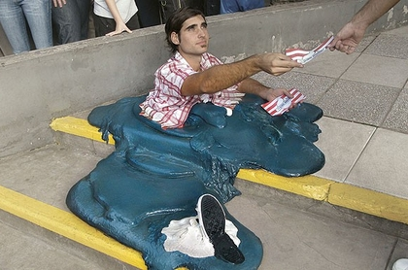 | THE MELTED MAN
 | ESTIMATED TIME: 1 day – 1 week
 | OBJECTIVE: To raise awareness of the consequences of climate change.
DESCRIPTION:
As indicated in the picture, this performance seeks impact through image. A melted man delivers messages about global warming and also provides information on how to mitigate the problem.
RESOURCES NEEDED:
- 1 person
- Preparation of costume.
EXTRA INFORMATION:
Original idea: Argentina Red Cross

