Site Visit and Solar Sizing Report for ACSE Solar Freezer project at Waisisi, March 12th to 14th 2017

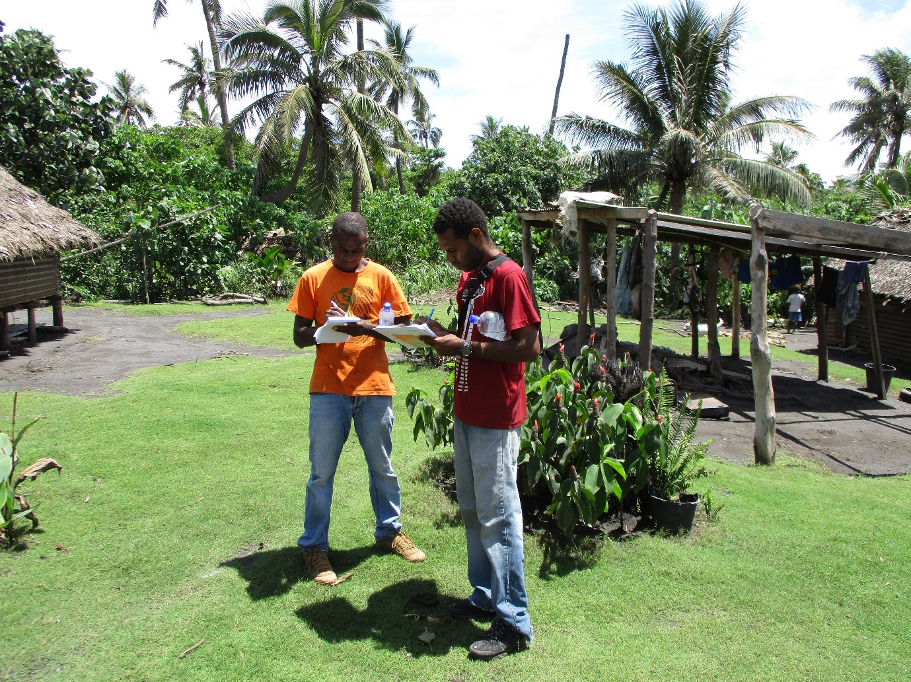

Prepared by Gavin Pereira

GIZ

Background and Trip Report
The ACSE team made a site visit to Waisisi in Tanna province from Sunday 12th to Tuesday 14th of March. The aim of the site visit was to visit the 3 potential project sites at Kualip, Nawanbai and Natanu and inspect the suitability of any potential structures for installing the solar-freezer systems.

The team’s first site visit considered the Divain school at Kualip. The school is at the juncture of the main road from Lenakel, and the dirt road leading down to the Waisisi fishing communities. It was decided during the site visit that housing the fish centre at the school would cause too much of a distraction for the students and teachers. The school will be considered as an additional beneficiary for project funds to provide power for the teachers to run their laptops and printers; should the budget calculations for the Freezer systems and construction of fishing centres be sufficient.

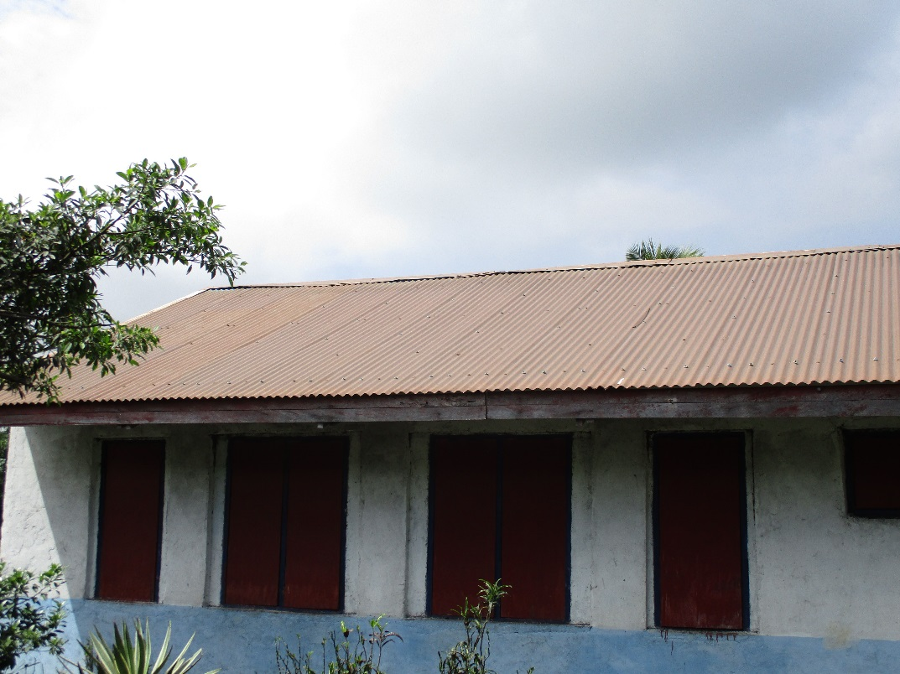
Figure 1: Suitable North Facing Roof for PV System at Divain School

Whilst the school isn’t an ideal location for the site; the high chief (Andrew Walu) and his family own the land across the road from the school, adjacent to the main road. They have marked out a part of their land for the project to contain a freezer.

The second site considered for the installation was the house of Marsel Bota, the Nawanbai Village chief. Nawanbai is approximately 200 meters from the sea-side, and its neighbouring Natanu village. The site has a concrete shell and foundations that remain after the damage from Cyclone Pam.

The third site considered for the installation was viewed at Natanu; the headquarters of the prior fishing centre (destroyed by Cyclone Pam). The community had already started rebuilding a small fishing centre area in anticipation for the project. After the site review, Osborne and Japeth worked on an agenda to discuss the Fisheries project with the community.

A community meeting was convened at Waisisi in which chief Andrew gathered the community members. ACSE Project Manager Japeth Jacob convened the community meeting. The meeting’s aim was to finalise the sites for the solar freezer installations; to agree on the community inputs to the project; and to share the intended approach for the project.

The community debated the merits of installing the solar-freezer systems at each of the 3 sites. After many rounds of discussions and different members voicing their concerns, it was decided in the end that only 2 sites would be pursued; a large ice making facility at Natanu and a smaller centre with 2 freezers at the main-road juncture in Kualip (chief Andrew’s property). The women’s group vocalised their support for this approach in particular; as they saw the benefit in having the ability to sell to at the main road to passers-by from other communities. The communities were also very happy to learn that project funds are sufficient to fund the purchase of materials to construct the fishing centres; as this has been the major hurdle for them in completing the current centre that they had wanted to build in Natanu.

Following on from the outcomes of the site visit, Gavin Pereira has provided solar system sizing for the 3 sites; the school at Divain, the larger center at Natanu and the small site at Kualip.

Energy Calculations for Divain School
The energy calculations below model the energy load for the school at Divain. The school is currently unpowered and based on consultations with the community, the proposed load for the school is:
- Classroom LED Tube Lights (6 per room x 4 rooms)
- 4 laptops and 3 in 1 inkjet/laser printer
- Adhoc Phone Charging
- 12 Lights for the Staff Houses
- Outdoor Sensor Lights for the School
- Miscellaneous Loads for the Houses (to provide an energy budget of 1 kilowatt-hour per day
Some sensible assumptions have been used to estimate the amount of hours of use for the appliances listed above. The energy calculations detailed below are listed with the estimated hours of use:

Table 1: Energy Assessment for Divain School, Waisisi
Load for Classroom blocks and 2 staff houses | Number of items | Watts (W) | AC Watts | Hours Per Appliance | Energy Usage Watt Hours (Wh)
Classroom LED Tube lights | 24 | 20 | 480 | 6 | 2880
Laptops | 4 | 25 | 100 | 6 | 600
3 in 1 printer | 1 | 100 | 100 | 2 | 200
Phone Charging (AC) | 3 | 3 | 9 | 4 | 36
House Lights for 2 houses | 12 | 10 | 120 | 4 | 480
Outdoor sensor lights for school | 6 | 15 | 90 | 2 | 180
Misc Loads for Houses | 2 | 1000 | 2000 | 1 | 2000
Total |  |  | 899 |  | 6376
Daily Energy Usage (Watt-hours) |  |  |  |  | 6376
Buffer for Growth (30%) |  |  |  |  | 8289
Inverter Efficiency (90%) |  |  |  |  | 9210
Final Design Load (Whs) | 9210

In the calculations above, a ‘buffer’ of 30% is added to the energy usage calculations as a margin of error, and also to provide a small amount of future growth capacity within the system. The above energy usage calculation is used to design the battery bank, controller, inverter and PV array to provide the right amount of generation and storage of energy.

Battery Bank Calculation
The calculation below allows for a period of 3 days of autonomy (zero-sun energy storage) to give the batteries within the system additional protection from overuse. The system will have the capability to take a battery charge from an external generator in periods of high cloud. Finally, as the bottom 25% of the battery’s storage is not available for use, the battery bank calculations are adjusted by 75%.

Table 2: Battery Calculation for Divain School, Kualip
Design Load (1) | 9210 | Whs
System Voltage (2) | 48 | Volts
Days of Autonomy (3) | 3
Battery Bank Output (4) | 576 | Ahs (1*3)/(2)
Maximum Depth of Discharge (5) | 75%
Required Battery Bank Capacity | 768 | Ahs (4)/(5)
Chosen Battery Bank Capacity Watt Hours | 36720 | 48V, 765Ah OPZV
Daily Depth of Discharge | 25% | Design Load/Battery Capacity
Expected Lifetime 7000 cycles | 18 years | From Graph

As outlined in the table above, GIZ recommends that the school use OPzV GEL lead-acid batteries and has modelled its calculations based on using the Sonnenschein A600 2Volt model. This battery is a superior unit, and typically achieves a lifetime of around 7500 cycles (or approx. 20 years) at 25% daily depth of discharge. The performance curve for the Sonnenchein A600 is shown below.

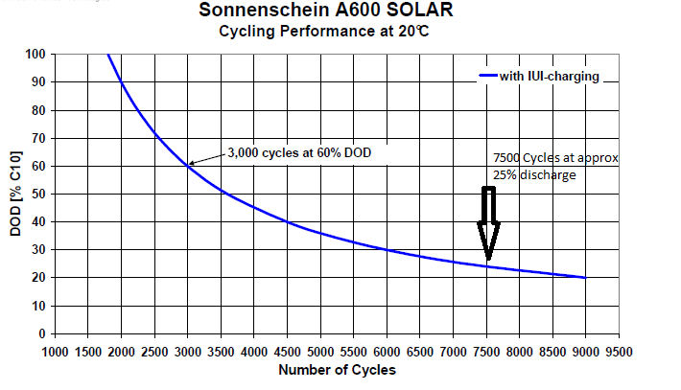

Sizing the Solar PV Array
The PV Array has been sized to cover associated losses from heat, dust and losses in charge controllers and wiring. The calculations also factor in an ‘over-charge’ factor of 50% to ensure that there is sufficient solar generation to provide boost charging and minimise battery draw. The final Solar PC Array is detailed below.
Table 3: PV Array Sizing
DC Energy Requirement (1) | 9210 | Wh/day
Battery Charging Efficiency | 90% | Loss factor
Losses from Ash/Dirt (5%) | 95% | Loss factor
Temperature Derating (15%) | 85% | Loss factor
Cable Losses | 97% | Loss factor
Charge Controller Losses | 95% | Loss factor
Final Derating Factor (2) | 0.67 | (Combining all Loss Factors)
Critical Design Month Insolation (PSH) (3) | 4.5 | PSH/Day
Required Power Rating of Array = | 3055 | Watts (1)/(2)/(3)
PV Array Oversize | 1.5
PV Array Sizing | 4582 | Watts

The above PV array can be made from 18X 260W panels, or 15X 305W panels; but the PV array should have a combined wattage as close to, or greater than 4.6kW. Roofspace at the school is not a problem for an array of its size.

Finally, a Victron 5kW Easy Solar unit (comprising inverter, charger and 100A controller) is recommended to power the system; though a display unit, inverter, charger and controller with AC distribution board could be mounted onto a meterbox and installed; the EasySolar option simplifies installation.

A basic layout of the system is shown below.

Figure 2 Basic System Layout
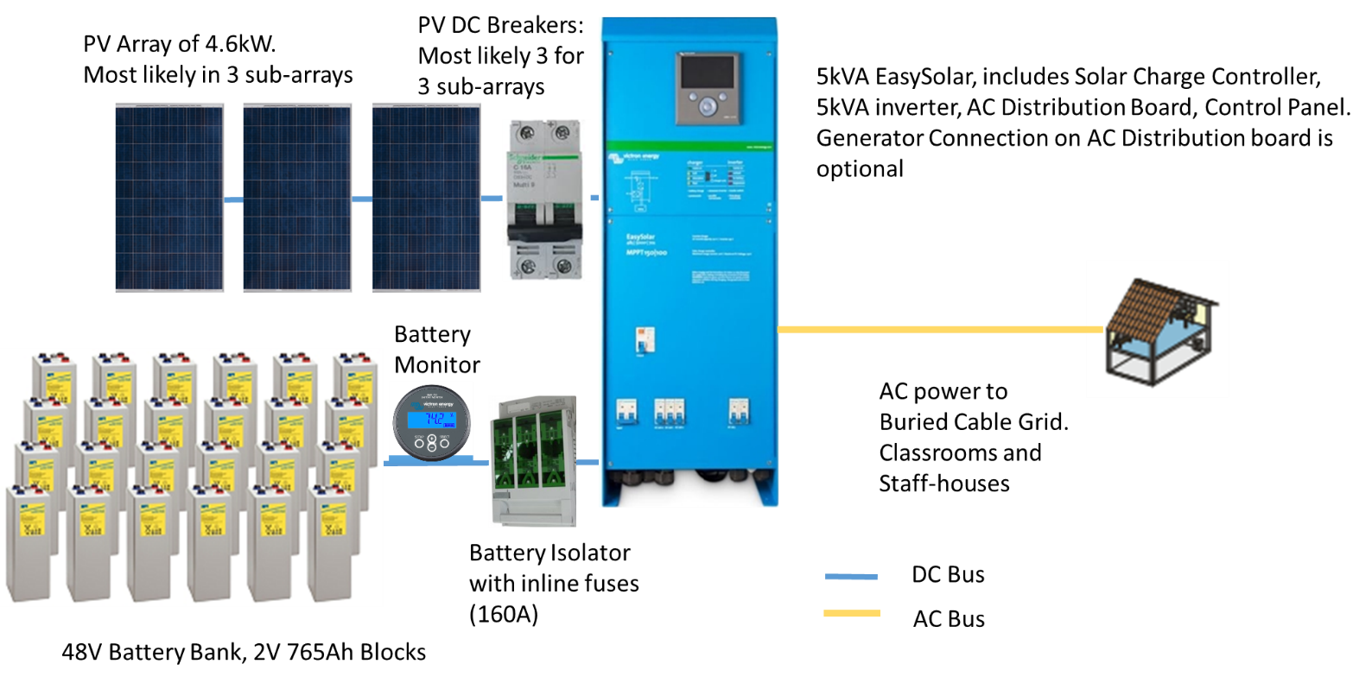

Final Costs of System
The final system design is detailed in the table below, and includes conservative cost estimates for what is available in the local market or international market (including bidders within the Pacific Islands group).

Table 4: System Cost Estimates for Divain School
Component | Qty | Cost Estimate EUR | Total Price EUR
260W Solar Panels | 18 | 220 | 3960
Racking for 18 Panels | 1 | 700 | 700
2V 780Ah OPzV Batteries + box | 24 | 500 | 13000
Victron 5kVA Easy Solar: 48V Controller, Inverter and Charger all in one | 1 | 4000 | 4000
BMV Victron Battery Monitor | 1 | 220 | 220
LED tube lights and fittings | 24 | 50 | 1200
LED lights and fittings for houses | 12 | 25 | 300
Sensor Security Lights | 5 | 100 | 500
Cabling and Pillar boxes (300M of 8mm2 cable; markers, conduit, 2 pillar boxes) | 1 | 2500 | 2500
MSB for each building; CBs, powerpoints, wallboxes, conduit, switches, cabling | 1 | 2500 | 2500
Freight to Waisisi | 1 | 2500 | 2500
Installation (including transport, meals, accommodation for 2 electricians). | 1 | 5000 | 5000
Total Installed |  |  | 36380

System Design Calculations for Natanu
The fisheries centre at Natanu is proposed to have 5 x 390 Litre Sundanzer freezers and an AC distribution system for phone charging and lighting (as these systems will be used at night times). The energy calculations for this are detailed in the table below.

Table 5: Load Calculations at Natanu Fisheries Centre
Load Description for Natanu | Number of items | Watts (W) | Total Watts | Daily Run Time (hours) | Total Watt Hours
LED lights 20 W (AC Power) | 4 | 20 | 80 | 6 | 480
Outdoor Lights 9W (AC Power) | 2 | 9 | 18 | 12 | 216
Deep freezers | 5 | 80 | 400 | 18 | 7200
Miscellaneous (laptops, tablets, mobile phones) (AC Power) | 1 | 100 | 100 | 6 | 600
Total AC Watts |  |  | 598 |  | 8496
 | DC | AC | Design Comment: Each freezer has an assumed load of 1.44kWh. 2 battery banks, one with 3 freezers, one with 2 freezers and the AC load. This is a split of 4320 and 4608 Wh
Loads | 7200 | 1296
Buffer for Growth (20%) |  | 1555
Inverter Efficiency (90%) |  | 1728
Final Design Load (Whs) (DC + AC) | 8928

The designer of this system obtained energy usage calculations for the freezers from brochures from Sundanzer, which had test energy usage of 800 Watt-hours. This was increased by a factor of 1.8 to account for the high intensity of usage.
In the calculations above, a ‘buffer’ of 30% is added to the energy usage calculations as a margin of error, and also to provide a small amount of future growth capacity within the system. The above energy usage calculation is used to design the battery bank, controller, inverter and PV array to provide the right amount of generation and storage of energy.

Battery Bank Calculation
The calculation below allows for a period of 5 days of autonomy (zero-sun energy storage) to give the batteries within the system additional protection from overuse. The system will have the capability to take a battery charge from an external generator in periods of high cloud. Finally, as the bottom 25% of the battery’s storage is not available for use, the battery bank calculations are adjusted by 75%.

It is proposed that the above energy load is divided into 2 systems; as the freezers need a 24Volt power supply and the energy usage from 5 systems is too high to connect to a single 24V battery bank. The load is split over 2 battery banks, one with 3 freezers, one with 2 freezers and the AC load. This is a split of 4320 and 4608 Wh. The 2 Battery Bank Calculations are detailed below.

Table 6: Battery Bank 1 Calculations
Design Load Battery Bank 1 | 4320 | Whs
System Voltage | 24 | Volts
Days of Autonomy | 5
Battery Bank Output | 900 | Ahs
Maximum Depth of Discharge | 75%
Required Battery Bank Capacity | 1200 | Ahs

Table 7: Battery Bank 2 Calculations
Design Load Battery Bank 2 | 4608 | Whs
System Voltage | 24 | Volts
Days of Autonomy | 5
Battery Bank Output | 960 | Ahs
Maximum Depth of Discharge | 75%
Required Battery Bank Capacity | 1280 | Ahs

The battery bank for each of the 2 systems can be compiled from twelve, 2 Volt, 1250Ah A600 Sonnenchein Batteries.

Sizing the Solar PV Array
The PV Array has been sized to cover associated losses from heat, dust and losses in charge controllers and wiring. The calculations also factor in an ‘over-charge’ factor of 50% to ensure that there is sufficient solar generation to provide boost charging and minimise battery draw. The final Solar PC Array is detailed below.

Table 8: PV Array 1
DC Energy Requirement | 4320 | Wh/day
Battery Charging Efficiency | 90%
Soiling Factor | 95%
Temperature Derating | 85%
Cable Losses | 97%
Charge Controller Losses | 95%
Final Derating Factor | 0.67
Critical Design Month Insolation (PSH) | 4.5 | PSH/Day
Required Power Rating of Array | 1433 | Watts
PV Array Oversize for Battery Charge Equalisation | 1.5
PV Array Sizing | 2149 | Watts

Table 9: PV Array 2
DC Energy Requirement | 4608 | Wh/day
Battery Charging Efficiency | 90%
Soiling Factor | 95%
Temperature Derating | 85%
Cable Losses | 97%
Charge Controller Losses | 95%
Final Derating Factor | 0.67
Critical Design Month Insolation (PSH) | 4.5 | PSH/Day
Required Power Rating of Array = | 1528 | Watts
PV Array Oversize for Battery Charge Equalisation | 1.5
PV Array Sizing | 2293 | Watts

It is suggested that an array of 9x 260 Watt panels are used, which would provide 2 arrays of 2340 Watts. Further, the designer recommends that the PV be roof mounted on the Fisheries Centre. PV Arrays will add additional strength to the roof, as it provides more reinforcement through the roof-top rail mount footings.

Roof Design, Controller, Inverter Selection

For resilience purposes, it is recommended that the roof be constructed with a purlin spacing of 450mm and a rafter spacing of 600 mm. The roof and panel spacing design is container below.

Table 10: Roof design for Natanu PV system

The above roof design allows a 3 feet clearance from the roof edges, which is the area of greatest force and vulnerability during cyclones.

There is also the added ability to add a 3rd rail to the panels above to further increase the strength of the PV array and the roof.

Each system would be paired with a 60Amp, 150V MPPT Charge controller. The second system would have the added inclusion of 24V, 1600W inverter, which would be connected to an AC distribution system via a 6Amp AC Circuit Breaker. The 6 Amp CB allows a total power draw of 230V X 6 Amps = 1380 Watts. The circuit breaker will provide added insurance against inverter failure.

The layout for the system with inverter is shown below.
Figure 3: System layout for System with AC circuit at Natanu
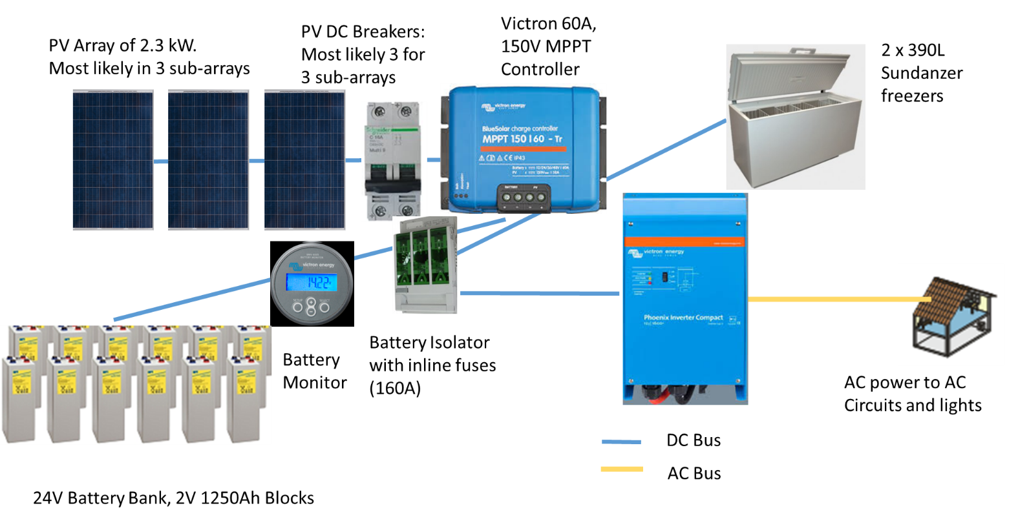

The layout for the system with 3 freezers is shown below:

Figure 4: DC system with 3 Sundanzer Freezers

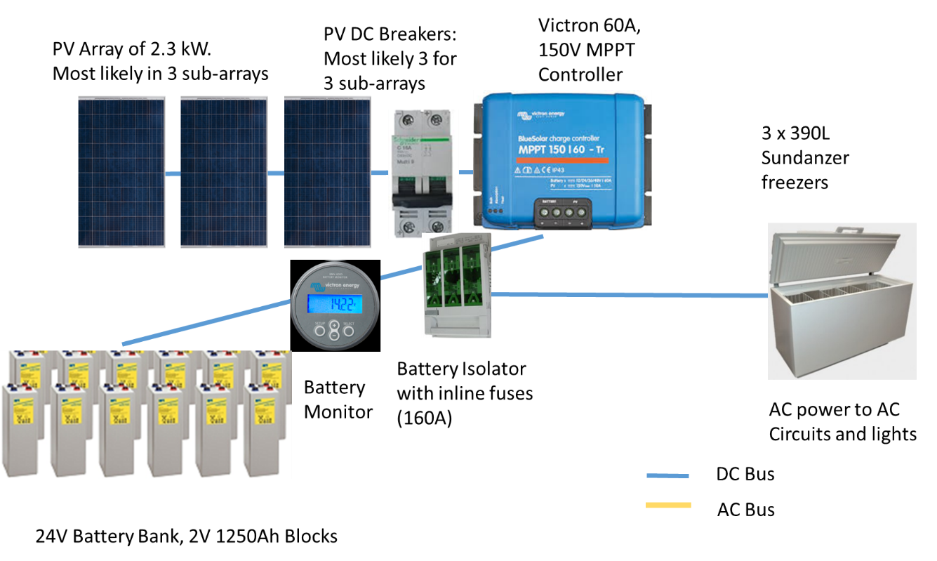

The final cost of the systems is detailed below.

Table 11: System Cost for Natanu Freezer system for Fisheries Centre
Component | Qty | Cost Estimate EUR | Total Price EUR
250 Watt Solar Panel | 18 | 220 | 3960
Racking for 18 Panels | 1 | 900 | 900
2V 1250Ah OPzV Batteries | 24 | 1000 | 24000
Freezers | 4 | 1350 | 5400
Victron 150/60A | 2 | 650 | 1300
Victron BMV Battery Monitor | 1 | 220 | 220
Victron 24V, 1600W Inverter | 1 | 900 | 900
Lights and Fittings | 4 | 70 | 280
Outdoor lights | 2 | 70 | 140
Fuses, Breakers, Cabling, Power Points, Wallboxes Switches, Meter box, Battery Box | 1 | 2500 | 2500
Installation | 1 | 2500 | 2500
Total Installed |  |  | 42100

Fisheries Centre for Kualip
A fisheries centre was designed for Kualip. This was in line with the request from the community forum, which wished to have a road side sales point for ice and fish. The system was to contain 2 freezers and the design for this is container below, starting with the energy calculations.

Table 12: Energy Usage Calculations at Kualip
Load Description for Kualip | Number of items | Watts (W) | Total Watts | Run Time (hours) | Total Watt Hours
LED lights 20 W (AC Power) | 4 | 20 | 80 | 6 | 480
Outdoor Lights 9W (AC Power) | 2 | 9 | 18 | 12 | 216
Deep freezers | 2 | 80 | 160 | 18 | 2880
Miscellaneous (laptops, tablets, mobile phones) (AC Power) | 1 | 100 | 100 | 6 | 600
Total AC Watts |  |  | 358 |  | 4176
 | DC | AC | A small AC load requirement is provided as it is envisaged that the site could provide aincome from laptop and phone charging
Loads | 2880 | 1296
Buffer for Growth (20%) |  | 1555
Inverter Efficiency (90%) |  | 1728
Final Design Load (Whs) (DC + AC) | 4608

Battery Bank Calculation
The calculation below allows for a period of 5 days of autonomy (zero-sun energy storage) to give the batteries within the system additional protection from overuse. The system will have the capability to take a battery charge from an external generator in periods of high cloud. Finally, as the bottom 25% of the battery’s storage is not available for use, the battery bank calculations are adjusted by 75%.
Table 13: Battery sizing for Kualip System
Design Load Battery Bank 2 | 4608 | Whs
System Voltage | 24 | Volts
Days of Autonomy | 5
Battery Bank Output | 960 | Ahs
Maximum Depth of Discharge | 75%
Required Battery Bank Capacity | 1280 | Ahs

The battery bank for the above systems can be compiled from twelve, 2 Volt, 1250Ah A600 Sonnenchein Batteries.

Sizing the Solar PV Array
The PV Array has been sized to cover associated losses from heat, dust and losses in charge controllers and wiring. The calculations also factor in an ‘over-charge’ factor of 50% to ensure that there is sufficient solar generation to provide boost charging and minimise battery draw. The final Solar PC Array is detailed below.

Table 14: PV Array for Kualip
DC Energy Requirement | 4608 | Wh/day
Battery Charging Efficiency | 90%
Soiling Factor | 95%
Temperature Derating | 85%
Cable Losses | 97%
Charge Controller Losses | 95%
Final Derating Factor | 0.67
Critical Design Month Insolation (PSH) | 4.5 | PSH/Day
Required Power Rating of Array = | 1528 | Watts
PV Array Oversize for Battery Charge Equalisation | 1.5
PV Array Sizing | 2293 | Watts

It is suggested that an array of 9x 260 Watt panels are used. Further, the designer recommends that the PV be roof mounted on the Fisheries Centre. PV Arrays will add additional strength to the roof, as it provides more reinforcement through the roof-top rail mount footings.

Roof Design, Controller, Inverter Selection
For resilience purposes, it is recommended that the roof be constructed with a purlin spacing of 450mm and a rafter spacing of 600 mm. The roof and panel spacing design is container below.

Table 15: Roof design for Natanu PV system
The above roof design allows a 3 feet clearance from the roof edges, which is the area of greatest force and vulnerability during cyclones.

There is also the added ability to add a 3rd rail to the panels above to further increase the strength of the PV array and the roof.

The above system would be paired with a 60Amp, 150V MPPT Charge controller. The second system would have the added inclusion of 24V, 1600W inverter, which would be connected to an AC distribution system via a 6Amp AC Circuit Breaker. The 6 Amp CB allows a total power draw of 230V X 6 Amps = 1380 Watts. The circuit breaker will provide added insurance against inverter failure.

The system layout is detailed in the picture below:

Figure 5: System layout for system at Kualip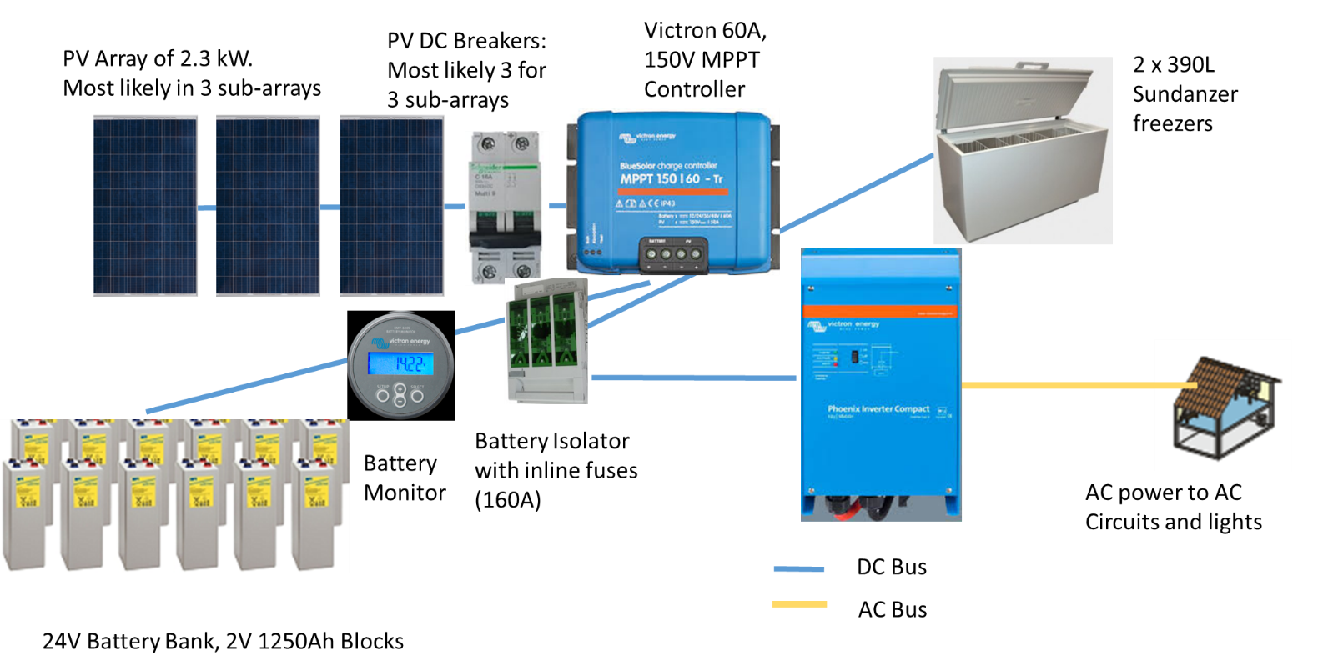

The final cost of the systems is detailed below.
Table 16: System Cost for Kualip Freezer system for Fisheries Centre

Next Steps
The estimated total cost of the 3 solar systems with all equipment is 22892 + 42100 + 36830 = 101822 EUR.
The ACSE budget allows for system and construction costs of approximately 150,000 EUR. So the PMU must decide whether to accept these system designs and costings; or whether they require revision to allow construction of the 2 fisheries centres at Kualip and Natanu.

