South Pentecost Community –
Ecosystems-Based Adaptation

project proposal
2013 – 2015

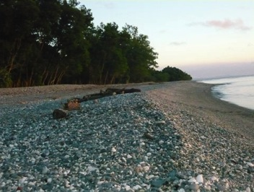

Contact:
Andrina Thomas vanuatu@livelearn.org
or
Anjali Nelson anjali.nelson@livelearn.org

Background to the Pacific Coral Triangle Program – Vanuatu

This proposal has been developed to support the program in Vanuatu of the ADB TA 7753-REG; Strengthening Coastal and Marine Resources management in the Coral Triangle of the Pacific.

The Quarterly Progress Report (2) dated 30 June 2012, prepared by ANZDEC as the PMC, outlines the following aim for the TA:

The aim of TA-7753 (REG) - Strengthening Coastal and Marine Resources Management in the Coral Triangle Initiative of the Pacific (Phase 2) is to strengthen coastal and marine resource management in the Coral Triangle region, particularly in the five participating countries, in order to increase the resilience of their coastal and marine ecosystem, and subsequently contribute to food and livelihood security for the five Pacific countries. The expected outcome is increased resilience of coastal and marine ecosystems through effective and sustainable coastal and marine management practices being implemented in the five participating countries. Achievement of the impact will be indicated by the quality of coastal habitats and their productivity in terms of biomass and biodiversity.

In an Aide Memoire of the ADB Consultation and Review Mission to Vanuatu dated September 2012, the following Vanuatu-specific outputs were identified:

- strengthen capabilities of national and local institutions in sustainable coastal and marine resource management; (ii) provide opportunities for coastal communities to gain experience in applying best practices in ecosystem-based management and climate change adaptation; (iii) enhance resilience of coastal ecosystems to climate change.

Specific focus is to be made on isolated communities in Vanuatu who receive little in the way of development assistance due to their isolation and small population.

Background to Live & Learn and Ecosystems-Based Adaptation

Live & Learn Environmental Education (Live & Learn) Vanuatu has been operating in Vanuatu as a locally-based NGO since 2001. As a locally registered NGO run by local staff with the support of Live & Learn International our projects are innovative, culturally appropriate and relevant. Our aim is to promote the integration of environmental, human, cultural and peace concepts in all education projects and programs. We have worked across formal and informal education programs in areas like WASH, climate change adaptation, biodiversity conservation, community forest management, waste management, good governance and conflict resolution.

Building community resilience towards climate change through ecosystems based adaptation has become a top priority for us over the past two years and we participated actively on a UN panel of experts in identifying priorities for ecosystems based adaptation. Our team of climate change adaptation participated in the COP 15 and COP 16 process highlighting effective approaches to (i) protect food security through adaptation to climate change (ii) maintaining productive coastal ecosystems (iii) develop adaptive strategies to secure livelihoods (iv) undertake participatory vulnerability assessments and (v) build ecosystem resilience to climate change.
Our general organisational methodology on ecosystems based adaptation is expressed through a series of seven principles: (i) Promote inclusiveness through equitable and engendered implementation; (ii) Build up the relationship between communities and local authorities, (iii) Deliver visible results in the short, medium term (iv) Avoid over engineering, set realistic timeframes and manage risks (v) Develop and promote programmatic approaches and ensure the activities are embedded in the NAPA; (vi) Promote mutual accountability, disciplined and responsive partnerships at local and provincial level.

Background to engagement with South Pentecost

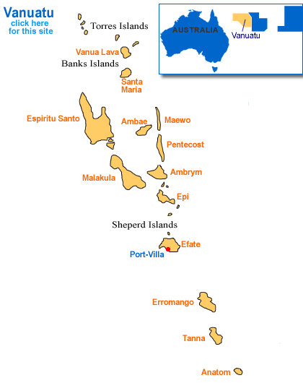
Live & Learn has been engaged with the community of Ranputor in South Pentecost since 2011. The organisation was approached to support leaders of the Ranputor and Homo Bay communities to develop a concept note for a funding grant to the United Nations Development Program (UNDP). These leaders, namely Ron Temakon TamTam and Chief Amon Wari worked with Live & Learn to set up a three-day project planning workshop 24 – 26th May 2011. Eighty adults attended the workshop (48 men and 32 women) as well as numerous children. The workshop was undertaken through Live & Learn’s methodology of a Research of Aspirations and Perceptions (RAP) and was focused on the topic of climate change. The community specifically looked at the ways their natural resources are being managed and what the future might look like if current practices continue in the face of climate impacts.

The below table lists the current challenges with resources in Ranputor as identified by community participants in the workshop. Some further field research will be needed to verify and further the baseline issues noted below.

- Reef & Marine Resources
- Crown of thorns starfish are destroying coral
- Plastic bags are causing damage to habitats & killing animals
- Harvesting any size fish or marine animals (crabs, lobster etc) is leading to less availability of mature breeding population
- Cyclone impacts destroying marine habitats
- Soil erosion from land is running into rivers and out to reefs destroying important habitat for marine life
- Overharvesting of reef fish & crabs is leading to decline in availability of these species
- Damage to reef from spear fishing that cause physical destruction of coral
- Human waste from ships and other pollution dumped into the ocean near reefs

- River & Freshwater Environments
- Washing in the river using soap that kills the living creatures in the river
- Destroying the dark bush is having negative impacts on water availability
- Overharvesting of prawns & eel-fish in the river is leading to a decline in availability of these species
- Clearing of trees & other vegetation close to the river & water sources is impacting on water quality and habitat for freshwater species.
- Breeding and habitat areas in and adjacent to the river are being destroyed mainly for gardening.

- Birds / Pijin
- Overharvesting through hunting too many birds (Pijin In particular) using guns and elastic shot
- Increased demand for food due to increased population growth rate is putting pressure on the availability of mature breeding birds.
- Destroying nests, habitat and feeding areas through clearing of vegetation for gardens and cutting timber for building materials

- Trees / Dark Bush
- Cyclones destroy the trees
- Increasing amount of timber tree species are being cut down to be used for building houses and not replanted
- Poison (type to be identified) is being used to kill trees and making it much easier to clear areas of dark bush
- Small scale logging is removing large trees and these are not being replanted
- Many trees are often cut without a specific purpose or intended use
- Big leaf (Merimia Peltata) is spreading over wider areas and destroying large forest areas and killing trees.
- Large trees are used for building canoes
- Timber tree species are harvested for wood carving
- Fungus (species to be identified) is destroying the roots of some trees

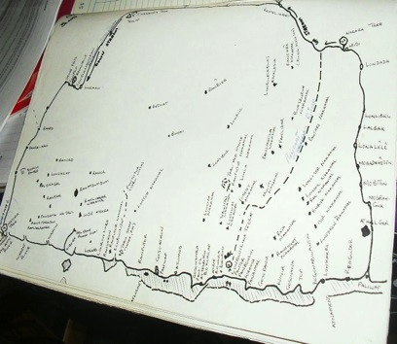

The community then suggested what activities could be done to build the resilience of the community and address some of the above key issues. They requested training and awareness in marine protection, small business development, sustainable farming and sustainable fishing. They noted a desire for revegetation of areas where habitat of key edible freshwater species (e.g. prawns, eels) had been destroyed especially along the river and in the water catchment area. The main drivers of deforestation are expansion for agriculture and the need for subsistence timber products. A nursery was suggested in order to provide trees for revegetation and for wood plots. The community made a strong connection between the health and resilience of their local ecosystem and future development opportunities. To this end they also requested small enterprise training as a way to motivate ongoing sustainable activities in the community.

A full report of the workshop in May 2011 is attached as Appendix A.

Project Concept

The project seeks to strengthen existing systems both within Live & Learn, Government Agencies and the Ranputor community to increase resilience to the shocks of climate change in Vanuatu. Live & Learn will use existing resources developed in water management, river care, food security, forest-management and good governance to support a holistic approach to ecosystems-based adaptation. The Departments of Fisheries, Agriculture and Forestry will be engaged in specific activities during the project increasing their capacity to respond to community vulnerabilities on a systems-level. For Ranputor itself, existing governance systems, institutions and customary practices will be empowered through the funded activities to enhance communities’ resilience to climate change.

The project will focus on three key areas:
(i) Governance and strengthening of social systems for long term project sustainability and social resilience (ii) Ridge to Reef conservation work as example of ecosystems-based resilience (ii) Food Security work to bring in other Pentecost communities and to make connection between ecosystems and food.

(i) Governance
Good governance is central to project sustainability especially for remote communities where interactions with project developers cannot be constant and community ownership of the process is essential to its success. Further to this the Ranputor community has identified a desire for small enterprise training and development. In 2012 Live & Learn has developed a Good Governance manual aimed at assisting communities in Melanesia who would like to develop small businesses and cooperatives. This resource will be adapted for the Ranputor community and while the set up of a business is not included in this phase of engagement with the community, the good governance training and establishment of a committee for the project will lay a strong foundation for its development in future. The Ranputor community also noted that any economic development in their community centers around their natural resources. Developing cohesive community-led actions in relation to resources is therefore key to the success of any equitable future economic development.

The first year of the project will focus on the establishment and strengthening of community-based governance processes through a project committee. The second year will require the committee and community it represents to develop a Marine Protected Area (MPA) or Conservation Area (CCA) and management plan for the marine area and work to implement the actions found within the plan. The community will be supported by relevant Government agencies and Live & Learn hopes to work closely with Reef Check and the Department of Fisheries (if a MPA) and Department of Environmental Protection and Conservation (if a CCA).

The first year of the project will focus on the establishment and strengthening of community-based governance processes through a project committee. The second year will require the committee and community it represents to develop a Marine Protected Area (MPA) or Community Conservation Area (CCA) and management plan and work to implement the actions found within the plan for the marine area. In discussions with Department of Environmental Protection and Conservation it has been made clear that the process for legal registration of the Conservation Area under the Environmental Protection and Conservation Act CAP 283 requires the following steps:
- Baseline study
- Survey of the proposed MPA/CCA area (Department of Lands)
- Management Plan Development
- Workshop with all landowners to ensure democratic decision making
- Administrative processing.

It is understood that the process for the establishment of an MPA under the Department of Fisheries is less clear but may take a similar length of time. Live & Learn understands that this process will take at a minimum 6 months. Given the desire to address terrestrial issues that are effecting marine health in the first year, the development of a MPA or CCA will be undertaken in Year 2 although some work towards it can be started towards the end of Year One. The decision of which legislation to be used (for either a MPA or CCA) will be a decision of the community with advice from Government during Workshop 5 in Year One.

The community will be supported by relevant Government agencies and Live & Learn hopes to work closely with the Department of Environmental Protection and Conservation, Reef Check and the Department of Fisheries on this protected site.

Live & Learn will also engage closely with Department of Forestry to align any work on Pentecost closely.

Indicative Budget for Year One: 1,338,200 VUV (Resource development costs and 2 workshops. Budget excludes Government per diems). Engagement of one Government Representative requested (local rep recommended)

(ii) Ridge to Reef
The concept of Ridge to Reef centers around establishing the clear connections between terrestrial environmental impacts and marine environmental impacts. This fact is not new to the Ranputor community who in the RAP report highlight the concerns for both river and marine health and were able to make connections between these two ecosystems. Live & Learn seeks to use already developed resources on climate change to explain to the community the connections between their surrounding ecosystem and climate change adaptation. A workshop will be developed and delivered which highlights an ecosystems-based adaptation approach as central to increased resilience in the face of climate change.

This education will then be put into practice through various activities to strengthen the health of the river and marine system. Such activities may include revegetation, exclusion zones, turtle monitoring, community education awareness training, water testing and data collection, tree propagation and planting, The Departments of Environmental Protection and Conservation, Forestry, Fisheries and NGO, Reef Check, will be key stakeholders in this implementation phase. All fieldwork will be done in agreement with the Provincial Government and use Government extension employees where possible rather than bringing experts from Port Vila.

Live & Learn will be responsible for carrying out all activities. It will seek the engagement of Government Agencies for in-community advice on how to proceed and will therefore budget for these field trips. Live & Learn will seek further support from Government should it require assistance with tree planting, water quality maintenance or marine baseline determinations although it is hoped that the current budgeted field work can cater for this.

Indicative Budget Year One: 1,968,900 VUV (3 workshops, infrastructure costs, one extra trip for nursery set up. Budget excludes Government per diems). Engagement of Government Representatives requested for each workshop and nursery set up. Local Representative sought to fit into budget.

(iii) Food Security
Recent research undertaken by Live & Learn has suggested that the impacts of climate change on food security is already being felt throughout Vanuatu. During the RAP, the communities of Ranputor identified that a key driver of environmental degradation was local agriculture. In order to ensure that the benefits of the project are lasting, it is important that Live & Learn addresses the key drivers of deforestation and overharvesting. Live & Learn is now undergoing the second phase of a Food Security Program throughout Melanesia that establishes knowledge hubs of local farmers and partners closely with agricultural departments in each country. For Ranputor, water taro is a main staple crop as well as key cash crop supplied to markets for sale. River systems are affected by diversion to feed water taro plots and other cash crop plots. In Year Two of this project, Live & Learn’s food security experts will support the project to assess food security needs such as improved taro production. The Department of Agriculture will be asked to support this work by providing expertise and planning experience.

Using the skills of Live & Learn’s Food Security staff will provide huge added benefit to the project’s long-term as well as addressing local capacity to build a sustainable food-base in the face of climate change. The Live & Learn Vanuatu Food Security team engage various stakeholders in their work including VARTC, Department of Agriculture and the FSA.

Due to commitments in Year One, the Food Security may be unable to undertake this work until Year 2 of the project.

Indicative Budget: 800,000VUV (to be undertaken in Year 2). Engagement of Department of Agriculture to occur through Food Security staff.

Sustainability

The sustainability of any actions undertaken through this project is of central importance. Sustainability becomes a challenge when projects have short timeframes. To address this Live & Learn will undertake the following actions:

- Existing community governance systems will be assessed in the first workshop and where effective used to embed activities within existing governance structures,
- Live & Learn will undertake good governance training for the project committee within the community and seek to build management skills from the start of the project.
- Live & Learn will engage the Government of Vanuatu in every step of the project as it is Government who is often relied upon after the project to provide support to the communities. The Government’s awareness and support for the project is therefore key to its long-term sustainability.
- Should the committee not be ready to run independently at the end of the 18 month period, Live & Learn will seek a small further grant in order to provide some ongoing support to the community.

Project Plan
Colour Key
Completed Work
Year One (ideally 6 months only)
Year Two
Year Three (only if extra support is required)
Throughout Project

Monitoring and Evaluation

Activities For Year One

APPENDIX A
2011
Live & Learn Environmental Education
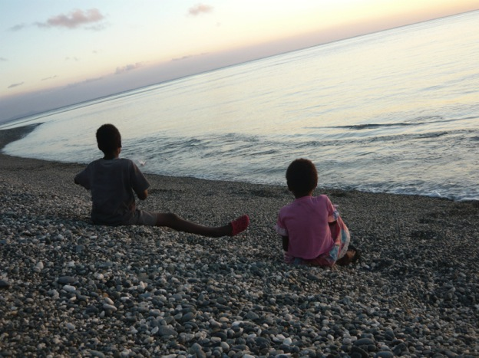

[South Pentecost Community Conservation planning ]
In May 2011, the community of Ranputor, South Pentecost hosted a workshop to look at the ways the natural resources were being managed and what the future might look like if current practices continue. The need for the workshop was driven by recognition that land, water and sea resources people depend on for every life are being degraded. Access to once plentiful fish and timber as well as native birds has declined and the impact of invasive species such as the highly destructive Merimia Peltata Big Leaf vine has increased. This report presents a summary of community discussions and outcomes that will form the basis for a proposal for funding from the Global Environment Facility Small Grants Program to implement a three year project addressing important biodiversity conservation issues whilst developing sustainable livelihood opportunities for village communities in South Pentecost.

Contents
Background 3
Introduction 4
Preparation & Planning 4
Aims & Objectives 4
Workshop Approach 5
Community Workshop Planning 5
Participants 6
Activity Groups 7
Workshop Process 8
DAY 1. AWARENESS & EDUCATION 9
DAY 2. ISSUES & PRIORITIES 14
DAY 3. PROJECT PLANNING 20
Conclusions 25
Appendix I - Workshop Program 26

Background

In May 2010 Pastor Shem Tema submitted a concept note to the United Nations Development Program (UNDP) Global Environment Facility Small Grants Program (GEF SGP) for funding to undertake an environmental conservation and stewardship conservation project.
The underlying aim for the project concept was to raise awareness and increase the effective participation in conservation and restoration of natural resources in the Ranputor / Bay Homo area of South Pentecost.
Live & Learn Environmental Education, Vanuatu were approached to assist further developing the concept note into a full project proposal by Ron Temakon TamTam and Chief Amon Wari.
A planning grant proposal was subsequently submitted and approved with funding provided in April 2011 to organize and facilitate a workshop to design the project more fully in a participatory manner.
This report presents the findings from a three day project planning workshop held from Tuesday 24th May to Thursday 26th May 2011 in Ranputor, South Pentecost that will underpin a proposal to implement a three year project with funding from the Global Environment Facility (GEF) Small Grants Program (SGP).

Introduction

Preparation & Planning
In April 2011 Live & Learn received planning grant funding from GEF SGP to facilitate a workshop to gather information required & scope a full project proposal for a South Pentecost Environmental Conservation and Stewardship Project.
A meeting was convened on Tuesday 11th April, at the Live & Learn Office, FresWota Four to help plan workshop. Pastor Shem Tema, Ron Temakon Tamtam, Ian Kalsuak and Geoff Robinson attended the meeting. A representative from the Department of Environment and Conservation was invited to attend.
The purpose of the meeting was to organize a community workshop to develop the concept for a project to help protect the environmental resources of the south Pentecost area and develop opportunities for people to benefit from.
Issues discussed at the meeting included the objectives for the workshop and what could be expected at the end of the for the workshop, when it would be held, what the workshop would cover, how the workshop would be run, who would attend and an outline for a draft program.
A Work Breakdown Structure (WBS) was developed to plan the main tasks that needed to be undertaken in planning for the workshop.
Live & Learn would coordinate development of a detailed program of activities for facilitation of the workshop to gather information to be used to develop a full project proposal.
Pastor Shem and Ron Temakon Tamtam would coordinate workshop logistics and participants.

Aims & Objectives
The aim of the workshop was to provide an opportunity to raise awareness on the environmental issues effecting the habitats and natural resources of South Pentecost and the types of actions people can take to improve their situation by protecting these environmental resources.
The workshop was also to allow people of south Pentecost to identify and explain what issues are important and what they would like to see happen to address these issues now and importantly what people wish for in the long term.
Importantly activities needed to identify priorities and actions that can be taken by the Ranputor community to:
- Protect the environmental resources people depend on; and
- Improve the financial and economic situations of people from protect the environmental resources.

Workshop Approach
It was recognized that this workshop would be the first of this kind to be run in the Ranputor community and as such it would be important for the program to allow for a process of first raising awareness of issues before identifying priorities and discussing possible project activities and approaches. Three stages were identified that the workshop program should include in order to help ensure commitment and ownership as well as understanding of the logic underpinning the final project proposal to be developed (rationale & description). The three phases to the workshop program activities were designed to cover are summarized below.

WORKSHOP PROGRAM STAGES

- AWARENESS & EDUCATION
RATIONALE
DESCRIPTION
- Environmental Issues
- Examples & Opportunities
- PRIORITIES FOR THE FUTURE
- Priorities for environmental protection and rehabilitation
- Priorities for developments to improve livelihoods
- PROJECT PLANNING
- Project Activities (what activities will be implemented)
- Project Approach (how the project will be implemented, who will be involved)
- Project Sustainability (how will the project’s impact is sustainable)
- Risks to the Project

Community Workshop Planning
Pastor Shem organized a meeting with the Ranputor community on 26th April 2011 to introduce the proposed workshop program, discuss expectations and identify roles and responsibilities for the running of the workshop. A draft program was provided to the community to assist with preparing workshop logistics and to give an idea of what to expect from activities during the workshop. This meeting was an important stage in the process as it allowed the community to consider the objectives of the workshop & prepare in advance.

Participants
The workshop was held in the new kindergarten school building in the community of Ranputor on Pentecost. Over the three days, more than 80 people from the Ranputor, Point Cross, Londar & Haroplolous communities attended the workshop. This included 48 men, 32 women and numerous pikinini.

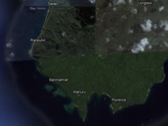

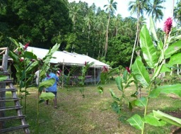
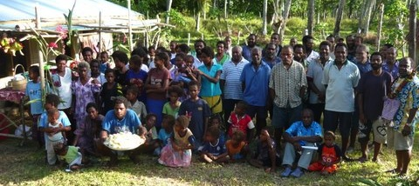

Activity Groups
Participants were asked to decide how best they would like to work together for each of the small group activities with unanimous agreement to work in mixed groups with men, women & youth together.
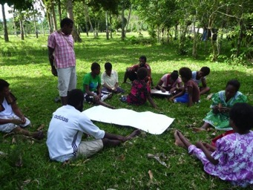
Initially it seemed uncharacteristic that this would be the most effective means for ensuring an environment for full participation of all groups within the community however it became very obvious that the opinions and contributions of all people, men women & youth were presented and equally considered in both small and large group discussions.
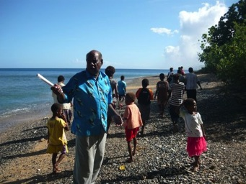
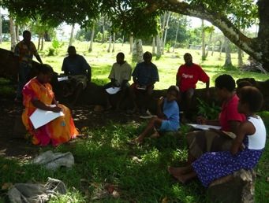
This was something that was specifically raised when undertaking an evaluation of the workshop where a number of participants commented that they felt this was of great benefit as young people had the opportunity to hear stories from the older people that they did not know before and the older people in turn were able to listen to the views and aspirations of the younger generation. The fact that knowledge and idea sharing across generations and gender was a strong part of the how the workshop participants interacted is no doubt is one of the strengths of the Ranputor community.

Workshop Process

At the beginning of the workshop an overview of the process and the intended program for the three days was provided. In summary this included:
- What the workshop would talk about
The workshop was to provide an opportunity to raise awareness on the environmental issues affecting the habitats and natural resources of South Pentecost and the types of actions people can take to improve their situation by protecting these environmental resources. The workshop will allowed people to identify and explain what issues are important to them and what they would like to see happen to address these issues now and importantly what people wish for in the future.
- How the workshop would be run
Collectively, over three days people will get talk about the community and the problems they are facing with the plants, animals and natural habitats in their area and think together about the things they can do to address these problems. This discussion also would allow key people or groups who can help or who may know better about the problems or who can share their knowledge to be identified.
- What to expect at the end of the workshop
At the end of the workshop people should be able to explain what sort of project they would like to undertake and why they would want to have this project. This also means knowing what outcomes to expect from carrying the main tasks and activities that are identified during the workshop.

DAY 1. AWARENESS & EDUCATION
The focus for day one of the workshop was to raise awareness of environmental issues through five activities designed to get people sharing their ideas, knowledge and experience. These are summarized below.
Activity 1. Important Plants, Animals & Places
Activity 2. Traditional Knowledge
Activity 3. Old Ways / New Ways
Activity 4. Community timeline
Activity 4. Climate Change - What is does it mean for Vanuatu?

Activity 1. Important Plants, Animals & Places
In this activity participants worked in small groups to talk about and identify the important plants, animals and areas that are significant to their community. Discussion focussed on not just identifying these but also thinking about why is it important, how is it used, where it is, issues that are effecting it and what can be done to preserve it or knowledge about how to manage it for the future.
Important natural resources & issues identified included are summarized below:

Natural Resource | Importance | Issue
Fish | Provide meat for food  Provide financial benefit | Population size is declining  Overharvesting  Population size is declining
Gower Cane | Building material for houses  Provide financial benefits | Clearing areas for gardening  Cutting without using materials
Trees | Building material for houses  Provide financial benefits  Soil stabilisation  Habitat for birds & animals | Clearing areas for gardening  Cutting without using materials  Trees are not being replanted quickly enough
Flying Fox | Provide meat for food  Provide financial benefit | Population size is declining  Habitat is be degraded
Coconut crab | Provide meat for food  Provide financial benefit | Population size is declining  Habitat is be degraded
Snake | Provide meat for food  Provide financial benefit | Population size is declining  Habitat is be degraded
River | Provide water for people to use  Habitat for fish, birds and other species  Important cultural areas | Habitat is be degraded
Coastal areas | Important for people to use  Habitat for fish and other specie | Habitat is be degraded
Naora (prawns) | Provide meat for food  Provide financial benefit | Population size is declining  Habitat is be degraded
Turtles | Provide meat for food  Provide financial benefit | Population size is declining  Habitat is be degraded
Crabs | Provide meat for food  Provide financial benefit | Population size is declining  Habitat is be degraded
Nawinba (birds) | Provide meat for food  Provide financial benefit | Population size is declining  Habitat is be degraded
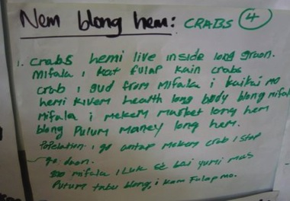
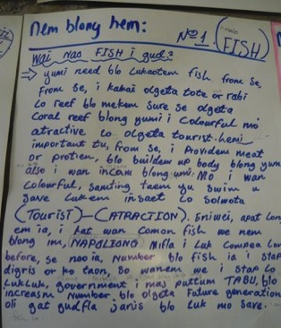
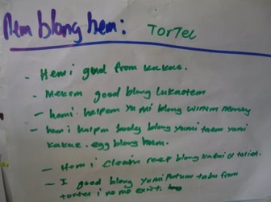
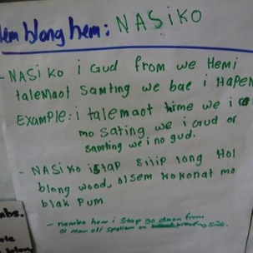
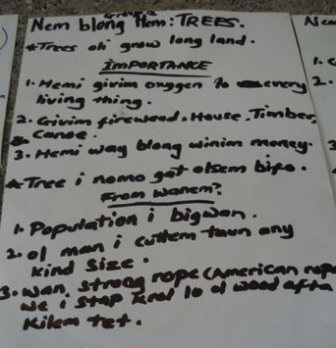

Activity 2. Traditional Knowledge
This activity developed a Traditional Knowledge Seasonal Calendar that documented what the community know about important plants, animals & areas such as breeding seasons for birds or hunting seasons for different fish and animals or the best time for picking certain fruits.
Participant groups worked in groups mark on a one-year calendar using their traditional knowledge when events or patterns happen with important plants, animals and areas. This included:
- Time of year & location where animals reproduce
- Time and location where foods are easily available
- Time of year when significant cultural events occur
- Environmental indicators of change (when a particular plant is in flower, or when turtles lay their eggs)
- Tabu places where populations of signifcant species are protected
- Tabu times when no hunting or collecting is allowed
- Special skills or equipment are used or obtained (i.e Nagol Land diving)

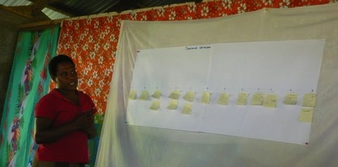

Discussing important events & times throughout the year as a ‘Seasonal Calendar’

Activity 3. Old Ways / New Ways
During this activity participants shared their knowledge about how plants, animals and places have been used traditionally and then talked about at how this has changed today with the introduction on new modern technology. Groups worked together with older and younger members and questions focussed on the cultural practices for how the important plants & animals identified are used and managed and how these have changed. This included the types of food people eat, how food is prepared, medicines, building materials, tabu's, ways of catching fish or hunting, ceremonies, decorations, types of money

Activity 4. Community Timeline
Following on from talking about how old ways / new ways groups worked together to develop a community timeline that mapped out when the types of changes discussed in the old ways/new ways activity happened. Importantly groups discussed whether changes were positive or negative as well as talking about:
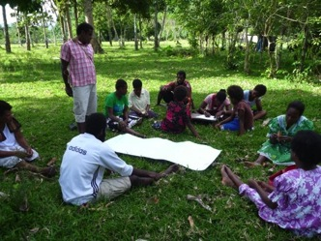
- Why did these changes happen?
- Who benefited or who was disadvantaged?
- What lessons can we learn from the past that we should consider in the future?

Discussing when changes happened

Activity 5. Climate Change - What is does it mean for Vanuatu?
This activity involved watching a dvd produced on the impacts of climate change in Vanuatu. The DVD covered basic climate change science and identified the types of impacts communities in Vanuatu need to prepare for. There was significant interest in understanding more about climate change and how to better prepare communities for changes in weather patterns causing drought, increased frequency and intensity of storms and options for ensuring food & water security.
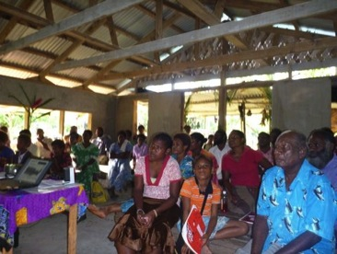

Community members watching climate change DVD

DAY 2. ISSUES & PRIORITIES
The focus for activities on day two was to get the community thinking & talking about issues, impacts and causes particularly related to the important values identified during day 1. Cause and effect relationships between issues and impacts were investigated and priorities for action identified. Community strengths & decision making processed were discussed and a DVD highlighting examples of different outcomes from decisions made to manage forests on other islands was watched. The seven activities for day two included:
- Activity 7. Identifying Issues
- Activity 8. Resource Mapping & Community Profile
- Activity 9. Listing & Ranking Issues
- Activity 10. Problem Tree Analysis
- Activity 11. Community Profile
- Activity 12. Community Decision Making
- Activity 13. Fujia Blong Bus (DVD) and discussion

Activity 7. Identifying Issues
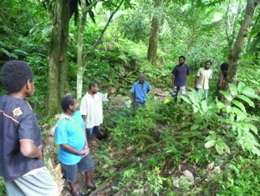
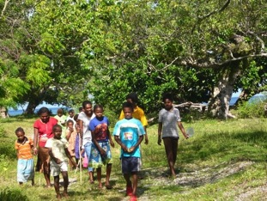
This activity involved breaking into three groups and doing a transect walk to look more specifically at some of the issues identified already, discussing potential opportunities & solutions as well as challenges. The transect walks covered three priority areas including ‘dark bush’, ‘coastal & reef’ and ‘river’ environments. After the walk each group presented back on their observations & discussions.

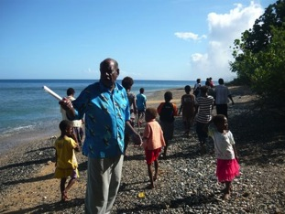

Issues being discussed during transect walks

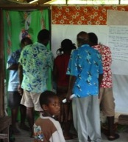
Activity 8. Resource Mapping & Community Profile
This activity followed on from the transect walk with the community looking at the issues & opportunities and then identifying them spatially on map. During this exercise challenges & problems were also identified and discussed later in the day..

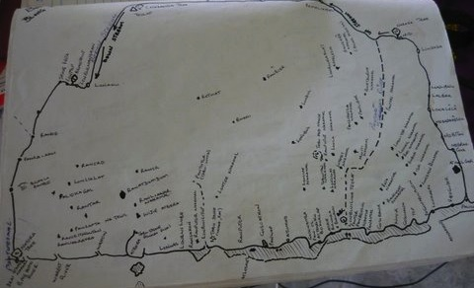

Activity 9. Listing & Ranking Issues
This activity allowed the community to talk more about the problems & challenges identified in the mapping exercise & identify key strengths and opportunities. This will allow the group to discuss why each problem or is important. This was done working in small groups to create a list of either problems or strengths. Each issue, problem, strength or opportunity was then prioritised from least important to most important. Individual groups then presented their rankings to the other groups allowing discussion in any differences in rankings and to develop an agreed list of priority issues. A problem tree analysis was then undertaken to discuss the cause & effect of these issues as a precursor to identifying actions and activities.
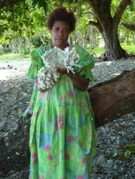
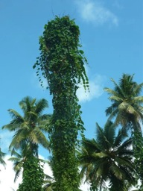

Dead Coral; Coastal erosion underminingg vegetation; Big Leaf Vine killing coconut trees (Meremia Peltata);

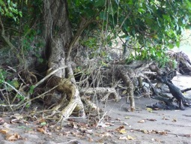

Activity 10. Problem Tree Analysis
This activity allowed an open discussion about the issues the community prioritised as being most important to address and then investigated the cause & effect of these and how they are connected. This activity is a precursor to identifying actions to address the cause of issues and not just deal with the impacts.
Key areas were identified where issues & problems were discussed. These were
- Reef & Marine Resources
- River & Freshwater Environments
- Trees & Dark Bush
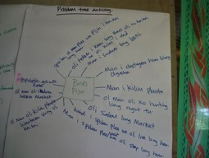
- Birds / Pijin

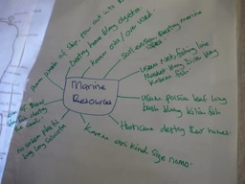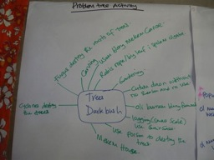

- Reef & Marine Resources
- Crown of thorns starfish are destroying coral
- Plastic bags are causing damage to habitats & killing animals
- Harvesting any size fish or marine animals (crabs, lobster etc) is leading to less availability of mature breeding population
- Cyclone impacts destroying marine habitats
- Soil erosion from land is running into rivers and out to reefs destroying important habitat for marine life
- Overharvesting of reef fish & crabs is leading to decline in availability of these species
- Damage to reef from spear fishing and other activities that cause physical destruction of coral
- Human waste from ships and other pollution dumped into the ocean near reefs

- River & Freshwater Environments
- Washing in the river using soap that kills the living creatures in the river
- Destroying the dark bush is having negative impacts on water availability
- Overharvesting of prawns & eel-fish in the river is leading to a decline in availability of these species
- Clearing of trees & other vegetation close to the river & water sources is impacting on water quality and habitat for freshwater species.
- Breeding and habitat areas in and adjacent to the river are being destroyed mainly for gardening.

- Birds / Pijin
- Overharvesting through hunting too many birds using guns and elastic shot
- Increased demand for food due to increased population growth rate is putting pressure on the availability of mature breeding birds.
- Destroying nests, habitat and feeding areas through clearing of vegetation for gardens and cutting timber for building materials

- Trees / Dark Bush
- Cyclones destroy the trees
- Increasing amount of timber is being cleared to be used for building houses and not replanted
- Poison is being used to kill trees and making it much easier to clear areas of dark bush
- Small scale logging is removing large trees and these are not being replanted
- Many trees are often cut without a specific purpose or intended use
- Big leaf (Merimia Peltata) is destroying large areas and killing trees.
- Large trees are used for building canoes
- Timber is harvested to be used for wood carving
- Fungus is destroying the roots of some trees

Activity 11. Community Profile
This activity was designed to allow the community to talk about the strengths, knowledge, skills and resources currently available that can be drawn on the help address the issues identified. Specifically the group was asked to identify & record:
i. Their knowledge (what they know about?)
ii. Their skills (what they can do?)
iii. Resources (what groups are they associated with that can be used for support, or what equipment do they have access to)
After this was discussed, a brief gap analysis was carried out to identify any perceived weaknesses where the community would need additional support to carry out activities.

Key strengths, knowledge, skills & resources identified included having a sizable population of more than 100 people with a Chief, Pastor, Teachers & Elders as well as youth & football club broad range of skills in carpentry, mechanics, farming, fishing & diving. Community infrastructure is also established such as an Aid post, Kindy school, secure water supply, mobile phone communication, transport (canoe, boat, truck), guesthouse, church and store. It was also noted that the natural environment of the area was a significant resources that has potential for development of enterprises such as tourism and sustainable farming of crop, livestock & fisheries. An important recognition was that most of these business development opportunities would be based around establishing & promoting land and marine conservation areas. Support will be needed from a range of organisations including:

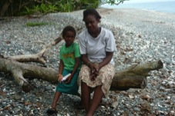
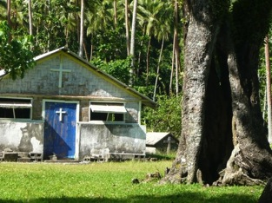
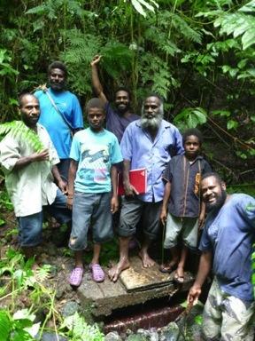

Activity 12. Community Decision Making
This activity allowed the community to reflect on how decisions are made regarding resource use and management. Who makes decisions and who is effected by them. Working in small groups participants identified the people or groups that make decisions, those that have little or no say say in decision-making.

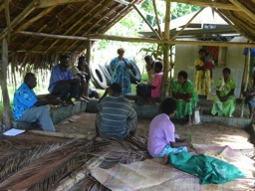
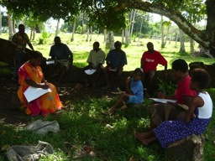

Activity 12. Fujia Blong Bus (DVD) and discussion
This activity involved watching a 20 minute DVD on decision making and sustainable forest management. It was intended to demonstrate some examples from other communities in Vanuatu of different outcomes from decision making processes for forest management. After watching the DVD facilitated discussion explored the different outcomes in the context of their own area.

DAY 3. PROJECT PLANNING
The focus for day three was to focus on what steps the community can take to address priorities identified over the previous two days. Specifically the aim was to identify actions, challenges and desired outcomes from implementing a coordinated program of activities allowing the community to describe project, why the community wants the project. Four activities were carried out to facilitate achieving this. Additionally an evaluation activity was carried to review the overall workshop success and achievements.

Activity 13. Identifying Actions to address issues (what can be done, where & when)
This activity looked at more detail the actions identified (leaves from the problem tree) yesterday and how these might come together in a project. This allowed the community to discuss what the project would be and why they want to do it. Specifically the main tasks or activities to be implemented, where & when these will occur and what is needed in order to carry them out successfully including:
Key activities that should be implemented to address important issues identified by the community include:
- Training, awareness & skills development
- Reef check monitoring
- Small business development
- Sustainable farming & fisheries practices
- Climate change adaptation
- Coconut crab monitoring
- Marine conservation
- Turtle monitors
- Establishing management guidelines for important natural resources & places
- Establishment of plant nurseries for trees to be used in revegetation projects & breeding programs for important species such as freshwater prawns (Naura) coconut crab, troka & eel-fish
- Re-introducing species that have declined or are no longer present.
- Development of local business opportunities including prawn farming, tourism enterprises &
- Management of invasive species in particular Big Leaf (Meremia Peltata)
- Revegetation / replanting of trees & vegetation
  - along coastal areas
  - along river areas
  - areas where gardens have been cleared & are not being used anymore

Activity 14. Potential Problems & Challenges
This activity aimed to explore any potential problems or challenges the project may face &what steps can be taken to avoid these. Potential challenges identified included
- Natural disasters such as cyclone, flooding, landsides & earthquakes;
- Attitudes and behaviour of some people not respecting the conservation objectives through disobeying management guidelines & tabus, stealing or continuing to dump rubbish;
- Ongoing damage to natural resources through erosions, virus, invasive species or animals (pig, cattle, flying fox & wild birds).
- Availability of people to provide labour or participate in activities due to sickness, other commitments such as work or school.
- Being able to ensure community & financial (funding) resources for people to use are available such as accommodation, transportation, communication, tools & equipment

Activity 15. Stakeholder Analysis
This activity allowed the community to identify who the key people connected with the project will be. This included discussion on:
- who the key stakeholders & groups are
- the level of influence stakeholders will have on the project,
- the extent to which the project will affect stakeholders,
- any specific needs or concerns the stakeholder may have,
- their level of interest in the project.


Activity 16. What Success Would Look Like
This activity allowed people to reflect on if the project was implemented, what changes might occur and how they would know that it has been successful. It was intended to allow an open discussion in small groups on what they would like to see as a result of the project and to think about who will benefit. Key areas that were identified where a noticeable impact would occur if the project is implemented included

- Conservation Progress
- There will be an increase in the numbers and size of species that have declined. In particular crabs, birds, turtles, fish, naura, namari.
- There will be an increased respect and value placed on conservation of natural resources

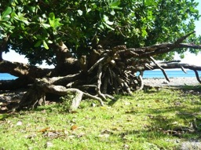
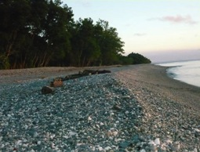


- Community Development Progress
- Tourism & other business opportunities will be established
- There will be increased financial capacity & opportunities for people
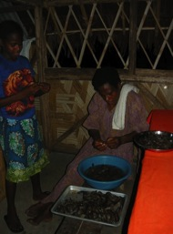
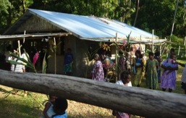
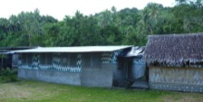

Activity 17. Workshop Evaluation
A simple workshop evaluation was carried out using a facilitated discussion to identify what worked well & what could be improved if another community workshop was to be run. Three evaluation questions were asked with key comments & points recorded summarized below.
- Were the expected outcomes for the workshop achieved?
- Yes, we learnt more about conservation and how and why we must look after the resources we have.
- Yes, we learnt about climate change
- The workshop was really good, it helped me to think back about how I destroyed the resources in my area so now I know how to conserve them
- Yes, it's a really big need for the community to attend this workshop to gain more knowledge and skills to preserve our resources
- On the eastern side of Pentecost, we had heard about global warming so it clears in my mind as I learned more in the workshop, so this will help our people to adapt
- Climate change is a big thing that I learned that I was confused about before.

- What went well at the workshop?
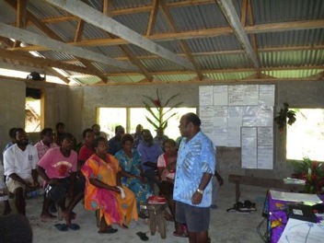
- Children also being involved in the workshop was really good
- Group activities where everyone had the chance and was glad to discuss and share ideas together
- DVD's helped us to gain a lot of information in a short time
- The Facilitator explained things clearly for participants to understand
- Catering (kaikai) was really good
- The whole community had a chance to attend the workshop which is good

- What would we keep the same or do differently next time?
- Same participants to attend the next workshop or training event
- We need to gain more knowledge & skills from the workshop but it helps
- Maybe next time it should be 4 days or 1 week
- Timing is important, starting on time and sticking to time
- Continue to run other workshops in the future

Conclusions

Funding was made available to this community through the GEF Small Grants Program (SGP) to explore the project concept more fully and a full project proposal has been developed and should be funded.
The workshop was the first time communities in this area had come together to openly discuss the values they hold associated with their environment and the impacts and challenges for sustainable management of these resources.
It was evident throughout the workshop that there is a strong degree of commitment from young and older people alike to address the challenges of sustainable resource management now and for the future. The community willingness and motivation should be harnessed and resources should be mobilized to support community action.
A full project proposal has been developed as a result of this workshop that the community will seek funding for to implement. Whilst this is a community owned & driven project, they have asked Live & Learn Environmental Education to assist facilitating the implementation of activities as part of the project.
A summary of the project proposal is provided below

