 | REPUBLIC OF VANUATU  NATIONAL ADVISORY BOARD ON CLIMATE CHANGE AND DISASTER RISK REDUCTION  C/O Corporate Services Unit  Ministry of Climate Change and Natural Disasters  Private Mail Bag 9074, Port Vila  Telephone: (678) 22068; Email: nab@vanuatu.gov.vu; Web: www.nab.vu | 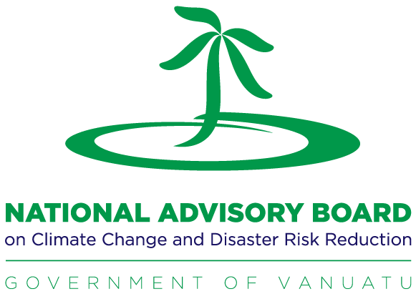

National CCDRR Policy Awareness Workshop
GOVOERNMENT STAKEHOLDER CONSULTANTION WORKSHOP

Date: 31st of August, 2022
Venue: Melanesian Hotel
Master of Ceremony: Royson Willie, PRO MOCC

Time | Session | Facilitator(s)
8:30am-9am | Participants arrival & Registration | NAB Sec Team
9am-9:20am | Welcome and Opening Remarks  - Welcome by the NAB Sec Strategic Manager  - Opening remark and official launching of the workshop by MoCC DG | NAB Sec Strategic Manager, Florence Iautu  MOCC Director General, Esline Garaebiti
9:20am-9:45am | Introduction and Objective for the workshop  - Introductions of participants (Name, Occupation and Their understanding and/or their have in anyway involved in climate change and disaster risk reduction).  - Objective of the National Workshop & Agenda overview | Workshop Participants  NAB Policy and Planning, Ericksen Packett
9:45am-10am | Morning Tea  - Group Photo
10am: 10:15am | Presentation: A Preview of the CCDRR Policy  - The development of the Policy  - The enhancement of the CCDRR Policy throughout the years.  - CCDRR Policy landscape for Vanuatu  - Key Awareness Notes for this workshop  - 5mins Q&A | NAB Strategic Manager,  Florence Iautu
10:15am: 10:35am | Presentation: The 2nd Edition of the CCDRR Policy 2022-2030  - Review of the CCDRR Policy  - 5mins Q&A | NAB Policy and Planning, Ericksen Packett
10:40am: 11am | Presentation: Vanuatu CCDRR Policy Implementation Plan 2022-2026  - Presentation by thematic programs.  - 5mins Q&A | NAB Policy and Planning, Ericksen Packett
11:05am-11:20am | Presentation: CCDRR Policy Implementation Plan Monitoring & Evaluation Framework | MoCC Senior Monitoring & Evaluation Officer, Winy Marango
11:30am-12pm | Group Exercise: Mainstream CCDRR Policy | Workshop Team
12pm-1:15pm | Lunch
1:15pm-3pm | Continue…Group Exercise: Mainstream CCDRR Policy | Workshop Team
3pm-5pm | Launching of the CCDRR Policy 2nd Edition 2022-2030 & the CCDRR Policy Implementation Plan 2022-2026  - Official Launching of CCDRR Policy and its Implementation Plan  - Official Closing of the workshop  - Light Refreshments | Minister for MOCC, Hon. Silas BULE MELVE  Everyone

