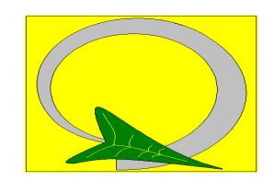

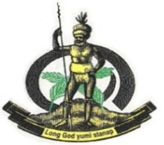

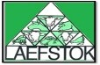
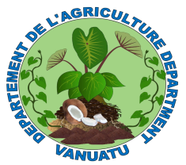

FOOD SECURITY & AGRICULTURE CLUSTER (FSAC) Meeting
Date: 2nd November 2016
Time: 14:00 – 16:30
Venue: Yumi Go Haos Building (Directorate) Conference Room

AGENDA | FACILITATOR
- VMGD presentation | Melinda Natapei / VMGD
- 4 Ws | Paul Worwor / RRU
- Outcomes - Rapid Technical Assessments on Erromango, Emae, Makira and Mataso | RRU
- FSAC TOR – Validation | RRU
- Oxfam – Good practices on CCDRR | OXFAM
- Update FSAC Priorities:  - MALFFB SOP for DRM  - Food Assistance SOP  - Contingency Plan  - Revision of Technical Assessments  - Standards and Guidelines for Humanitarian Intervention | RRU
- Update: Provincial training | RRU
- Update from partners | FSAC Partners

