World Nutrition Day - is a worldwide initiative to fight malnutrition in health care institutions ( 6th November)
Our Mission is
to improve patient safety and quality of care by raising awareness and increasing knowledge about disease-related malnutrition.
Our Vision is
to provide the healthcare community, including acute care facilities, rehabilitation facilities, home healthcare and nursing homes, with a full spectrum of resources to assess and ultimately minimize healthcare-related malnutrition.
Our vision is that nutritionDay becomes an ongoing and annually repeated systematic collection and analysis of data in hospital units and nursing homes worldwide and is recognised in the health care and scientific communities. nutritionDay will become a standard tool for determining the nutritional status and behaviour of a hospital unit’s and nursing home’s population and will be used by health care professionals and the hospital management level likewise to improve patient safety and quality of care.
Malnutrition in hospitals and nursing homes will be regarded as important public health concern and will be targeted as apriority issue at political level. Our vision is that nutritionDay will be adopted as asurveillance tool to monitor malnutrition at national level.
http://www.nutritionday.org/en/about-nday/what-is-nutritionday/index.html

https://www.childprotectionmonth.org/

In September 2014, the first International Child Protection Month provided over 300,000 adults in over 150 countries with tools to honor, support, and inspire adult leadership worldwide in protecting and empowering young people!


International Child Protection Month honors the importance of each adult taking action as a Protector of Children through:
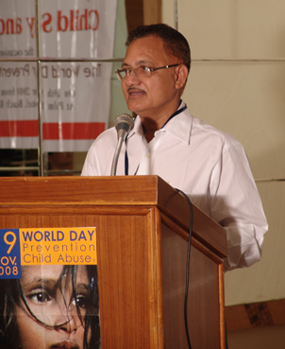
Dr. Vempadapu Venkata Ramana, founder of ARDAR and of Kidpower India, speaking on the World Day of Prevention of Child Abuse
- Awareness, advocacy, and intervention on behalf of all young people of all abilities.
- Empowerment of young people to take charge of their own lives as they learn, play, and grow.
- Listening to and learning from young people.
- Encouraging adult leadership in keeping kids safe.
As a community of caring adults, whether we are family, friends, neighbors, volunteers, or paid staff, we must work together to:
- Prevent and stop child maltreatment including all forms of bullying, violence, and abuse.
- Advocate for positive child development policies, practices, and education with our families, schools, youth-serving organizations, and professional groups.
- Provide kids and their adults with knowledge, skills, and experiences to help young people be safe and thrive.
- Provide opportunities for young people to develop self-advocacy skills and to speak for themselves.

Maternal, newborn, child and adolescent health

International Day of the Midwife May 5th, 2014

http://www.who.int/maternal_child_adolescent/news_events/news/2014/international-day-midwife/en/

WHO joins partners in celebrating midwives and their critical role for mothers and newborn babies
5 May 2014 - WHO joins partners in celebrating the International Day of the Midwife 2014, observed every year on May 5th. The International Confederation of Midwives (ICM) theme this year is “Midwives: changing the world one family at a time” accompanied by the overarching theme “The world needs midwives now more than ever”. WHO takes this opportunity of this day to highlight the critical role that midwives have in ensuring the care and survival of newborn babies.
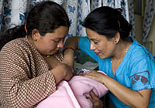
WHO/Chris Black
Every day, midwives around the world are to be thanked for their work in providing care to women and their newborns, in particular at the critical time around childbirth.
Much progress has been made in recent years in increasing access to skilled care at birth and the proportion of women who give birth in facilities. Nevertheless, every year, 2.9 million newborns die in the first month of life and another 2.6 million babies are stillborn with many of these deaths occurring around the time of birth. In addition, an estimated 287 000 women die as a result of pregnancy and childbirth. The highest burden of maternal and newborn death is in low-income countries, especially in rural areas.

