

MINISTRY OF AGRICULTURE, LIVESTOCK, FORESTRY, FISHERIES AND BIOSECURITY

STANDARD OPERATING PROCEDURES

FOR

DISASTER PREPAREDNESS AND RESPONSE

SEPTEMBER 2016

FOREWORD

TABLE OF CONTENTS

ACRONYMS AND ABBREVIATIONS 1
1.0 GENERAL 3
2.0 OPERATIONAL STRUCTURE 5
3.0 FOOD SECURITY AND AGRICULTURE CLUSTER 6
4.0 COORDINATION ARRANGEMENTS 10
5.0 INFORMATION MANAGEMENT 11
6.0 COMMUNICATIONS 14
7.0 RESOURCE DEPLOYMENT 15
8.0 FOOD ASSISTANCE, SEEDS & OTHER AGRICULTURAL INPUT 19
9.0 ASSESSMENT 20
10. LOGISTICS 24
11.0 TRAINING AND CAPACITY BUILDING 25
12.0 CROSS CUTTING ISSUES 26
ANNEX 1: MALFFB Corporate Services Unit Organisational Structure 28
ANNEX 2: FSAC ToR – Role of Cluster Lead, Co-Lead, Secretariat, Partners and Observers 29
ANNEX 3: RRU Staff – Roles and Responsibilities 32
ANNEX 4: Situation Report (SITREP) Template 36
ANNEX 5: FSAC Standard 4Ws Template 38
ANNEX 6: Initial Community Assessment (ICA) Form – Bislama Version 39
ANNEX 7: Rapid Technical Assessment (RTA) Template 45

ACRONYMS AND ABBREVIATIONS

ACDC – Area Council Disaster Committee
BV – Biosecurity Vanuatu
CC – Climate Change
CDC – Community Disaster Committee
CSU – Corporate Services Unit
DARD – Department of Agriculture and Rural Development
DG – Director General
DoF – Department of Forests
DRR – Disaster Risk Reduction
DSPPAC – Department of Strategic Policy, Planning & Aid Coordination
ENSO – El Nino Southern Oscillation
FAD – Fish Aggregating Device
FAO – Food and Agriculture Organization
FSAC – Food Security and Agriculture Cluster
GIS – Geographical Information System
GoV – Government of Vanuatu
HAP - Humanitarian Action Plan
ICA - Initial Community Assessment
IM – Information Management
IMWG – Information Management Working Group
IS0 - Initial Situation Overview
MALFFB – Ministry of Agriculture, Livestock, Forestry, Fisheries, Biosecurity
MCCA – Ministry of Climate Change Adaptation
MLT - Media Liaison Team
MOOC – Massive Online Open Courses
NAB – National Advisory Board for Climate Change and Disaster Risk Reduction
NDC – National Disaster Committee
NDMO – National Disaster Management Office
NEOC – National Emergency Operations Centre
NGOs – Non Government Organizations
OCHA – Office of the Coordination of Humanitarian Affairs
OGCIO – Office of the Government Chief Information Officer
PDC – Provincial Disaster Committee
PDOC – Provincial Disaster Operations Centre
PDNA – Post Disaster Needs Assessment
PMO – Prime Minister’s Office
PSC – Public Service Commission
RRU – Risk and Resilience Unit
RTA – Rapid Technical Assessment
SimEx – Simulation Exercise
SOP – Standard Operating Procedures
SPC – Secretariat of the Pacific Community
TAG – Technical Advisory Group
TC – Tropical Cyclone
ToR – Terms of Reference
TNA – Training Needs Analysis
UN – United Nations
VASP – Vanuatu Agriculture Sector Policy
VFD – Vanuatu Fisheries Department
VHT – Vanuatu Humanitarian Team
VMGD – Vanuatu Meteorology and Geo-hazards Department
VNSO – Vanuatu National Statistics Office
WFP – World Food Program

1.0 GENERAL

  - 1.1 Background
Vanuatu is one of the most vulnerable countries in the world to climate change and disaster risks. The island nation experiences cyclones, storm surges, landslides, flooding and droughts, which may become more intense as a result of climate change. Vanuatu is also highly exposed to geophysical threats such as volcanic eruptions, earthquakes and tsunamis, as well as human, animal and plant diseases, and human-caused disasters (Vanuatu CC/DRR Policy 2015).

The country suffers from the third highest rate of annual losses to GDP resulting from natural disasters of any country in the world: almost 7 per cent of GDP every year (World Bank 2012). Since 1939, Vanuatu has experienced 124 tropical cyclones, of which 45 were categorized as having hurricane force winds – 14 of which have occurred since 1981, or an average of 1 major cyclone every 1.7 years (World Bank 2008).

The devastating consequences of the Category 5 tropical cyclone in March 2015 and the subsequent severe El Nino event highlight our country’s risk from natural disasters. Predicted increases in extreme weather from climate change means we will face even greater impacts in the future (Vanuatu CC/DRR Policy 2015).

Total agriculture sector damage and losses caused by Tropical Cyclone Pam are estimated to be around VT 6.1 billion. Consistent with its share in sector GDP, the crop subsector was the most affected (69%), followed by forestry (16%), livestock (9%), and fishery (6%) (Pam PDNA 2015)

  - 1.2 Purpose
TC Pam Lessons Learned Reports identified the need for development of Standard Operating Procedures to guide and strengthen the capacity of the Food Security and Agriculture Cluster (FSAC) and the Risk and Resilience Unit (RRU) of the Ministry of Agriculture, Livestock, Forestry, Fisheries and Biosecurity (MALFFB) to improve the effectiveness and efficiency of climate and disaster operations.

This Standard Operating Procedures (SOP) sets out operational guidance for Directors, Managers, Officers and sectoral partners during disaster planning, preparedness, response, and recovery. It also carries a multi-hazard consideration.

The SOP defines roles and responsibilities of the Food Security and Agriculture Cluster (FSAC), the Risk Resilience Unit (RRU) of the MALFFB, Departments under MALFFB, and partner agencies. It will also link operations of FSAC to the National Emergency Operations Centre (NEOC), across other clusters, and down to provincial and community-level disaster committees.

  - 1.3 Hazards and Risks
The SOP will enable the sector to plan, prepare and respond to disasters or events created by the following hazards:

  - 1.4 SOP Development
The MALFFB coordinates development of this SOP, and will continue to liaise with its partners to formally review it on an annual basis and make amendments where necessary to keep up to date with changes that may arise in future.

2.0 OPERATIONAL STRUCTURE

The Food Security & Agriculture Cluster (FSAC) sits under MALFFB but is also part of Cluster groupings established by the Vanuatu Humanitarian Team (VHT) who report to the National Disaster Management Office (NDMO) and the National Disaster Committee (NDC).

  - 2.1 National Disaster Organizational Structure

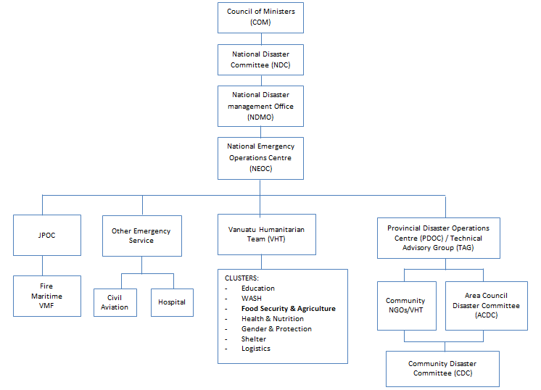

  - 2.2 MALFFB Structure
The structure of MALFFB (Annex 1) consists of four (4) main sections. These are:
- The Directorates (manages 5 departments under the Ministry)
- Administration Unit
- Project Management Unit (PMU)
- Risk Resilience Unit (RRU)

The Ministry collaborates closely with provincial authorities, private sector, farmers, NGOs, civil society, donors and other partners through the FSAC and extension network.

3.0 FOOD SECURITY AND AGRICULTURE CLUSTER

  - 3.1 FSAC Establishment and Objective
The FSAC was established by VHT to manage DRR within agriculture sector, chaired by MALFFB. The establishment is in line with the government position for agriculture development stipulated in the Vanuatu Agriculture Sector Policy (VASP):

“That there will be a Food Security and Agriculture Cluster led by the Department of Agriculture and Rural Development, with provincial focal points, to coordinate and monitor programs and issues related to food security, climate change and natural disasters.” – VASP; pg20

This cluster provides an action-oriented forum for bringing together national and international partners to improve the timeliness and effectiveness of assistance and advocacy to minimize the impacts of climate change and hazards for vulnerable communities and sectors in Vanuatu. In particular, it will help ensure coherent, coordinated and integrated initiatives that are driven by evidence-based assessment of food security and of the needs of affected populations.

The FSAC will work towards the following objectives:
- Facilitate effective coordination and sharing of information amongst agencies and organizations, including local organizations and local government partners involved in food and nutrition security efforts, disaster risk reduction, climate change adaptation and mitigation programs and recovery initiatives;
- In collaboration with the NDMO, ensure coordination of effective emergency food and nutrition security and agriculture response;
Oversee and coordinate provision of timely evidence-based reporting to MALFFB and NDMO of activities in food and nutrition security, and agriculture emergency response of sector partners/members;
- Promote the integration of CC/DRR across the agricultural sector;
- Increase resilience in the agriculture sector;
- Contribute to national/provincial FSAC contingency and preparedness planning, supporting cluster members to provide timely response during emergencies;
- Address disruption in the provision of existing MALFFB services during emergencies and liaise accordingly with sector partners and regional support agencies such as FAO, WFP, OCHA and SPC;
- Liaise and coordinate with the NDMO and other clusters- especially with joint initiatives such as DRR and response as required.

  - 3.2 FSAC Mandate Areas
- Provide policy guidance and strategic advice;
- Establishment and maintenance of appropriate integrated CC/DRM food and nutrition security, and agriculture sector coordination mechanisms;
- Provision of platform for evidence based food security assessment and appropriate response;
- Planning and strategy development;
- Information management, monitoring, evaluation and reporting;
- Application of standards, guidelines and best practices;
- Strengthen DRR capacity within the cluster;
- Training and capacity building;
- Contribute to inter-cluster coordination;
- Provision of assistance or service;
- Integration of cross-cutting thematic issues.

  - 3.3 FSAC Leadership and Membership
3.3.1 In peace time the RRU Manager shall be the chair of the FSAC;
3.3.2 In the event of a disaster, the Director General (DG) or Minister shall appoint an appropriate Director from MALFFB to chair the FSAC depending on the nature of the disaster. Appointment of the Chair in disaster time should specify clearly the term of engagement;
3.3.3 The United Nations (UN) Food and Agriculture Organization (FAO) is the co-lead and co-chair agency;
3.3.4 The RRU will act as the secretariat for the FSAC;
3.3.5 The Cluster Lead/Chair may appoint by letter a Coordinator to assist in the work of FSAC;
3.3.6 The Coordinator shall be responsible for facilitating meetings and representing the cluster membership at inter-cluster coordination and other meetings;
3.3.7 The voluntary membership in the FSAC will be as inclusive as possible, and will be comprised of among others, of the following:
- Government and local authorities
- National and international NGOs
- UN agencies
- Red Cross Movement
- Private Sector
- Civil Society Organizations
- Other stakeholders as relevant
3.3.8 Provision could also be made within the cluster for those actors who may wish to participate as observers, mainly for information sharing purposes or have limited participation relative, for example, to a particular geographical location or type of disaster;
3.3.9 The FSAC must have a Terms of Reference (ToR) to guide its operations, and is to be reviewed annually. The ToR (see Annex 2) should specify the roles of FSAC during peace and disaster times.

  - 3.4 Risk Resilience Unit (RRU)
3.4.1 Mandate
This unit was established by MALFFB and endorsed by the Public Service Commission (PSC) on the 29th October 2015 purposely to ensure coordination of food security and agriculture activities and programs among sector partners related to disaster mitigation, risk reduction, preparedness and response and climate change adaptation activities. The unit also serves as the secretariat and also Chair of the FSAC during peace time.

3.4.2 Roles and Responsibilities
- Advise the MALFFB on Climate Change & Disaster Risk Reduction (CC/DRR) and resilience
- Design projects related to CC/DRR and resilience
- Support the implementation of food security and CC/DRR policies and strategies under MALFFB
- Mainstream and monitor CC/DRR and resilience activities in the sector
- Ensure coordination of food security and agriculture activities and programs under the MALFFB
- Monitor food security concerns
- Facilitate access to climate change and DRR funding by grant writing
- Act as Secretariat of the Food Security and Agriculture Cluster (FSAC)
- Provides Chairmanship to FSAC during peace time

  - 3.5 RRU Structure and Staff
3.5.1 Structure

Manager

Food Security & Nutrition Officer

Monitoring & Information Officer

CC & DRR Officer

Administrative Support & Data
Capture Officer

3.5.2 RRU Staff
Below is the outline and purpose of the five (5) positions in the Risk Resilience Unit. Detailed roles and responsibilities of each position is referred to in Annex 3

I. Manager
The purpose of this post is to ensure continued integration of climate, environment and disaster risks to MALFFB work program through management of operations of the Risk and Resilience Unit, coordinating the Food Security and Agriculture Cluster if a disaster or emergency is declared by the Government.

II. Monitoring and Information Officer
The purpose of this post is to assist the Ministry to collect, organize, analyze and disseminate information to inform effective disaster preparation and response, promoting resilience and risk reduction and to provide information for sound decision-making for the Ministry

III. Climate Change and Disaster Risk Reduction (CC/DRR) Officer
The purpose of this post is to support the implementation of national policies, strategies and programmes on Climate Change and Disaster Risk Reduction (CC/DRR) under a multidisciplinary and a human rights vision in coordination and consultation with national authorities, civil society organizations, parliamentarians and other development partners

IV. Food Security and Nutrition Officer
The purpose of this post is to support the design and implementation of national policies, strategies and programmes on food and nutrition security under a multidisciplinary and a human rights vision in coordination and consult with national authorities, civil society organizations, parliamentarians and other development partners.

V. Administration Support and Data Capture Officer
This position exists to assist the Ministry to provide administrative support in the Risk & Resilience Unit as well as data capture/entry to ensure the effective monitoring projects in food security, climate change and agriculture preparedness and response projects.

4.0 COORDINATION ARRANGEMENTS

Planning and Preparedness

  - 4.1 Meetings
The RRU Manager and Coordinator are responsible for organizing FSAC meetings and asking the Cluster Lead to call meetings during disaster Planning and Preparedness Phase.

Invitations are to be sent to members and observers via FSAC email at least three (3) days prior to the meeting to advice on date, venue, time and meeting agenda.

All meetings during peace time are to be chaired by the RRU Manager, and the Admin & Data Capture Officer of the RRU is to register attendance and record minutes. Copies of Attendance Record and Minutes are to be circulated to members and observers via FSAC email within three (3) days after the meeting.

Meetings during this phase are to be conducted regularly to keep members informed.

  - 4.2 Coordination with PDOCs, ACDCs and CDCs
MALFFB Provincial Managers are members of the PDOC and TAGs

MALFFB Field officers are to work in collaboration with ACDCs and CDCs to develop, update and implement disaster plans

  - 4.3 Coordination with NDC and NDMO, NAB
DG MALFFB is a member of the National Disaster Committee (NDC)

All Directors under MALFFB are members of the National Advisory Board (NAB) for Climate Change and DRR

The NDMO must have a representative in the FSAC

  - 4.4 Communication with Donors
Communication with donor partners will be delivered by the Cluster Lead, Co-lead and/or Coordinator during peace time. During disaster time communication with donor partners should be done by the Cluster lead, Co- Lead and/or donor partner through the NDC.

Emergency Response and Recovery

  - 4.5 Briefings
The RRU Manager and Coordinator are also responsible for organizing and advise the Cluster Lead to call meeting/briefings during disaster emergency response and recovery stage. The RRU coordinator should collect a contact data base of initial stakeholder.

During emergency Response Phase, invitations are to be sent to members and observers via FSAC email, phone and SMS to immediately advice on date, venue, time and meeting agenda. Briefings or meetings are to be held daily, and with consideration of the scale of the disaster the cluster lead will advise when daily briefings shall cease or changed to longer time periods.

Moving into the Recovery Phase, the calling and staging of meetings/briefings are to be conducted as in the Preparedness Phase.

  - 4.6 Surge Capacity
RRU Staff, MALFFB Extension Officers, NGO Field Officers, and Volunteers are to be provided by attachment. The chair must be able to communicate clearly capacity needs to relevant institutions supporting the cluster to second staff to provide additional support.

5.0 INFORMATION MANAGEMENT

The Information Officer at the Risk and Resilience Unit will act as the Information Manager for the FSAC. The officer will also lead the information management working group and will be responsible to provide and share information within the cluster.

Planning and Preparedness

  - 5.1 Filing and Recording
The MALFFB has both an electronic filing system and paper filing system. The RRU must establish a shared drives which will contain:
- Databases;
- Maps and charts;
- Work documents;
- Final documents;
- Officer responsible for the creation of documents has to ensure it is saved into the filing system
- Documents that need to be updated are the responsibility of the RRU Admin and Data Capture Officer.

  - 5.2 Contact List – FSAC and Sector Focal Points
The RRU Monitoring and Information Officer will be responsible for maintaining an up to date contact list of the stakeholders. This includes the MALFFB department, the Directors and focal points, the MALFFB extension officers, the NDMO - Director and Operation Manager, the NGOs - Country Directors and Focal Points, the Donors - focal point and the Food Security Regional Coordinators.

  - 5.3 Maps and Charts
Maps and charts are used to record geographically and pictorially significant operational information including details of the area or specific locations under threat and the extent of damage caused. The Information Officer has to ensure that all relevant, updated and available maps and charts are in the electronic filing system.

The types of maps and charts are:
- Vulnerability maps: flood, landslide, tsunami, etc.;
- Maps for food security issues (Hotspot mapping);
- Land use maps;
- Hydrological maps;
- National and provincial maps – used to plot locations of damage, resources, problems, etc.;
- Vessel Locations Chart – used to show the location of surface vessels;
- Tracking Map – used to plot the location and movement of cyclones, etc. as reported by the Vanuatu Meteorological Service.

  - 5.4 Key Messages
The Monitoring and Information Officer is responsible for securing, collating and updating all multi-hazards key messages. The key messages will be validated by MALFFB and the FSAC and saved on the shared drive. The above Officer will disseminate them across the MALFFB and the FSAC.

  - 5.5 Data Collection and Management
The Information Management Working Group (IMWG) will be responsible to collect and manage relevant databases of disaster risk management in the sector. This includes, but not limited to:
- Disaggregated population data;
- Productive areas (crops, livestock, fisheries);
- Nurseries;
- Public infrastructure for agriculture, livestock, forestry and fisheries;
- Record and incidence of pest and disease outbreaks;
- Database of soil conditions;
- Risk and vulnerability mapping;
- Rainfall data;
- Operational 4Ws (Who, what, when and where);
- 4Ws CCDRR and Food and Nutrition Security activities in the sector.

Emergency Response and Recovery

  - 5.6 Contact List
The Monitoring & Information Officer will be responsible of maintaining an up to date contact list of the stakeholders. This includes all surge capacity coming in country.

  - 5.7 Data Collection, Management and Sharing of Information
The IMWG will be responsible for collecting managing and sharing the information within the cluster. The contact point of the working group is the Monitoring & Information officer.

The Monitoring & Information Officer will liaise with the provincial technical officers and the extension officers to collect information as and when required.

  - 5.8 Situational Report (SITREP) for FSAC only
The Cluster Coordinator prepares the SITREP with assistance from the MALFFB and RRU staff. This SITREP should contain a progressive update of the emergency situation in terms of:
- Details of the hazard.
- The areas affected.
- Impact on food security.
- Actions taken and progress of response.
- Any other relevant information.

The situational report template is in Annex 4

  - 5.9 The 4Ws
This is an important activity reporting tool adopted by the FSAC to gather information from cluster members on the 4Ws (Who, when, where, what)? The RRU Monitoring & Information Officer is responsible for collecting and updating this report on a monthly basis. A standard template is in Annex 5

6.0 COMMUNICATIONS

Emergency Response and Recovery

  - 6.1 Media Liaison Team
All external communication with media and communities will be delivered by the Media Liaison Focal Point. The Media Liaison Team (MLT), composed of one officer across all Departments of the MALFFB, will act as the focal point for all matters related to dissemination of important information to the media, the public and communities. The MLT will:
- Be responsible for liaising with the public and media and with other agencies with incident related information requirements;
- Report to RRU Manager;
- Assemble and prepare information for release to the media and public;
- Inform media and conduct regular meetings;
- Manage media requests and organize media interviews and briefings;
- Set-up an information board outside of the FSAC / MALFFB and update it on a regular basis;
- Liaise with media agencies and monitor all forms of media for inaccurate information;
- Record all media and public information releases and any information received from the media in the activity log;
- Pre-record / write articles on preparedness, response and recovery in the agriculture sector;
- Support communication officers - or MALFFB staff whose roles and responsibilities cover communication - in disseminating pre-recorded voice and SMS messages.

  - 6.2 Producing and Disseminating Key Messages - Written and Audio/Visual Messages
Should there be missing key messages, the communication officers - or staff holding this responsibility within the MALFFB will be responsible for the development of written and audio-visual messages related to response and recovery that the MALFFB and FSAC need to disseminate.

  - 6.3 Landline / Phone Contacts
A free landline/hotline under the MALFFB will receive calls from the public, and collect information and/or provide advice.

Focal contact points - specifically MALFFB Extension Officers - across all six provinces will be responsible to collect information, provide feedback and inform/advise on the status of the provinces. The Monitoring & Information Officer or RRU Manager will reach out to the focal points and collect, collate and store all incoming information.

  - 6.4 Communications Tree
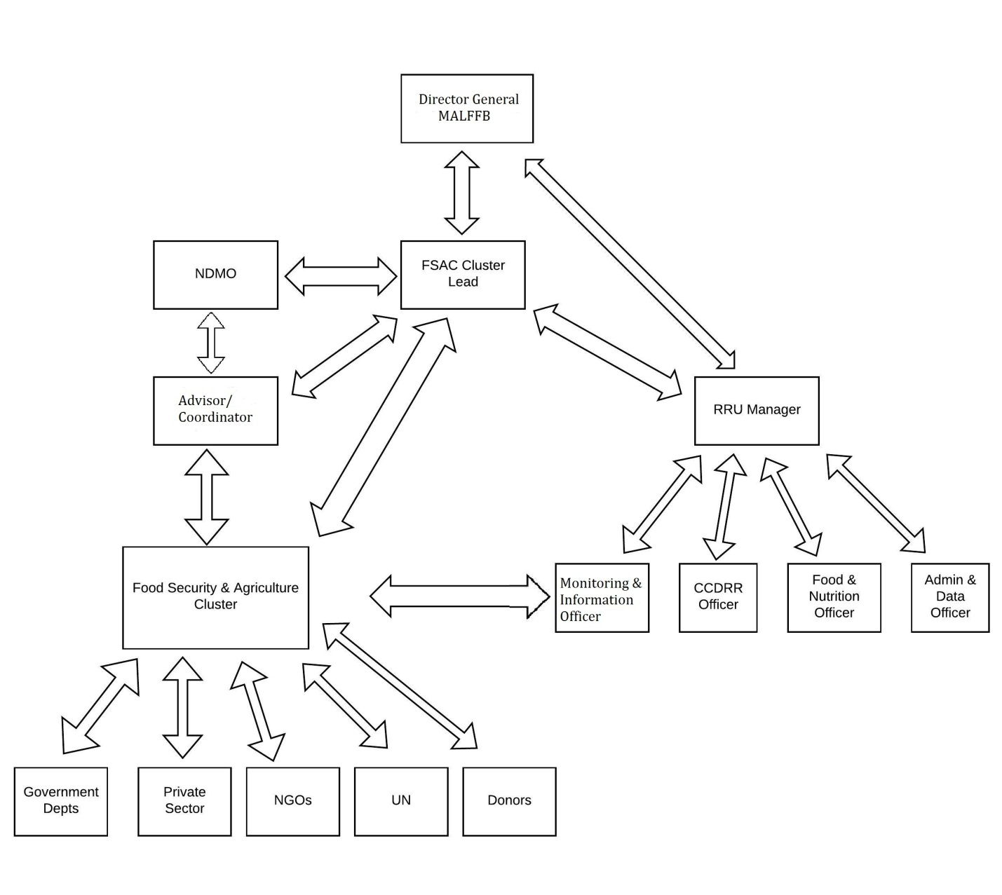

7.0 RESOURCE DEPLOYMENT

When a hazard or emergency is presented or following the declaration of a State of Emergency, the Minister of the MALFFB and his/her delegate(s) will take charge of other government department resources in order to respond well to the situation.

With additional officers or staff from sector partners deployed to assist, resource deployment must be well coordinated.

Types of resources may include but are not limited to:

• Staff (refer to section on secondment arrangements);
• Vehicles;
• Equipment;
• Equipment consumables;
• Office space and equipment;
• Petty cash;
• Transport and travel costs;
• Monitoring & Evaluation reports on resource utilization;
• Electronic devices.

  - 7.1 Human Resource Management
- Contact list (mobile phone, e-mail) up-to-date for
    - Local officers;
    - International officers
- Staff timesheets and overtime records to be completed on PSC standard forms (PSC Form 4.1) and agreed and signed by supervising officer. No late unauthorized, undocumented overtime will be paid. Unsocial Hours Payments may be considered (ordinary hourly rate + overtime + unsocial hours ) as per PSC Staff Manual 4.2 (b)
- ID Lanyards should be prepared using the NDMO NEOC template and NDMO SOP to ensure only authorized personnel have access to working areas in times of emergency/disaster.

  - 7.2 Staff Attachment
Planning Phase
To provide “surge capacity” in times of disaster and emergency, in peace time GoV and NGO officers with critical skills and expertise needed for the national response and early recovery efforts in a multi sector agency approach across whole of Government and NGO/CSO partners are to be identified. These officers are to be tracked on a data base.

Preparedness Phase
In peacetime, special preparedness workshops are organized with the nominated staff “work released” or attached at the request of the Minister responsible. This training in peace time will better equip them for emergency disaster response and early recovery attachments. SOPs developed by FSAC i.e. Food Distribution can be the basis for training.

Response Phase
Staff will be attached to the appropriate Unit i.e. NDMO or a Cluster in an Emergency Attachment, with salary, demobilization, overtime and benefits still paid by the Officer’s Department or Ministry or CSO/NGO.

Job Descriptions or Terms of Reference should be modified to reflect the additional responsibility/role.

Recovery Phase
As country enters the Recovery Phase, the officers can be sequentially demobilized back to their respective Departments or agencies.

In Pacific Island Countries where this system is used, it is referred to as a “Two Hat System.”

  - 7.3 Financial Management
It is proposed that a Cost Centre is created under the RRU for Disasters/Emergencies with a small budget allocated annually from MALFFB. In times of emergency/disaster, funds can be sourced from this Cost Centre to allow for resource deployment and purchasing. By creating a special Cost Centre, accounting and auditing of cost related to Disaster/Emergency response can be easily tracked through SmartStream to gather reports on:
- Correct financial documentation on all purchases related to response and recovery efforts;
- Local Purchase Orders (LPOs) correctly completed as per PFEM Act for
  - Food;
  - Fuel;
  - Stationery;
  - Travel expenses;
  - Stock Control in order i.e. tools, seeds;
  - Stock Control Received;
  - Stock Control Dispatched.
- Donations or pledges
  - Donations or pledges recorded on an Excel database;
  - Donation disbursement tracked and recorded;
  - Storage of donations must be referred to the NDMO Logistics Officer and the Logistics Cluster for decisions regarding location of storage and security.
- Petty cash
  - Petty cash on hand and secured;
  - Petty cash reported as per PFEM regulations.

  - 7.4 Office Space & Equipment
- Additional office space: Offices may need to house additional personnel. This can be negotiated with the Director General, Directors, Executive Officer and Managers of the MALFFB or other Ministries (as necessary);
- Equipment consumables must be recorded with LPOs to buy paper, cartridges, etc. against the approved Cost Centre for the Department but recorded clearly as Disaster Response for later tracking/auditing purposes.

  - 7.5 Asset Management
Equipment may need to be moved. This must be done in liaison with MALFFB’s two Assets Officers who will track relocation of equipment i.e. computers, desks, chairs, photocopiers, using the established Assets Register.

  - 7.6 Vehicles Use
Vehicle use for disaster operations both in peace and disaster times shall be guided by the following:
- Authority to Operate: Under PSC regulations no Non-Government Officer may drive a Government plated vehicle;
- Project vehicles may be used if the Project Team Leader so agrees. This will require a change in the Projects Insurance Policy with additional authorized driver information being provided to the Projects insurer;
- Licenses: Only drivers with a valid Vanuatu or International License may drive. It is noted that after three months of residency, any internationally licensed person must apply for and hold a Vanuatu license to be legally authorized to drive a vehicle. This license clearly specifies the type of vehicle;
- Vehicle Log: Government regulations require the completion of a vehicle log. This log book can be purchased from Sun Productions. Vehicle logbooks can be bought from local stationer businesses;
- Fuel must be used responsibly and its use and purchase clearly recorded;
- Petty cash or LPOs may be used to purchase fuel;
- Reimbursement for cash payments will only be made upon reception of proper receipts;
- Fuel use should be recorded in the Vehicle Log Book which is kept in each vehicle.

  - 7.7 Transport & Travel Costs – airfares, airfreight and shipping
- For Logistics Standard Operating Procedure refer to Logistics Section and/or to NDMOs SOP on Logistics & Logistics Cluster operations;
- Any transport or travel costs must be negotiated with the supervisor and approved:
  - LPOs must be prepared as per PSC and FEM regulations;
  - Travel and transport invoices should be kept for reimbursement processes according to the PSC Manual & PFEM Regulations.

  - 7.8 Monitoring & Evaluation Reports on Resource Utilization
- M&E reports on resource utilization must be completed as per GoV or donor regulations;
- Timely reports to supervising or designated focal point officer may be needed to release next tranche of funds;
- Acquittals may be required to be made in different forms depending on donor.

  - 7.9 Electronic Devices
- Electronic equipment should be utilized for rapid assessments, IM gathering and in-field communications such as but not limited to:
  - Mobile phones;
  - Laptops;
  - Tablets;
  - VHT Radios;
  - Cameras;
  - Movie Cameras;
  - Drones.
- MALFFB Asset Officers and OGCIO staff will allocate asset numbers to these devices and record number, user, travel/location details and equipment condition return:
  - Asset Officer will be responsible for up-to-date status and tracking of MALFFB electronic devises/assets;
  - OGCIO staff will be responsible for registry and tracking of OGCIO equipment.

8.0 FOOD ASSISTANCE, SEEDS & OTHER AGRICULTURAL INPUT

8.1 Food Assistance

Food assistance in the areas of food transfers, cash and voucher transfers, and livelihoods is covered in a separate SOP for food distribution.

8.2 Seeds & Other Agricultural Input

Response and Recovery
Sourcing, purchase, import and distribution of seeds for disaster response and recovery shall adhere to all Biosecurity import requirements, and guidelines in the MALFFB Seeds Policy (draft).

Tools and inputs sourced and distributed for disaster response and recovery shall follow appropriate guidelines developed by the FSAC (draft). These inputs include:
- Hand tools;
- Rotary machines;
- Forestry tools and milling machines;
- Livestock shed and fencing materials;
- Animal feed;
- Fishing gears and FADs.

9.0 ASSESSMENT

Assessment is an on-going process in both peacetime and emergency/disaster periods.

Planning Phase

The NDMO is tasked in its legislation to review NDMO Plans annually for disaster and emergency response. As part of sectoral response strategies, MALFFB policies and plans must be up-dated regularly to ensure mainstreaming of CC/DRR initiatives to improve resilience and recovery from emergencies and disasters to accommodate priorities in the following for action:
- Sendai Framework for Disaster Risk Reduction;
- The Climate Change and Disaster Risk Reduction (CCDRR) Policy 2016 – 2030
- Vanuatu Agriculture Sector Policy 2015 – 2030;
- MALFFB Corporate Plan (2014 – 2018);
- MALFFB Contingency Plan for Multi Disaster Response (in preparation);
- Overarching Productive Sector Policy (OPSP) 2012-2017;

A number of sub-sectoral policies sit under the OPSP to further guide the actions of the MALFFB’s planning for preparedness, response and recovery.

Key sub-sectoral policies under MALFFB include:
- National Livestock Policy 2015-2030;
- Agriculture Sector Policy 2015-2030;
- Vanuatu Forest Policy 2013-2023; and
- Vanuatu Fisheries Policy (in draft)
- Biosecurity Policy (in draft)

Specific reference was given to Thematic Area 12 in the Agriculture Sector Policy – Climate Variability, Climate Change and Disaster Risk Reduction and “the mainstreaming of climate variability, climate change and disaster risk reduction using adaptation and mitigation strategies in all agricultural initiatives and developments;” as well as to the vision of CCDRR Policy that “Vanuatu is a resilient community, environment and economy.”

MALFFB plans, including this Standard Operating Procedure (SOP) seek to operationalize planning objectives.

Preparedness

In peacetime, MALFFB and FSAC will collect data through assessments as the basis for effective planning and preparedness to improve resilience and recovery in times of disasters and emergencies. The following means are to be considered:
- Build capacity in country through training of designated staff in Clusters and stakeholder agencies to undertake research assessment and reporting to reduce dependency on regional and international agency support i.e. PDNAs;
- Vulnerability Assessments;
- VARTC research utilized to improve resilience (resistant crops, cropping & planting systems);
- Regional best practice research utilized to improve resilience (resistant crops, cropping & planting systems);
- MOUs with Seed Bank through CePaCT Centre;
- Monitoring & Evaluation;
- Crop Availability;
- Growth Stages/Production;
- National Cattle Audit;
- Agro-Forestry data (tree cash & food crops)
  - Annual Report with data;
  - Project reports.
- Fisheries – Annual Report
  - Fishermen (number and location through Fisherman’s Association);
  - Aquaculture stock reports;
  - Surveillance reports.
- Vanuatu National Statistics Office (VNSO) website and publications provide a variety of data for use in planning evidence based responses.

Emergency Response

  - 9.1 Initial Situation Overview (ISO)
This is also referred to as the Fly Over in which designated members of the NDC and/or Ministry/Cluster representatives will fly over the affected areas to quickly ascertain the extent of damages soon after the threat has diminished. The ISO is expected to be completed within the first 24-36 hours after the disaster has occurred. The Cluster Lead in collaboration with the Director of NDMO, and NEOC staff will coordinate. The members of the team will be selected based on the type of emergency as seating is limited due to seating capacity of the aircraft that will be engaged. The focus here is on issues such as areas affected, damage to lifelines and critical facilities. In most instances the technical report of the ISO team will assist the NDC to determine the next step of response action, for example, declaration of a State of Emergency or activities to be undertaken by MALFFB through the FSAC.

  - 9.2 Initial Community Assessment (ICA)
The ICA (Annex 6) is carried out within the first 48 hours after a disaster has occurred and is coordinated at the provincial level. Assessment forms are then sent to the NDMO for collation by the Information Management Officer who the presents to the Cluster Leads.

Those responsible to undertake an ICA are:
- Community Disaster Committees;
- Area Secretaries;
- Provincial Governments – through TAG;
- Vanuatu Humanitarian Team (VHT) Partners (NGO’s, Civil Society, Churches etc.);
- Clusters.

  - 9.3 Humanitarian Action Plan (HAP)
Shortly after the disaster/emergency, the GoV (PMO/NDC) requests International Agencies to enter the country to conduct assessments as the basis of a Humanitarian Action Plan (HAP). The NDMO and its stakeholder Ministries with the support of the Cluster System (Including FSAC) assist in this process to guide planning and coordination of initiatives to meet the identified emergency/disaster needs.

  - 9.4 Post Disaster Needs Assessment (PDNA) – Damage and Loss Assessment
Undertaken at the request of the Prime Minister’s Office and NDC, where possible utilizing capacity in GoV and NGOs and supported by international actors such as the World Bank, the Damage and Loss Assessment provides a national appraisal of the impact of the disaster/emergency.

MALFFB and FSAC to play a critically important role in provision of information on crop loss, food availability, agro-forestry damage, livestock loss, livestock availability and critical infrastructure loss – bridges, wharves, fencing, animal containment, FAD loss. This provides data for decision making by central GOV Agencies and donor partners for their Response Phase efforts and in the Recovery Phase.

  - 9.5 Secondary Data
Secondary Data is collected and collated by NDMO’s Information Management Officer and by FSAC’s nominated M&E/Information Officer. This may be an officer from within the Risk and Resilience Unit or another Agency selected by the Cluster Lead of FSAC.

  - 9.6 Census Data
The Vanuatu National Statistics Office (VNSO) Website and publications provide a variety of data for use in planning evidence based responses. VNSO staff may be invited to provide data or to attend planning/Cluster meetings to assist with data.

  - 9.7 Rapid Technical Assessment (RTA)
This assessment tool applies to rapid-onset disasters/hazards such as a cyclone or flash flood.

The RTA (Annex 7) is carried out as soon as teams are able to be deployed. Cluster members with expertise in Education/ Child Protection, WASH, Logistics, Health and Agriculture and Food Security with NDMO officers will make up the RTA teams. The Rapid Technical Assessment Form is available to guide the assessment impact.

  - 9.8 Rapid Technical Assessment (RTA) Data Collation
Assessment teams will visit affected areas and return to base. The Information and Planning Officer will collate information. Based on the information collected the Assessment Team/s will make recommendations. Operations will draft a report with recommendations for the NDMO Controller to present to the NDC. Report will also include whether the RTA team/s recommend declaring a disaster.

Information will be supplied to Clusters such as FSAC to guide evidence based decision making on food, seeds, planting material and tool distribution. The RRU Monitoring & Information Officer will ensure easy access to collated data in close cooperation with the Information Management Working Group (IMWG).

Recovery Phase

The Recovery Phase is guided by the assessments of the previous phases and by the category of disaster.

However, in addition a Lessons Learned Report should be prepared for significant disasters to appraise the effectiveness and operational gaps in the Planning, Preparedness and Response Phases. Depending on the type of disaster/emergency, a Lessons Learned Report will be prepared by FSAC for inclusion in national reports.

Donor funded initiatives will require assessment as per DSPPAC and specific donors requirements, procedures, Reporting Matrices & Assessment Tools.

10. LOGISTICS

The National Disaster Management Office is legally mandated under the National Disasters Act Cap 267 as the coordinating agency for emergency response in Vanuatu. This Act has been reviewed to further define and strengthen the NDMO’s capacity to act as Vanuatu’s national emergency and disaster coordinating agency by building strong capability through establishment of robust partnership with other line emergency responders to save lives and reduce losses to properties of all citizens. This role is articulated clearly in NDMO’s Strategic Plan 2016 – 2020

“The National Disaster Management Office is not an implementing agency. It is a coordinating agency – the doorway through which services, guidance and information flows to the 76% of people who live in rural areas, urban populations and to our sector stakeholders and development partners.” Excerpt Page 6 NDMO Strategic Plan 2016 – 2020

The Ministry of Agriculture, Livestock, Forest, Fisheries and Biosecurity is one of the sector stakeholders and host agency for the Food Security and Agriculture Cluster (FSAC), established as part of a Cluster System to improve coordination. NDMO has seven Clusters organized to assist in its coordination role:

- Logistics,
- Shelter,
- Food Security and Agriculture,
- Education,
- Health and Nutrition,
- Gender and Protection; and
- Water, Sanitation & Housing

All of these Clusters are coordinating agencies – including the Logistics Cluster.

Neither the National Disaster Management Office nor the Food Security and Agriculture Cluster are mandated to undertake logistics/food distribution roles but rather to coordinate programs on evidence based decisions.

11.0 TRAINING AND CAPACITY BUILDING

Training and Capacity Building is essential for sector stakeholders MALFFB and FSAC to improve organizational and systemic capability to support NDMO in its role as a coordination agency for

- Planning
- Preparedness
- Response &
- Recovery

A Training Needs Analysis (TNA) Survey should be undertaken every second year to determine emerging training needs for CC/DRR initiatives in these four designated areas.

Needs identified through an informal TNA conducted with FSAC partners indicate the following:

- Grant Application Preparation
- PDNAs
- Project Management
- Project Design Writing
- Report Writing
- Excel – Introduction, Refresher and Advanced Levels
- PowerPoint – Introductory & Advanced
- Kobo Toolbox
- GIS – Introduction
- SimEx – a Simulation Exercise to test the MALFFB SOP
- Drafting Press releases
- Web Site Management
- Use of Social Media in Emergencies (WEB 2.0)
- VHT Radio Use (through OGCIO)
- Inclusivity Sensitivity Training
- CC/DRR Training utilizing MOOC

12.0 CROSS CUTTING ISSUES

  - 12.1 Gender and Protection
The FSAC must engage coordination with the Gender and Protection Cluster

Planning and Preparedness
Disaster plans should be developed by and disseminated to both men and women, to ensure responsibility and awareness. Ensure women, youths and other vulnerable groups are engaged in disaster preparedness from the beginning.

Response and Recovery
Women, youths and other vulnerable groups need to be given information and power to make decisions in a disaster, be equally represented on assessment teams, and be equally involved in coordination and decision-making.

Women and children have different needs to those of men following a disaster. These needs should be addressed by the response. Ensure information about response is communicated directly to women, and meeting times and locations are appropriate for women.

  - 12.2 Environment
MALFFB and FSAC disaster response operations must incorporate environmental considerations.

Response and Recovery
12.2.1 Disaster Waste Management
Natural disasters such as cyclones, floods, and tsunamis can generate large quantities of solid and liquid wastes which can pose risks to public health through direct or vector-induced exposure to uncollected hazardous wastes. Waterways, agricultural areas, and communities are also at risk of contamination (Draft National Waste Management Strategy 2016).
Waste Management Plans developed by the Provinces and Municipalities also includes disaster waste management activity in their respective plans.

The FSAC will coordinate with the above authorities and the Department of Environmental Protection and Conservation (DEPC) as and when necessary to address disaster waste in line with the National Waste Management Strategy.

ANNEXES

ANNEX 1: MALFFB Corporate Services Unit Organisational Structure
Version Control: 11/08/2016

Director General

Codex
Secretariat
X2

Information Communications Technology (ICT) Manager

ICT & Help Desk Officer

Administration & Data Officer

Procurement & Contracts Officer

Administrative Support

Senior M&E Officer

Manager
(Projects Management Unit)

Sectoral Development Officer

Manager
(Risk & Resilience Unit)

Project Development Officers
X3

Finance Officer
(PMU)

HR
Manager

Finance Manager

Compliance Manager

Asset Officers
X 2

Food Security + Nutrition Officer

CC & DRR Officer

Monitoring & Information Officer

Directorate Agriculture

Directorate Livestock
Directorate Forests

Directorate Fisheries

Directorate
Bio-Security

Executive Officer

Office Cleaner

Secretary
(Directorate)

Executive Secretary

Handyman driver
Gardener

ANNEX 2: FSAC ToR – Role of Cluster Lead, Co-Lead, Secretariat, Partners and Observers

A. Role of the cluster lead and chair
- Represent the interest of agreed food security and agriculture priorities in discussion with stakeholders on priorities, resource mobilization and advocacy;
- Maintain appropriate links and dialogue with other national and local authorities, state institutions, civil society and other relevant actors;
- Ensure regular meetings are taking place with the support of the RRU;
- Participate actively in cluster/inter-agency contingency planning and preparedness;
- Participate actively in priority setting and the development of crises response strategy and cluster action plan;
- Endorse training and capacity building activities of partners and national authorities on CCDRR in the sector;
- The Cluster lead may delegate these roles.

B. Role of the cluster co-lead
- Maintain appropriate links and dialogue with other national and local authorities, state institutions, civil society and other relevant actors- ensuring that the FSAC position is informed by multi agency;
- Participate actively in cluster/inter-agency contingency planning and preparedness, ensuring that the multi-agency community is also contributing to and sharing FSAC responsibilities ;
- Represent the interest of the sector in discussions with stakeholders on priorities, resource mobilization and advocacy;
- Participate actively in gap analysis, priority setting and the development of crises response strategy and cluster action plan- in order to improve the quality of food security and agriculture based humanitarian responses in Vanuatu. Ensure that NGOs participate in and assume their responsibilities as part of any emergency response work, including planning, assessments, analysis and response;
- Promote/ support training and capacity building of partners and national authorities on the CCDRM cycle in the sector;
- Ensure regular meetings and cluster coordination are taking place and that the NGO members of the cluster are kept fully informed of the meetings and decisions that take place outside of regular FSAC meetings;
- Share cluster based support to NDMO;
- Facilitate linkages with the Regional Food Security Cluster.

C. Role of the FSAC Secretariat
- Provide technical advice to the FSAC and MALFFB on CCDRR, and Food and Nutrition Security;
- Support coordination and elaboration of gap analysis, capacity and vulnerability assessment, CCDRM strategy, and cluster action plan;
- Develop funding proposals for CCDRR, and food and nutrition security in the agriculture sector;
- In support of the cluster lead and co-lead, ensure regular meetings are taking place;
- Participate actively in cluster/inter-agency contingency planning and preparedness as requested by the cluster lead;
- Promote/support training and capacity building of partners and national authorities on CCDRR in the sector;
- Facilitate information sharing between the FSAC partners.

D. Role of Cluster Partners and Observers
Stakeholders can participate in the development of common CCDRM activities and plans. They are expected to be proactive partners in assessing needs, developing appropriate strategies and plans for the sector, and implementing agreed priority activities. Provision is also made in the cluster for those actors who may wish to participate as observers, mainly for information-sharing purposes.

Partners are focused on three core areas: support (technical, operational and strategic), guidance (technical, operational and strategic) and advocacy. These are areas where the diverse perspectives and contribution from organizations actively engaged in the CCDRM cycle, food and nutrition security and the agriculture sector.

Observers provide additional insights, contribute to strengthening mechanisms for dealing with inter-clusters gaps and contribute to strengthening operational coordination.

- Partners
- Partners will support as requested by the GoV to plan, harmonize, implement, integrate and report on CCDRR and food and nutrition security activities;
- Each partner organization will identify a dedicated Focal Point to facilitate communications, as well as to ensure that partners have the opportunity to participate to their maximum capacity;
- The partner organization will attend to regular FSAC meetings as resources allow;
- The Focal Point will assist in the strategic planning processes and with the development of the annual FSAC work plan;
- The organization will, if possible, provide support to the FSAC through participation in assessment missions and joint analysis;
- Partners will collaboratively consult to strengthen, harmonized and integrated FSAC activities;
- The organization will provide necessary data to the FSAC so that an up to date picture of programmatic operations can be maintained in relevant reporting;
- The Focal Point, or a suitable technically skilled alternate, if available will support relevant working groups established by FSAC;
- Resourcing for partners will be provided by their institutions.

- Observers
- Each observer organization will identify a dedicated Focal Point to facilitate communication between the FSAC and the observer organization;
- As determined to be appropriate by the partners of the FSAC, this dedicated observer Focal Point will be invited to:
  - Provide input on technical and strategic documents;
  - Attend FSAC meetings on regular basis;
  - Provide additional insights;
  - Contribute to strengthening mechanisms for dealing with inter-clusters gaps;
  - Contribute to strengthening operational coordination;
  - Update FSAC partners on specific areas of concern;
  - Resourcing for observers will be self-provided.

ANNEX 3: RRU Staff – Roles and Responsibilities

I. Manager
Duties and Responsibilities:
- Support integration of risk into sector policies, strategies, planning and programming for the integration of disaster, climate and environment risk, risk reduction & Food & Nutrition Security;
- Support integration of risk into provincial planning and budgeting processes by collaborating with DRR, Food & Nutrition Security focal points in other sectors and agencies
- Work with provincial government planning officers to ensure integration of risks related to food security and agriculture into provincial and area council strategies and development plans & JDs of sectoral officers;
- Ensure the food security and agriculture emergency projects have proper integrated monitoring and evaluation mechanisms at sector, provincial and project levels that include indicators related to climate, environment and risk issues.
- Identify available budgets for the Cluster during ‘peace’ time and in disaster events, including liaising with donors based in Port Vila providing updates on the agriculture and food security status
- Work with NDMO and PMO to ensure tracking of agriculture and food security emergency, recovery and development projects focusing on building resilience;
- Coordinate appropriate, timely and effective agriculture and food security & DRR activities to support sustainable development of the agriculture sector;
- Assist MALFFB’s Director General in the coordination of FSAC medium and long-term recovery planning and strategy development;
- Support mainstreaming climate, environment and risk resilience into ongoing development and recovery planning through development of DRR initiatives including risk training, public education and awareness programs in collaboration with MCCA;
- Identify and organize regular briefing and training of national and provincial staff working within MALFFB with support from NGO agencies, including but not limited to: i) integration of risk into MALFFB policies, design, planning, budgeting and monitoring processes; ii) identification of climate, environment and disaster impacts and screening projects for risk; iii) and identification of key risk management measures (e.g. introduction of climate risk resistant plant and tree crops)
- Any other duties as reasonably requested by Supervisor

II. Monitoring and Information Officer
Duties and Responsibilities:
- Report to the RRU Coordinator and respond to the stakeholders needs for information;
- Provide IM services to RRU and MALFFB for key decision-making. These activities will include data collection, cleaning, collation, and analysis, dissemination processes relevant to the needs of the sector. This may require building additional and appropriate capacity through the training of additional staff and managing, organizing, and conducting these activities;
- Proactively gathering of information from other sectors/organizations/military which may be of use to MALFFB for informing decisions, including movement of population, potential camp locations, road networks;
- As appropriate, assist in the design of Food Security and agriculture data collection forms, ensuring that the purpose and use of all data collected is clear, questions are simple, clear, collectable and easily collatable, highlighting where potential problems might arise; organize and manage the data input and initial analysis and presentation of data for the Food Security sector;
- Create and update contact directories of food security and agriculture stakeholders including Food Security humanitarian and development partners;
- Needs and gap identification for the sector; facilitating and agreeing boundaries /benchmarks to enable prioritization within the sector, mapping abilities and design;
- Inventory of relevant common Sector data sets, including population data disaggregated by age, sex and diversity; vulnerability maps, 4ws, agricultural production density maps;
- Development of simple, Food Security monitoring reporting formats in consultation with the local authorities, providers of Food Security assistance and other key stakeholders;
- Liaise with NDMO and IM Focal Points in other sectors – share information as appropriate and identify and gather information from other sectors which can inform Food Security response and preparedness decisions;
- Monitor and report on food security and DRR interventions implemented in the sector;
- Liaise with Information Working Group in NDMO to share data and information;
- Liaise with local, regional and international agencies for information and data collection, capture, sharing & retrieval;
- Any other duties as reasonably requested by Supervisor.

III. Climate Change and Disaster Risk Reduction (CC/DRR) Officer
Duties and Responsibilities:
- Support the implementation of national policies, strategies and programmes on Climate Change and Disaster Risk Reduction (CC/DRR) under a multidisciplinary and a human rights vision;
- Coordinate and consult with national authorities, civil society organizations, parliamentarians and other development partners to achieve implementation of national policies, strategies and programmes on Climate Change and Disaster Risk Reduction (CC/DRR);
- Develop appropriate governance and accountability mechanisms to improve the impact and effectiveness of national and regional initiatives on CC/DRR;
- Provide technical support to the formulation and implementation of GoV field programme and perform other duties related to promotion of improved CC/DRR in the sector;
- Design programmes, projects and activities to support the implementation of CC/DRR policies, strategies and programmes, as well as to build capacity around this area in the agricultural sectors;
- Support the FSAC to create interventions around CC/DRR programing throughout the Disaster Risk Management Cycle;
- Develop necessary tools to investigate sectors and individual projects at risk from natural hazards;
- Provide detailed information on the nature and level of risk and ensure that appropriate risk reduction measures are taken;
- Provide analytical assistance on RRU reports, documents, publications and projects related to CC/DRR with Ministerial and DG Briefings as needed/directed;
- Provide technical advice on CC/DRR matters to reinforce the commitment of stakeholders mainstream CC/DRR in the sector.

IV. Food Security and Nutrition Officer
Duties and Responsibilities:
- Support the implementation of national policies, strategies and programmes on food and nutrition security under a multidisciplinary and a human rights vision in coordination and consult with national authorities, civil society organizations, parliamentarians and other development partners;
- Develop appropriate governance and accountability mechanisms to improve the impact and effectiveness of national and regional initiatives on food security and nutrition;
- Provide technical inputs on food security policy matters to reinforce the commitment of stakeholders to end hunger and malnutrition;
- Provide technical support to the formulation and implementation of GoV field programme and perform other duties related to promotion of improved food policy and food security
- Provide analytical assistance on RRU reports, documents, publications and projects related to food security;
- Design programmes, projects and activities to support the implementation of food and nutrition security policies, strategies and programmes;
- Design and organize field missions, seminars, workshops to support the above work in Vanuatu;
- Support the FSAC to create interventions around food and nutrition security throughout the Disaster Risk Management Cycle;
- Any other duties as reasonably requested by Supervisor.

V. Administration Support and Data Capture Officer
Roles and Responsibilities:
- Provide professional, prompt reliable administrative and secretarial duties to the Risk & Resilience Unit to ensure service delivery;
- Ensure filing is undertaken both e-filing & traditional to secure data and records of RRU;
- Support robust monitoring for Early Warning Systems;
- Support project database linked to Food Nutrition and DRR in timely, secure data entry;
- Design data collection and reporting templates;
- Assist with production of monthly RRU newsletters;
- Develop participatory monitoring tools for use at the community level;
- Assist Information Officer to produce monitoring and evaluation reports, utilizing quantitative and qualitative data, photos, charts and maps;
- Liaise with other data collection entry staff in the disaster emergency response sector to promote retrieval sharing and data capture;
- Provide information to Assets Officers as required;
- Any other duties as reasonably requested by Supervisor.

ANNEX 4: Situation Report (SITREP) Template
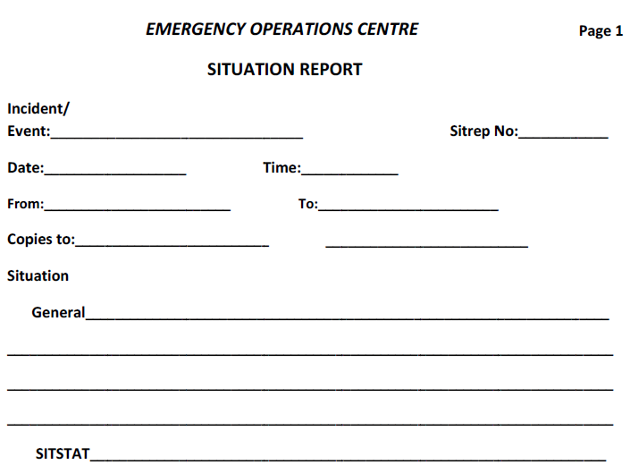
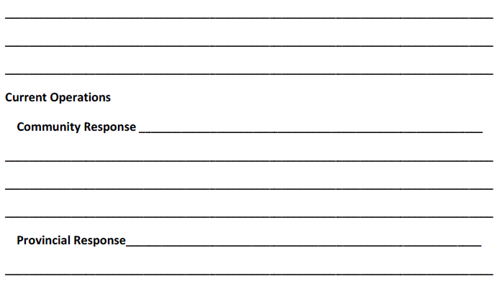
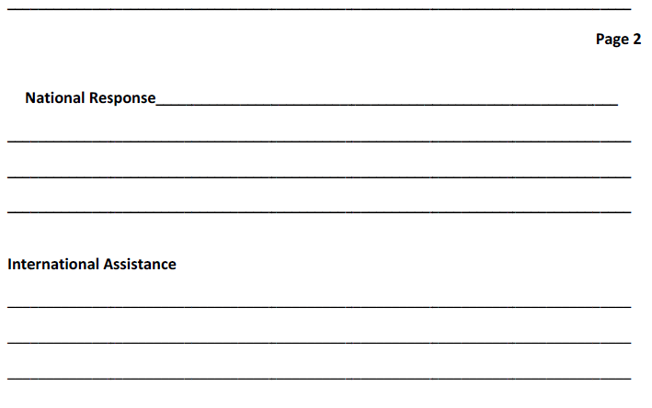
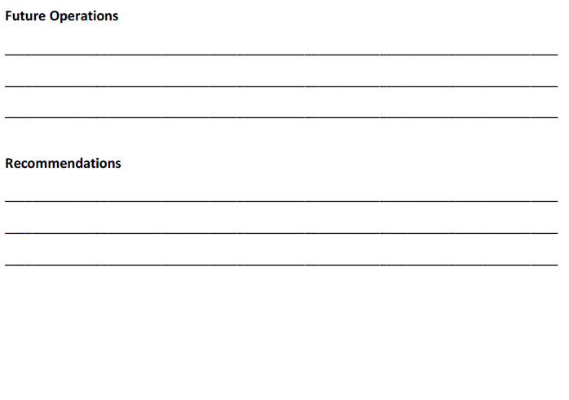

ANNEX 5: FSAC Standard 4Ws Template

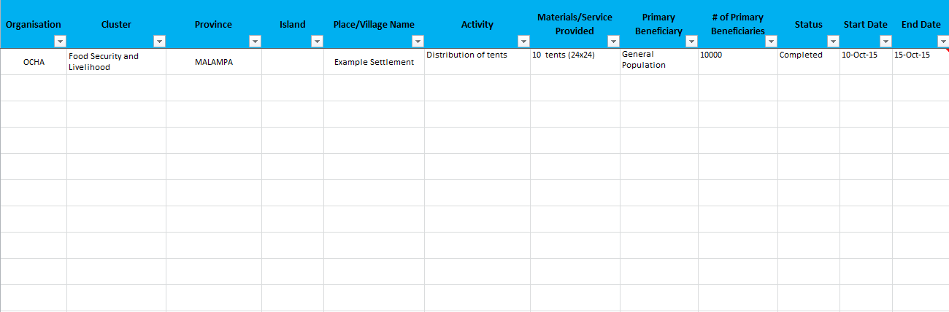


ANNEX 6: Initial Community Assessment (ICA) Form – Bislama Version

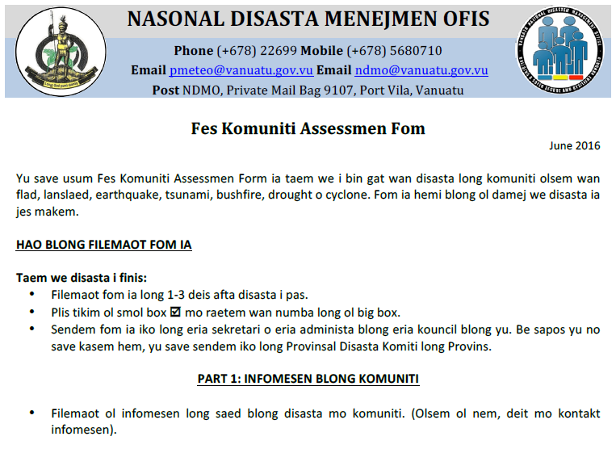
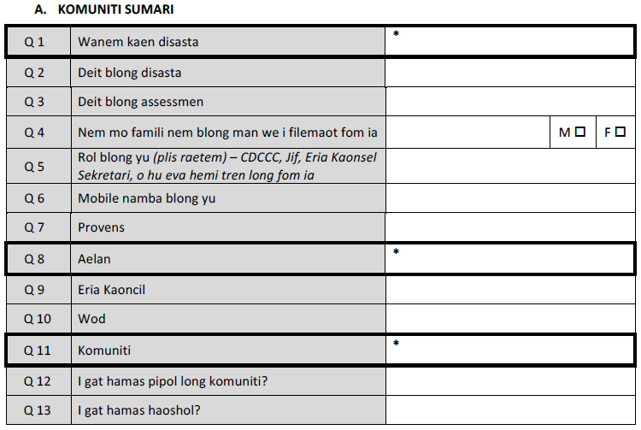

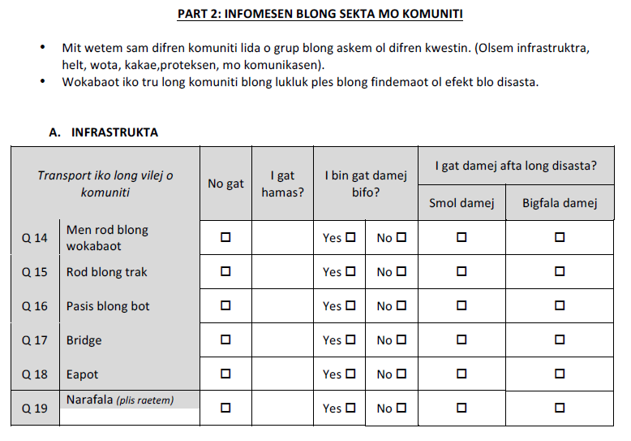
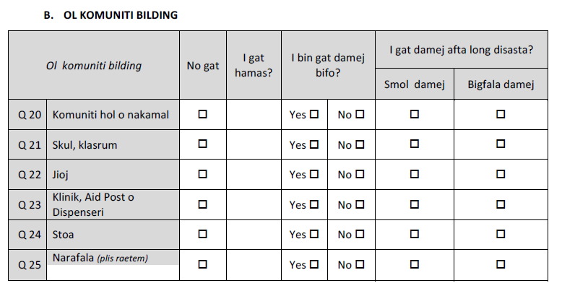

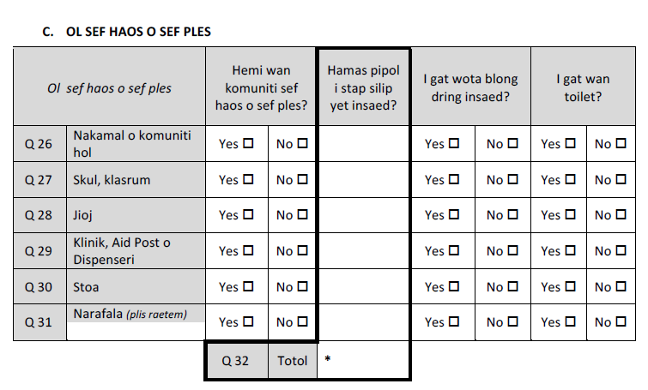
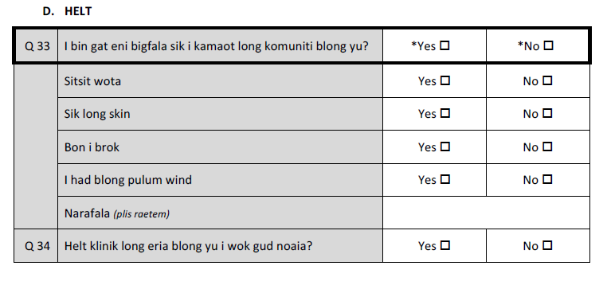

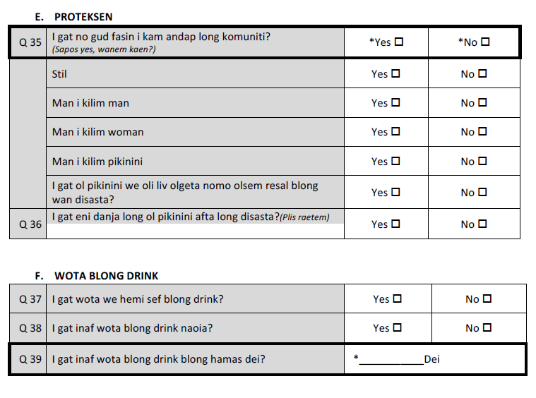
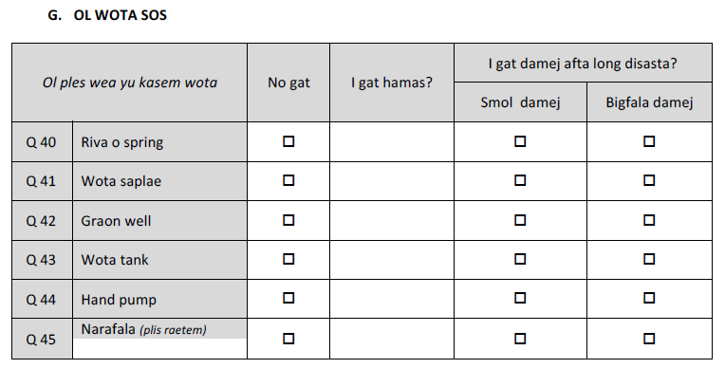

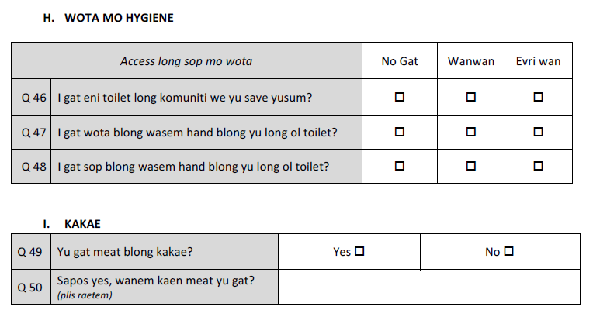
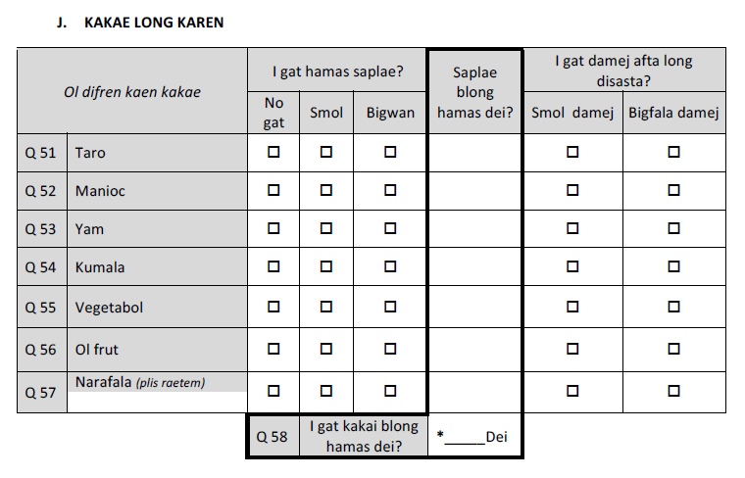

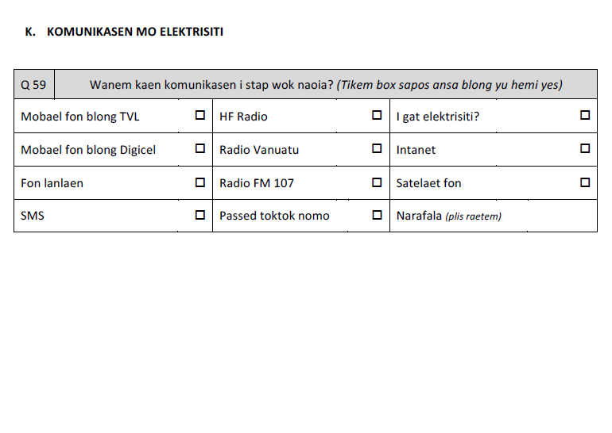

ANNEX 7: Rapid Technical Assessment (RTA) Template

