
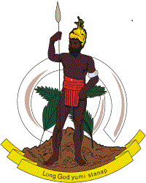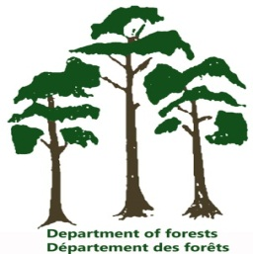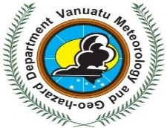
VANGO
Vanuatu Association of Non-Governmental Organisations

National Tree Planting Day – 27th June 2017 Program
Theme: “Planem Wud, Savem Wol”
Organization / Responsibility | Activity | Timeframe | Venue
Bae evriwan I kam tugeta long Agriculture Park – Tagabe Agriculture Station, Port Vila long 8am.
Mr. Kaloris Toara – Chairman, Efate CSO Network for Climate Change & REDD+ | Welcome Speech | 8:00am | Agriculture Stage, Tagabe Agriculture Station – Opposite Forestry Department & Livestock Department
Pastor Dorolyn Laloyer – Seventh Day Adventist / Vanuatu Christian Council | Opening Prayer | 8:15am | Agriculture Stage, Tagabe Agriculture Station
Coordinator for National Tree Planting Day – Mrs Jeanette Raupepe | Official Opening Speeches of the National Tree Planting Day:-  - Chairlady –National CSO REDD+ Platform – Mrs Maryline Arhambath Abel  - Acting Director (Department of Forestry)– Mr Watson Lui  - Acting Director General of Forestry –Mr. Benjamin Shing  - Director General ( Ministry of Climate Change) – Mr Jesse Benjamin | 8:30am | Agriculture Stage, Tagabe Agriculture Station
CSO Organizing Committee  Litiana Kalsrap Carlo | Entertainment by Menamuria Youth String Band  Official Function with VIPs | 8:45am  9:30am | Agriculture Stage,Tagabe Agriculture Station  Agriculture Stage, Tagabe Agriculture Station
CSO Organizing Committee  Litiana Kalsrap | Official Declaration for the Tagabe Green Space by the Minister for Lands & Natural Resources - Hon. Ralph Regenvanu (MP) | 9.45am | Agriculture Stage, Tagabe Agriculture Station
CSO Organizing Committee  Philip Iesul | Distribution of Planting Material | 9:50am | Agriculture Stage, Tagabe Agriculture Station
CSO Orgnizing Committee  Kaloris Toara | Tree Planting Ceremony:  Hon. Charlot Salwai Tabimasmas (MP)  Prime Minister  Hon. Ralph Regenvanu (MP), Minister for Lands  Hon. Ham Lini Vanuaroroa (MP), Minister for Climate Change  Hon. Ishmael Kalsakau (MP),  Leader of the Opposition  Hon. Ulrich Sumptoh (CR)  Lord Mayor of Port Vila  Hon. Leimara Malachai (CR)  Deputy Lady Mayor of Port Vila  Ps. Dorolyn Laloyer  Ernas Community Pastor  Mrs. Maryline Arnhambath Abel  Chairlady – National CSO Platform  Mrs. Julie Rereman  Acting Secretary General – Shefa Provincial Government | 10.00am | Tagabe Agriculture Station
CSO Organizing Committee  Charlie Netvunei | Relocate to VTU Agro-Forestry Planting Site | 10:15am | Agriculture Stage, Tagabe Agriculture Station
CSO Organizing Committee  Mr William Bani,  Mr Michael Tabi  Mr Robert Manaroto | National Tree Planting commence in VTU Agro-forestry Plot in Teouma | 11:00am | VTU Agroforestry Demo Plot – Teouma
Lunch 12:00 Noon
CSO Organizing Committee  Mr William Bani,  Mr Michael Tabi  Mr Robert Manaroto | Continue – Activities for National Tree Planting Day | 1:00pm | VTU Agroforestry Demo Plot – Teouma
Coordinator for National Tree Planting Day – Mrs Jeanette Raupepe | Closing Remarks | 3:30pm | VTU Agroforestry Demo Plot – Teouma
CSO Organizing Committee  Junior Avock | Buses Leave the Planting Site – Return back to Port Vila & Around Efate | 4:00pm | VTU Agroforestry Demo Plot - Teouma
END OF DAY!!

