Programs for Victory Parade
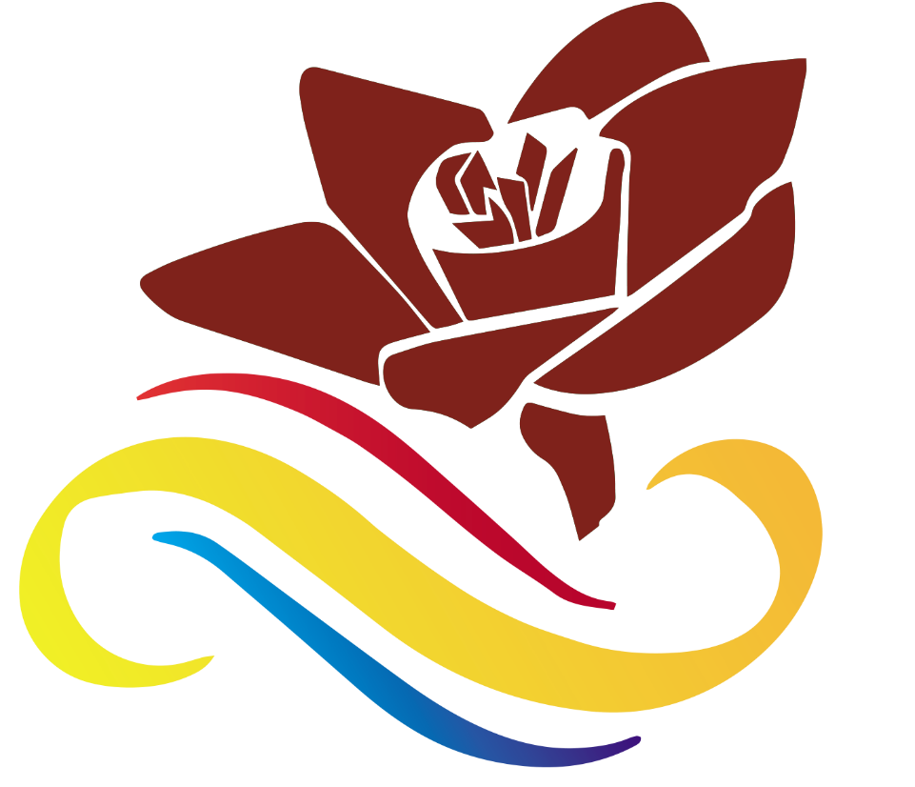
Date: Monday 25th July 2022. (Public Holiday).
Master of Ceremony (MC) – Peter SAKITA (Town Clerk PVCC),

7:30 AM ASSEMBLE AT THE MOORINGS HOTEL

7:45 AM ARRIVAL OF DISTINGUISH GUEST

08:00 AM ARRIVAL OF LORD MAYOR

8:15AM ARRIVAL OF DEPUTY PRIME MINISTER

8:25AM ARRIVAL OF PRIME MINISTER

8:30 AM PARADE LEAD BY VMF BAND FROM MOORINGS HOTEL TO FEIAWA PARK. (Sea Front)

- GUARD OF HONOUR- (Lord Mayor PVCC).

- HANGING OF SALUSALU - (PVCC Staffs)

- OPENNING PRAYER - (VCC - PS: Shem Temar).

- WELCOME REMARKS – Lord Mayor.

- Port Vila Town Council of Chiefs (Custom Ceremony).

- OFFICIAL SPEECH BY – Hon: Ishmael Alatoi Kalsakau Maau Koro - DPM/ Minister of Internal Affairs).

- CLOSING PRAYER AND PRAYER OVER THE REFRESHMENTS - (VCC - PS: SHEM TEMAR).

REFRESHMENTS OPEN FOR GUEST.

Stage Entertainments.

One Man Bands.
- 12pm – Monique & John Berry.
- 1pm- Jimmey Taea.
- 2pm- Family Rhythm.
- 3pm- Amos Korikalo & Kathy Harry.

String Bands.
- 4pm North Efate Sound.

End of Programs.

