## First PARTneR Advanced training on

## Disaster Risk Management and Risk Tools

## **Worksheets**

**Activity 1)**

What are the underlying issues and barriers that result in poor DRM planning/ decision making?

**Activity 2)**

Key DRM terms- write down examples:

Risk

* The probability that loss will occur as the result of an adverse event, given the hazard and vulnerability
* **Hazard x Vulnerability = Risk**

Ex. _____________________________________________________________________

Hazard

* A process, phenomenon or human activity that may cause loss of life, injury or other health impacts, property damage, social and economic disruption or environmental degradation.

Ex. _____________________________________________________________________

Asset

* A person or man-made or natural resource that has a tangible or intangible value.

Ex. ________________________________________________________________________

Attribute

* Characteristics of an asset that affect its vulnerability

Ex. ________________________________________________________________________

Exposure

* Assets that will be impacted by a hazard event or scenario

Ex. ________________________________________________________________________

Vulnerability

* The characteristics and circumstances of a community, system or asset that make it susceptible to the damaging effects of a hazard.

Ex. ________________________________________________________________________

Aggregation

* Area or location for calculating hazard impacts.

Ex. ________________________________________________________________________

**Activity 3)**

Scenario: There is a category 4 cyclone headed this way and we are all stuck in this building.

* + Name the hazard(s)
  + Identify the assets
  + Identify what assets are exposed
  + List the attributes that make this building vulnerable/ not vulnerable
  + What is one of the aggregation units are we located in?
  + Is the risk high, medium or low?
  + What other information would be useful to assess the risk?

**Activity 4)**

**Review of the RiskScape Interface**

* How would you add new data?
* Where are the builder tools located, and what do they do?
* How can you identify features in the map?
* How can you change your settings i.e. the memory RiskScape uses?
* Where can you turn layers on and off?

RiskScape User Interface (UI)

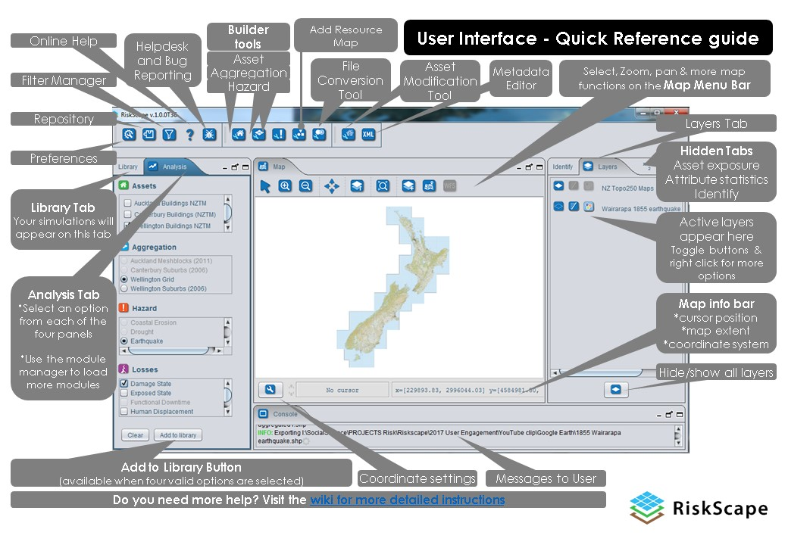

**Activity 5)**

**Required Data to collect for RiskScape Tsunami Calculations**

|  |  |  |  |  |
| --- | --- | --- | --- | --- |
| Label | Represents | Options if more than one | Choices or default? |  |
| X | Latitude |  | Write Latitude |  |
| Y | Longitude |  | Write Longitude |  |
| OBJECTID_1 | Unique number |  | Default- gives new number | Default- gives new ID number |
| ID | Unique number |  | Default- gives new number | Default- gives new ID number |
| BLDG_ID | Not required |  |  |  |
| POINT_X | Latitude |  | Write Latitude |  |
| POINT_Y | Longitude |  | Write Longitude |  |
| Use_Cat | Building Use | |  | | --- | | 1 : Residential Dwellings | | 2 : Commercial - Business | | 3 : Commercial - Accommodation | | 4 : Industrial - Manufacturing, Storage | | 5 : Industrial - Chemical, Energy, Hazardous | | 6 : Fast Moving Consumer Goods | | 7 : Government | | 8 : Territorial Authority/Civil Defence | | 9 : Lifeline Utilities | | 10 : Police | | 11 : Hospital, Clinic | | 12 : Fire Station | | 13 : Community | | 14 : Education | | 15 : Resthome | | 16 : Religious | | 17 : Forestry, Mining | | 18 : Farm | | 19 : Lifestyle | | 20 : Parking | | 21 : Clear Site | | 22 : Other | | Choose number |  |
| Storeys | Number of Stories |  | Write number of stories |  |
| Flr_Area | Floor area in sq. metres |  | Write floor area |  |
| Flr_Hgt | Height of ground floor in metres |  | Write floor height |  |
| Const_Type | Construction type | |  | | --- | | 1 : Reinforced Concrete Shear Wall | | 2 : Reinforced Concrete Moment Resisting Frame | | 3 : Steel Braced Frame | | 4 : Steel Moment Resisting Frame | | 5 : Light Timber | | 6 : Tilt Up Panel | | 7 : Light Industrial | | 8 : Advanced Design | | 9 : Brick Masonry | | 10 : Concrete Masonry | | 11 : Unknown Residential | | 12 : Unknown Commercial | | Choose number |  |
| Wall_Clad | Outside Wall type | |  | | --- | | 1 : Weatherboard | | 2 : Stucco, Roughcast | | 3 : Corrugated Iron | | 4 : Plastic | | 5 : Fibre Cement Sheet | | 6 : Fibre Cement Plank | | 7 : Reinforced Concrete | | 8 : Concrete Masonry | | 9 : Brick | | 10 : Glass | | 11 : Curtain Wall Glazing | | 12 : Sheet Metal | | 13 : Other Sheet - Combustible | | 14 : Other Sheet - Non-Combustible | | 15 : Other | | Choose number |  |
| Rep_Cost | Replacement cost of the building in local currency |  | Estimate replacement cost |  |
| Cont_Value | Contents value in local currency |  | Estimate contents value |  |
| Occ_Day | Number of people in the day |  | Write number of occupants |  |
| Occ_Night | Number of people at night |  | Write number of occupants |  |
| Flr_Type | Floor type | |  | | --- | | 1 : Timber | | 2 : Concrete Slab | |  |  |
| Build_Earn | Building earning potential |  | Default | Default- 0 |
| Year_Const | Year constructed |  | Choose year constructed |  |
| Stock_value | Stock value |  | Default | Default- 0 |
| Plant_Value | Plant value |  | Default | Default- 0 |

**Activity 6)**

**RiskScape Feedback**

Make a list of the positive and negative aspects of the RiskScape tool for the following components:

* Overall user interface
* How to run a scenario
* How the results are formatted