Student Activity Sheet

Activity 1: Layers in the Atmosphere:

Earth’s Atmosphere

The picture shows layers in the atmosphere above the earth’s surface.

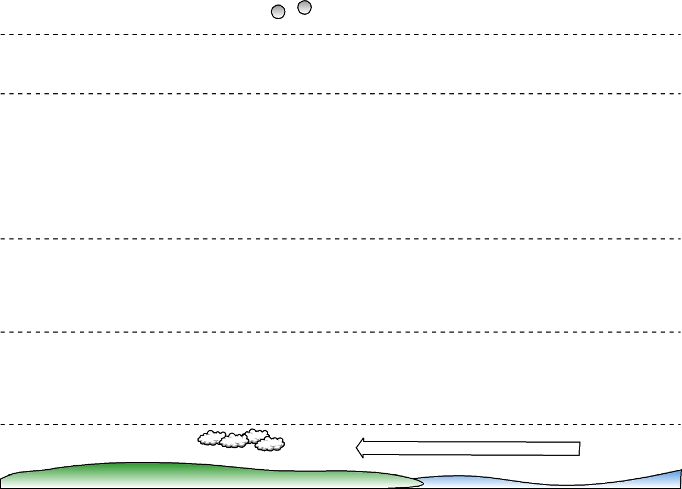
The labels contain a series of facts that relate to each of the layers. They are not in the correct order.

Copy each of the labels into the picture where you think it fits.
The air in the exosphere is very thin. There is very little air here. The top of the layer is 900km above the ground.
The top of the stratosphere is about 50km above the ground. The temperature at the top of this layer is 0oC. It cools down as you get lower.
This is where we find the ozone layer.

The thermosphere contains gases, which absorb some of the sun’s harmful rays. The top of this layer is 450km above the surface and the temperature here is 2000oC.
The magnetosphere is the top layer. There are no gases, but it still stops some of the harmful particles reaching earth’s surface. This is where we would find weather satellites.

The troposphere varies in height from between 10km and 20km. The temperature at the top is about –50oC, but it warms up as you get lower. This is where there is the most air and what we call weather is found.

The mesosphere reaches a height of 80km above the surface of the earth. The temperature at the top is about –100oC. It warms up as you get lower.

Student Activity Sheet

Activity 2: The Heating Effect of the Sun on Earth’s Surface

This activity is to help you understand the heating effect of the sun on the surface of the earth and why some places are warmer than others.

Look at the diagram below. Use the words below to label it:

Sun, sun’s rays, equator, north pole, south pole.

On your sheet:
- Colour in the areas of the world, which you think are the coldest. Colour these blue.
- Colour in the hottest areas red
A Step further: We recognise that the weather changes at certain times of the year. We call these times seasons. Some places have a wet and dry season, others spring summer, winter and autumn.

Why do we have different seasons?

The earth actually goes around (orbits) the sun on a tilt.
Look carefully at the picture below.

On your sheet:
- Colour in the areas of the world, which you think are the coldest. Colour these blue.
- Colour in the hottest areas red.
- How different is it from your first picture you coloured in?
- Write summer, south of the equator, and write winter, north of the equator,

Now 180 days later the earth is half way around the sun in its orbit. That’s half a year.

The picture below shows the earth in its new position as it travels around the sun.

On your sheet:
- Colour in the areas of the world, which you think are the coldest. Colour these blue.
- Colour in the hottest areas red.
- How different is it from your first picture you coloured in and the second picture?
- Can you explain why there are differences in the hot and cold areas of the earth?
Draw out a large picture of the earth like the one below. Put your country on the map.

Use the pictures you have drawn in the previous exercises on your sheet to:
- Colour in the area of the earth that you think will be the hottest part all year round. This area is closest to the sun.
These are known as the ‘tropical’ regions of the planet.
- Colour in the two areas of the earth that you think will be the coldest.
The sun’s rays are not so strong here, so they would be coldest.
These are the polar regions.
- The area in between the tropics and the polar regions are known as the temperate regions. It is common to experience four seasons in these regions. Colour this area green.
Equator

Student Activity Sheet

Activity 3: What is Air Pressure?

These activities will show you what air pressure is and how weather scientists measure air pressure.
Activity 3.1: Does air weigh anything?
What you will need: 2 balloons. A stick or length of bamboo about 45cm long. String. Piece of Sellotape. Measuring cylinder. Tubing

What to do:
- Blow up the balloons so they are about the same size.
- Tie the piece of string to the middle of the stick and hang the stick from it so it is balanced.
- Put a piece of Sellotape on each balloon.
- Tie the balloons onto the stick. Move the balloons so they balance each other.
- Prick one of the balloons carefully through the Sellotape.

Observe: What has changed?

Explain: Why has this happened?
What does this tell you about the particles in air?

Extension: Can you use the other gear to work out the volume of air in the balloon?

Student Activity Sheet
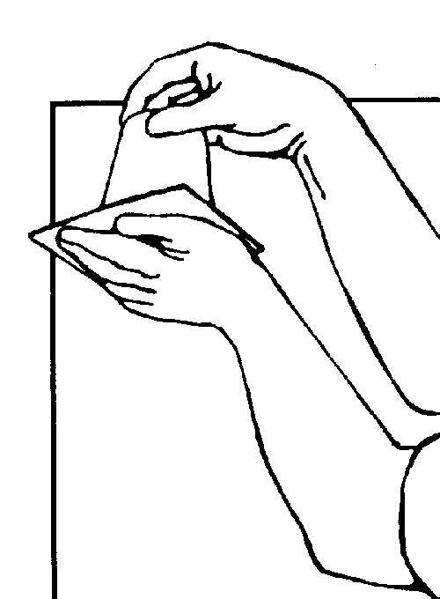
Activity 3.2: A simple demonstration of the effect of air pressure.

What you will need: a glass or paper cup. A stiff piece of cardboard big enough to completely cover the glass. A jug of Water.

What to do:

- Fill up both glasses to the brim with water.
- Slide the piece of card over one of the glasses of water. Make sure there is no air between the water and the card.
- Gently turn the glass with no card upside down over a sink or bucket.
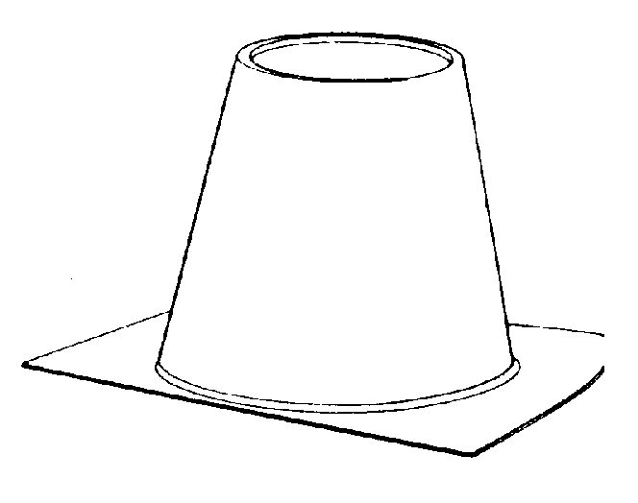
- Gently turn the glass with the card upside down, whilst holding the card in place.
- When the glass is upside down, take your hand off the card.

Observe: What happens when the glass are turned upside down?

Explain: Can you explain what has happened? What is holding the card in place?

Student Activity Sheet

Activity 4: A “do it yourself” barometer

What you will need: Jam jar. Balloon. Elastic Band. Drinking straw. Cardboard Box. (a shoe box will do). Clingfilm. Blu-tack or sticky tape. Fish tank.
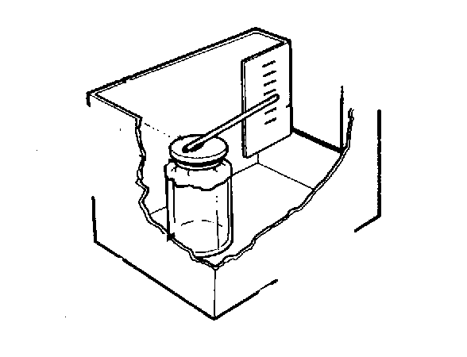
What to do:

- Warm the jar in hot water.
- Cut off the neck of the balloon and stretch it over the jar.
- Fasten it with the elastic band to make sure it is airtight.
- Glue or tape one end of the straw to the middle of the balloon.
- Place the jar in the cardboard box and mark the box behind the straw with a scale marked in centimetres. (Tape a ruler to the box)

To test the barometer.

Put the barometer in an empty fish tank. Cover the fish tank with the cling film. Press down gently on the cling film.
- What do you notice happen to the end of the straw?
- Does it move up or down?
- Is this high or low pressure?

Using the barometer:
At the same time each day record the weather and the pressure on the barometer.

What pattern do you notice between the measurements you made on the barometer and the weather each day?

Student Activity Sheet

Activity 5: Weather Watch

The purpose of this activity is to make up a daily of record of information regarding the weather, and from this possibility work out weather patterns.

To start with: Introduction to Weather Watch

Some questions to think about and find out about:

- Why is important to study weather?
- What are some of things that you would like to know about the weather every day?
- What kinds of information is it important to collect?
- Is there a better way to study (or collect information about) weather than just describing it in words and pictures?
- What kinds of instruments could you use to collect information about weather each day?
- What things should these instruments measure?

Now some more difficult questions:

- How can we tell which direction the wind is blowing from?
- How can we tell how fast the wind is blowing?
- What kind of container would be good for collecting rain?
- How could rain be measured?

SETTING UP THE WEATHER STATION.

Step One: Choose the site and the time.

The best place for a weather station is out in the open. A garden is a suitable place. Buildings and tall trees can cause problems, so keep away from these.
It would help if there was a suitable shady place out of direct sunlight for the thermometer.

The best time to record this information is around midday. It does not have to be exact as an hour either side is fine.

Step Two; Measuring Temperature.

What you will need: Thermometers, a Maximum and Minimum Thermometer.

The thermometer is best placed about 1.2 to 1.5m off the ground. It should be partly in the shade. Hang the thermometer off a fence.

You may be able to use a maximum and minimum thermometer, which is even better. The maximum and minimum temperature for the previous 24 hours as well as the current temperature can be recorded.

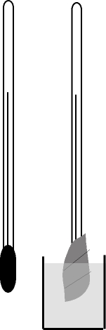
Step Three: Measuring Humidity.

Humidity is a measure of the amount of water in the air. It requires a wet and dry bulb thermometer.

A simple version of this is to place two thermometers side by side in a shady place. One of the thermometers has some cotton wool or muslin wrapped around it. The end of the cotton wool is dipped in a tub (small yoghurt pot) of water.
in water
in air
The picture shows how this is set up.

To find the humidity:

- Read the temperature of the dry thermometer.
- Work out the temperature difference between the dry and wet thermometers.
- The humidity (as a percentage) can be found by reading the temperature difference against the dry temperature on the table below.

Difference between the wet and dry thermometers
Temperature of the dry thermometer | 1ºC | 2ºC | 3ºC | 4ºC | 5ºC | 6ºC | 7ºC | 8ºC | 9ºC | 10ºC
10 – 14ºC | 85 | 75 | 60 | 50 | 40 | 30 | 15 | 5 | 0 | 0
15 –19ºC | 90 | 80 | 65 | 60 | 50 | 40 | 30 | 20 | 10 | 5
20 –24ºC | 90 | 80 | 70 | 65 | 55 | 45 | 40 | 30 | 25 | 20
25 –29ºC | 90 | 85 | 75 | 70 | 65 | 55 | 45 | 40 | 30 | 25
30 –34ºC | 95 | 85 | 80 | 75 | 70 | 60 | 55 | 50 | 45 | 40
35-40ºC | 95 | 90 | 80 | 75 | 70 | 65 | 60 | 55 | 50 | 45

Step Four: Measuring Rainfall

What you need: A large plastic drink bottle. Craft knife. Ruler or measuring cylinder.
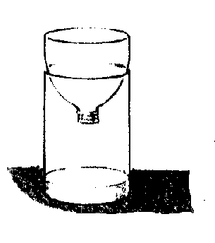

What you do:
- Cut the top off the bottle just below the shoulder.
- Turn the top upside down to make a funnel.
- Push this back inside the cut off rim of the bottle.
- Use a ruler to mark a scale on the side of the bottle. The scale can be in cm or in mls of water.
- Find a clear area of ground. Dig a small hole in the ground to fix the rain gauge in position. This will stop it getting moved around. (Sand helps keeps it in place and it is easy to take the bottle out and put it back in place again.)

At the same time each day: Measure the amount of water in the container by either tipping it out into a measuring cylinder or measuring the height of the water in the bottle.

Remember tip out the water each day.

Step Five: Measuring Wind

Activity 5. 1 Measuring wind direction.

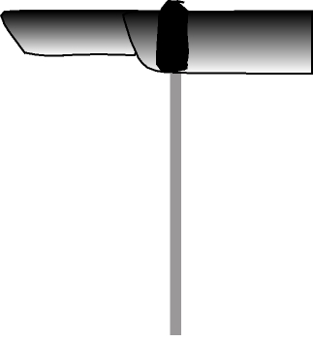
What you need: Craft knife, Shoe box, Coreboard or Card and Contact plastic (if available), Protractor, A piece of 5 mm dowel (1m long), Strong tape, marker pen,. Pen cap or the end of a broken biro. (It needs to be big enough to fit over the dowelling.)

What to do:
- Use the plan on the next page to draw out the wind vane. Note the diagram is not to scale.
Completed wind vane
- Cut it out.
- Score a line down the centre and fold in half.
- Stick the folded halves together.
- Cover one side of the wind vane with the protective plastic then fold the plastic over the other side.

Stick the pen cap to the vane.

Find a post or fence that is out in the open.
Fix the piece of dowel to the post or fence. (Use clips if possible) Make sure it is vertical and the weather vane spins freely when put on top.

Let the vane spin in the wind. It will spin in the wind and point to the direction the wind is coming from.
You will need to mark out the directions north, south, east and west. Use a compass or better still a map. (This will give you true north.)
Use landmarks to give you a reference point for the directions.

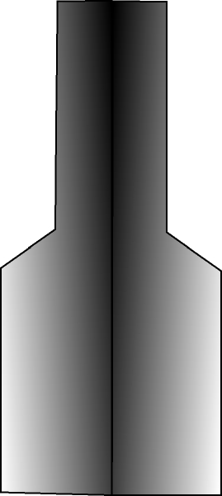
12cm
25 cm
8 cm
12 cm
3 cm

Activity 5.2 Measuring Wind Speed;

There are two ways to measure the wind speed. Firstly there is an anemometer.

Activity: Making an anemometer.
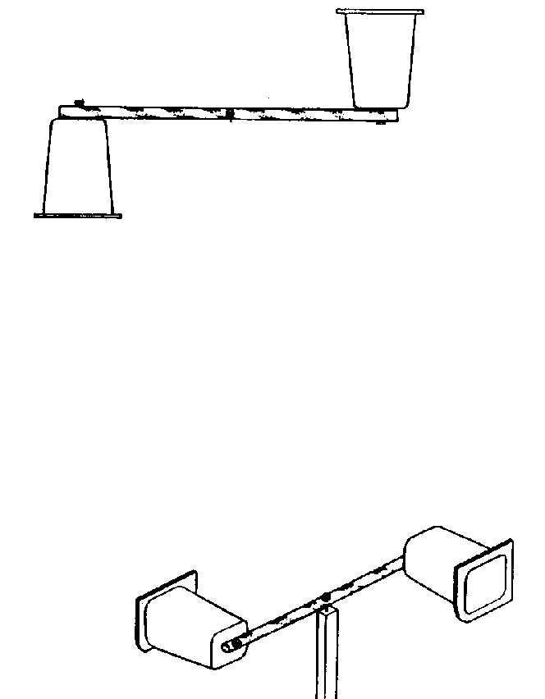
What you will need:
Two yoghurt pots, drinking straw, test tube or pen barrel, dowelling pins, a post, tape.

What to do:
- Fix the pots to the straw using the pins or tape.
- attach the testtube or barrel to the centre of the straw.
- Attach the dowelling or small stick o a suitable post outside.
- Place the wind speed machine on a post so that it spins.

Observe:
- Record the number of turns in 10 seconds.
- Do this four times and work out the average wind speed.

Other things to try:

- Try comparing the wind speed at different heights.
- Try making an anemometer with four cups instead of two.
- Make up a record of the average number of turns for different wind speeds.

Activity 5.3: Wind Speed box.

What you will need: Craft knife, Shoe box, Card, Protractor, A piece of 5 mm dowel (wider than the box.) or metal rod, Clear plastic sheet, Strong tape, Marker pen.

What to do:
- On the clear plastic sheet and using the protractor and marker pen, mark off 5 degree intervals between the angles of 0 and 90 degrees.
- Cut the ends off the show box and lid you have a wind tunnel.
- Cut a hole near one end like the one shown in the diagram.
- Stick the clear plastic film with the scale on the inside. It should be clearly seen through the hole in the side of the box.
- Using the cardboard from one of the end you cut out earlier, cut it so it slightly smaller than the end of the box. Fix it to the rod. Check that the flap you have made swings freely.
- Make a hole in the side of the box above the scale and directly on the opposite side.
- Push the rod through the holes. Move it around to make sure it can rotate freely.

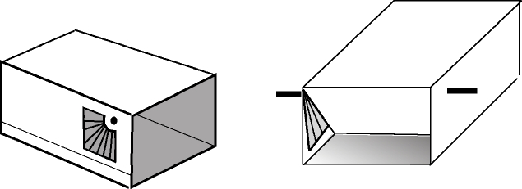

Clear plastic with marked angles

swinging flap

Observe: Hold the box so it faces into the wind. Measure the angle of the flap. Use the table to work out the wind speed

Angle (degrees) | Speed (km/hr) | Angle (degrees) | Speed (km/hr)
90 | 0 | 50 | 28-30
85 | 8-11 | 45 | 31-33
80 | 12-14 | 40 | 34-36
75 | 15-17 | 35 | 37-39
70 | 18-20 | 30 | 40-43
65 | 21-23 | 25 | 44-48
60 | 24-25 | 20 | 49-54
55 | 26-27

Activity 5.4: Wind Speed and the Beaufort Scale

Observations of the sea and trees can be used to give an idea of the wind speed. The scale that is used for these is called the Beaufort Scale and is used to represent wind strength. The

You can use this table on the next page to record the wind speed each day on suitable chart:

Following page

What to do:
A mix and match activity: The boxes are all jumbled up. The wind speeds do not match the descriptions. Cut the sheet up to match the wind speeds to what you think are the correct descriptions. (The boxes in bold are correct!)

Beauf’t Wind Force No | Name | Ave Wind Speed  (km/hr) | Land observation. | Sea observation.
0 | Calm | 0 | Leaves don’t move | Sea like a mirror
1 | Light Air | 1-5 | Smoke drifts slowly, Leaves don’t move | Sea is slightly rippled
2 | Slight Breeze | 6-11 | Smoke shows direction. Leaves rustle | Small wavelets which don’t break
3 | Gentle Breeze | 12 -19 | Twigs and large palm leaves move.  Small flags extended. | Large wavelets. The crests just begin to break
4 | Moderate Breeze | 20 -29 | Small branches move, Flags flap | Waves with whitecaps
5 | Fresh Breeze | 30-38 | Small trees sway.  Flags flap and ripple | Moderate waves with many whitecaps
6 | Strong Breeze | 39-50 | Large branches sway, Flags beat and pop | Larger waves with regular whitecaps
7 | Moderate Gale | 51-61 | Whole trees sway. | Large waves Sea heaps up. White foam streaks
8 | Fresh Gale | 62-75 | Twigs break off trees | Moderately high sea with foam blowing off the tops
9 | Strong Gale | 75-86 | Branches break of trees | High crested waves
10 | Whole Gale | 87-101 | Trees blown down.  Building damage | High waves. Churning white seas.
11 | Storm | 102-120 | Widespread damage to trees and buildings | Mountainous seas, covered in white foam
12 | Cyclone | 120+ | A lot of damage | Air is filled with spray. Sea is completely white.

Beauf’t Wind Force No | Name | Ave Wind Speed  (km/hr) | Land observation | Sea observation
0 | Calm | 0 | Branches break of trees | Moderately high sea with foam blowing off the tops
5 | Light Air | 1-5 | Smoke drifts slowly.  Leaves don’t move | Mountainous seas, covered in white foam
1 | Slight Breeze | 6-11 | Small branches move.  Flags flap | Small wavelets which don’t break
8 | Gentle Breeze | 12 -19 | A lot of damage | Large wavelets. The crests just begin to break
11 | Moderate Breeze | 20 -29 | Leaves don’t move | Sea like a mirror
2 | Fresh Breeze | 30-38 | Small trees sway.  Flags flap and ripple | Large waves Sea heaps up. White foam streaks
10 | Strong Breeze | 39-50 | Trees blown down.  Building damage | Air is filled with spray. Sea is completely white
9 | Moderate Gale | 51-61 | Whole trees sway | High crested waves
3 | Fresh Gale | 62-75 | Twigs break off trees | Larger waves with regular whitecaps
12 | Strong Gale | 75-86 | Twigs and large palm leaves move.  Small flags extended | Moderate waves with many whitecaps
6 | Whole Gale | 87-101 | Widespread damage to trees and buildings | High waves. Churning white seas.
4 | Storm | 102-120 | Smoke shows direction.  Leaves rustle | Sea is slightly rippled
7 | Cyclone | 120+ | Large branches sway  Flags beat and pop | Waves with whitecaps

Step Six: Measuring Cloud Cover

There are two things to look for with clouds. One is the amount of cloud cover; the other is the type of cloud.

Activity: Cloud cover.

What you need:
A clear space and open-mindedness.
A piece of clear plastic with a circle on it. The circle is split up in eight segments.

What to do:
- Lie on the ground or stand and look around you.
- Hold the clear piece of plastic in front of you.
- Use the chart below to estimate the amount of cloud cover, out of a factor of 8.
- Check your value out with 3 others. Do you all agree?
- Decide amongst yourselves what is the best value. (No answer is wrong!)

Cloud Cover Scale
0 out of 8 | no cloud
1 out of 8 | very little cloud
2 out of 8 | about a quarter of the sky is covered
3 out of 8
4 out of 8 | about half of the sky is covered
5 out of 8
6 out of 8 | about three quarters of the sky is covered
7 out of 8 | nearly all the sky is covered. Very few blue patches
8 out of 8 | total cloud cover

Step Seven: Cloud Types:

What you need: a clear space
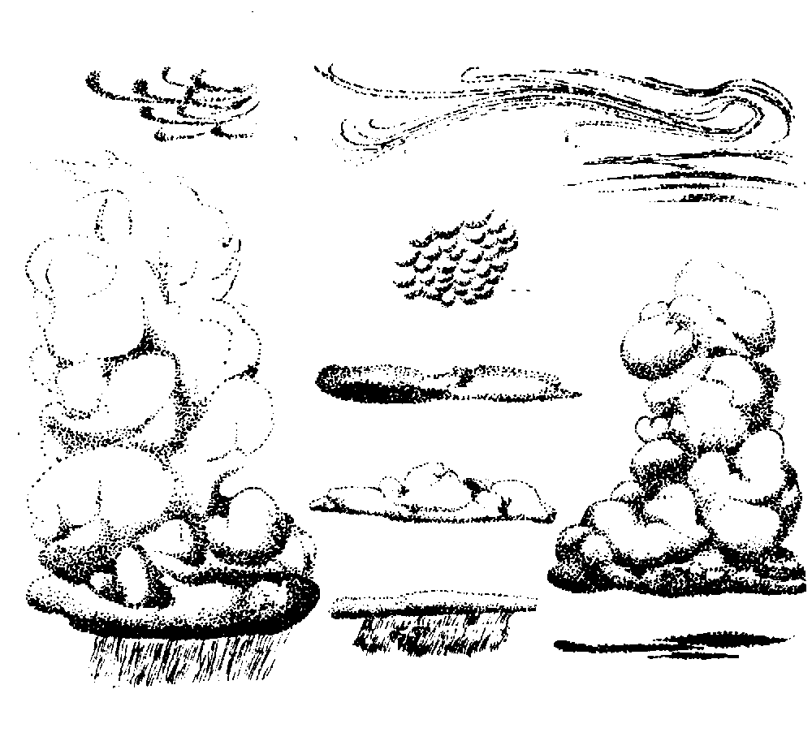
thin high clouds known as Cirrostratus
streaky high Cirrus.

What to do:
Guessing the type of cloud is not easy.
There are four main types:
altocumulus
towering Cumulonimbus
Cumulus: the fluffy cotton wool clouds.
Cumulonimbus
Stratocumulus
(the fluffy cotton wool ones)
Cirrus: high streaky clouds.

Stratus: sheet or layer cloud.
nimbostratus

stratus:

Nimbus: Rain clouds.

- Take a look at the clouds and compare them to the pictures.
- There are eight cloud types shown in the picture.
- Decide on the type of cloud you see.
- Record the information over a period of days on a suitable chart.

Something to think about:

- Do all clouds bring rain?
- What kind of clouds do you see on sunny days?
- Have you ever seen clouds that look like feathers, animals, cotton wool, etc.?

Step 8: Recording all the weather information.
The reason for recording all this information is not only to see what is happening now but also to look for patterns and predict future weather patterns from observations.
Recording is important and should be methodical so that anyone can understand what you have done.
An example of a chart is shown below. It assumes that you have recorded all of the measurements indicated in the activities above. You can even use the weather forecasts to see how accurate it was.

Day and Date | Time | Air Press’ | Wind |  | Cloud |  | Temp | Hum’ty | Rain | General Weather
 |  | Raising  Or Falling | Speed | Direct’n | Cover | Type
Mon 21 Feb | 11.30 |  | 4 | SE | 3/8 | Cu | 24 | 65 | 0 | Clear, windy

What to do:
Design your own weather recording chart.
Don’t forget to record the names of the people in your group.

Suggested follow-up activities

Work with your partners to compose three questions about the data you have collected, for example:
- What was the coldest day? The day with the most rain? The windiest day?
- Swap questions with another group.
- Use the charts to compose word problems for the other groups.
For example: What was the difference between the temperature of the coldest day and the warmest day?
- Make bar or circle graphs showing the number of sunny, cloudy and rainy days.
- Make line or bar graphs to show the temperature of each day.
- Make a chart showing the temperature of each day. Illustrate each day with a picture.

Student Activity Sheet

Activity 6.1: How well does the Sun heat the Earth?

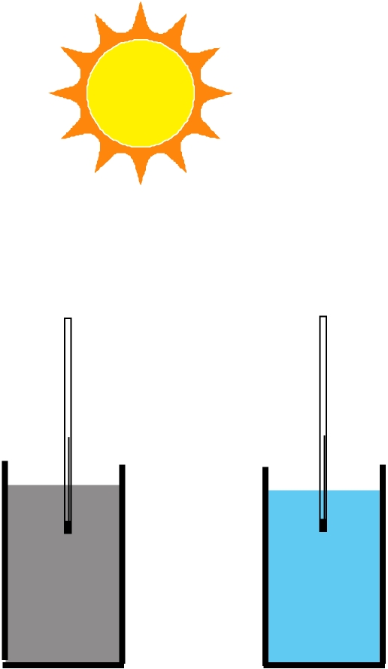
Prediction: Which heats up the fastest, land or sea?

What you will need: 2 buckets, sand, water, 2 thermometers.

What to do:

- Fill up the two jars; one with sand, the other one with water.
- Put a thermometer into the jar of sand. The bulb of the thermometer should be about 2cm into the sand.
- Put the thermometer into the jar of water. The bulb of the thermometer should be held at about 2cm into the water.
sand
water
- Place the jars in the sun.

Observe:
- Record the temperature at the start.
- Record the temperature after 10 minutes.
- Do this a couple more times so that you end up with the temperature after 30 minutes.

Question: Which one had the greatest increase in temperature?

Student Activity 6.2:

Prediction: If the buckets are moved in to the shade or somewhere cool, which one will show the greatest drop in temperature?

Observe: Move them to a shady place and record the temperature of the two buckets, and then leave for 10 minutes.
Measure the temperature. Do this again a couple more times, so they have been left for 30 minutes.

Explanation: Was your prediction correct?
Can you explain what has happened and why?
What effect do you think this would have on our climate, particularly places by the sea?

Student Activity Sheet

Activity 7.1: Air on the move.

Mobiles
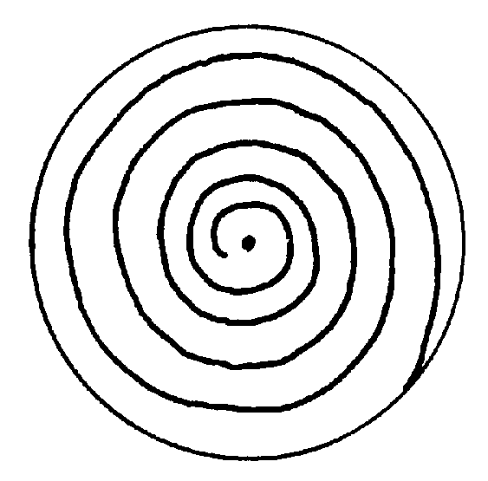
This activity is designed to show how heat energy travels in air.

Prediction: What do you think will happen if a coil is held over a candle flame?

What you need: Cotton thread. Candle or heat source such as a light bulb. Aluminium foil. Scissors.

What to do:

- To make the mobile, cut a 14cm diameter circle on the foil.
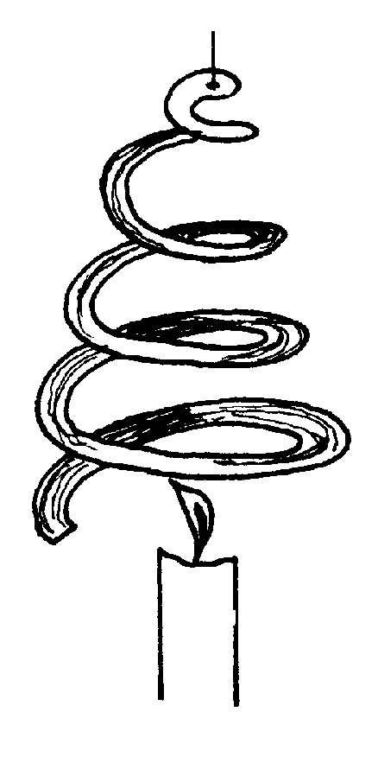
- Draw a spiral on it of about 5 turns as shown in the picture.
- Cut along the line.
- Make a small hole in the centre of the spiral and thread the cotton through it.
- Light the candle and hold the mobile above the candle.

Observe: What happens?

Explain:
- Can you explain why the mobile turns.
- Which direction is warm air moving?

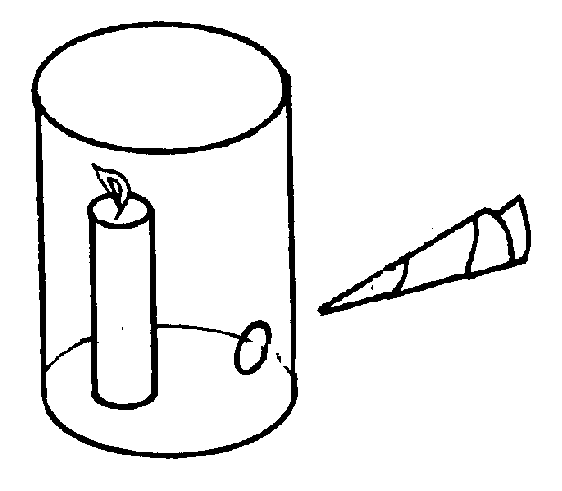
Student Activity Sheet

Activity 7.2 Air on the Move

Prediction: What will happen to the smoke from the burning paper?

What you need: A large empty soup tin or similar. A candle. A piece of rolled up newspaper.

What to do:
- Punch a hole in the side of the can, near the base.
- Stand the candle in the can.
- Light the candle.
- Place the smoking piece of paper near the hole in the can.

Observe: What do you see happen?

Explain: Why is the smoke moving through the hole?
- Can you explain this in terms of air movement?

- What happens if you put your finger over the hole in the can?
- Can you explain why?

Student Activity Sheet

Activity 8: Which way does heat move in water?

Prediction: What do you think you will happen to the colour in the water?

What you will need:. Burner or Candle, (Hobby Stove), Lamp, Food Colouring, Dropper.

Experiment 1

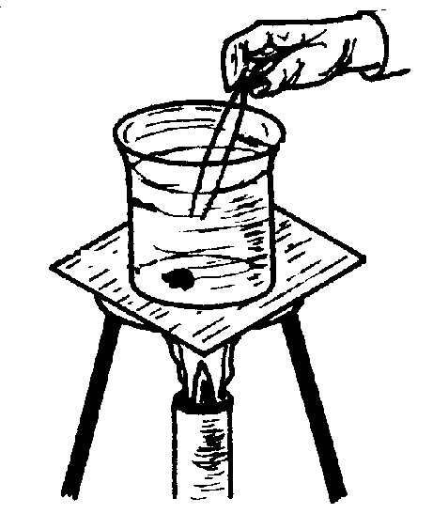
What to do:

- Place the beaker on the stand.
- Fill the beaker with water.
- Very carefully using the dropper put a drop of some food colouring in the bottom of the beaker.
- Sketch what you see.

Now light the burner. Sketch a diagram of what you see now.

Observe: Sketch the beaker before the burner has been lit and after. Use coloured pens to show clearly what you see.

Explain: Describe what is you see happening and why you think it is happening.

Experiment 2

Set up the experiment as before but this time put the lamp over the top of the beaker. There should be no heat coming from underneath.
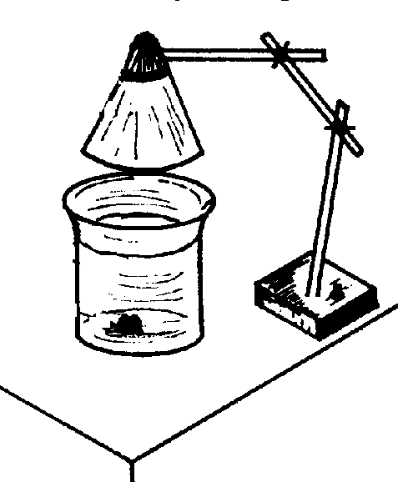
Observe:
- Sketch the jar before the lamp was placed over the top and after.
- Use coloured pens to show clearly what you see.

Explain: What has happened this time? Can you explain what you have observed?

Student Activity Sheet

Activity 9.1: Argo Floats

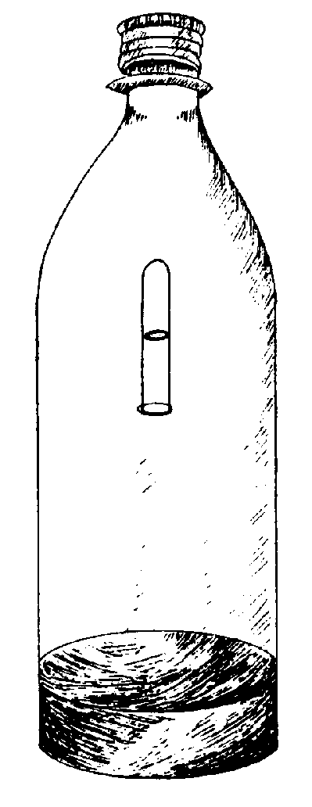
The idea of this activity is to show how an Argo float can work. The principle is based on internal pressure in the buoyancy chamber. In this case the buoyancy chamber is a small tube part filled with air.

What you need: Large plastic lemonade or coke bottle, Small tube that will fit inside, Blue Tac

What to do:

- Set up the bottle as shown in the picture.
- Place a small amount of Blue Tac on the open end of the small tube then fill it with water.
- Insert the tube upside down into the bottle trying to keep as much water in it as possible. Adjust the Blue Tac so that the test tube just floats in the middle of the bottle.
- Screw on the top and gently squeeze the bottle.

Observe:
- What happens when you squeeze the bottle?
- What happens when you stop squeezing?
- Draw what you see happening in the diver, when the bottle is squeezed and released.

Explain:
- How do you think what you have seen might explain the way the diver behaves?
- How do you think this might explain how fish can go up and down in the water?
- How do you think this works in an Argo float?

Prediction:
What will happen if you were to stand the experiment out in the sun where the water will get warm?

Try it and see.
Student Activity Sheet

Student Activity 9.2: What do Argo Floats do?

Argo floats are designed to go up and down in the oceans. They go down to depths of 2 kilometres before coming back up to the surface. They measure the temperature of the ocean as they come up to the surface from the deep.
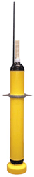
Use you ideas from the previous activities to answer these questions.

What do you think?

- Do you think that the oceans will get colder or warmer as you go deeper?
- Do you think the sun heats the top of the ocean or all the way down?
- Can the heat possibly travel downwards after trying these experiments?
- What do you think an Argo float would record as it goes down to 2 kilometres in the ocean?

Argo floats travel in the currents deep in the ocean and then come up again every 15 days or so.

- How do you think the temperature will change as they go down and then come up?
- Will the temperatures they measure change from place to place?
- What sort of temperature range would an Argo float measure in the South Pacific near New Zealand, compared to the Pacific Ocean near the Islands of Samoa, Rarotonga?
- If the water is warmer near the equator, what do you think will happen to the amount of evaporation of water from the sea in this region?
- Would this make the climate wet or dry?
- Now a tricky one: if the sea gets warmer what do you think will happen to the amount of evaporation and the climate in this region of the Earth?

Something to think about?
Why do you think scientists want to know this information?

Student Activity Sheet

Activity 10: What’s on the weather map?
What you will need: Weather maps sourced from newspapers or meteorological office.

What to do:
Look at the weather map.
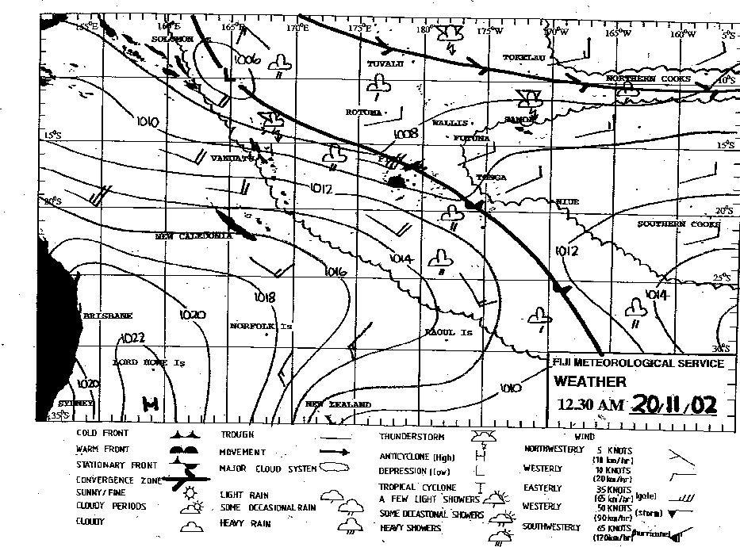

- Identify the following if they are on the weather map:
- Isobars, Low Pressure centre, High Pressure Centre, Warm Front, Cold Front.
- Where do you think the air is rising on the map?
- Where do you think the air is sinking on the map?
- Where do you think the winds will be strongest?
- Draw an arrow to show the direction of the wind.
- Where do you think the winds will be lightest?
- Draw an arrow to show the direction of the wind?

Extension Activity: Find some weather maps.
Your job is to predict the weather for the TV or radio.
Use the maps to write your forecast from the maps and read it to the class.

