Teacher Activity Sheet

Activity 1

What ideas do children have about water?

Starter question: What are all the things we can think of about water?

Purpose: To get children thinking about the importance of water in our daily lives. It is just a general discussion starter.
Use drawings, Children can work in groups to draw pictures of their associations with water.

Some question ideas:
What does it feel like?
What does it look like?
What does it taste like?
Where do we get it?
Where does it come from?
Where does it exist?
Who needs water?
What do we do with it?

For the teacher: What to look for?

We need water to live
We can find water in different places (river, sea, wells, rain) and in different forms (ice, rain, steam)
We get water from different places (river, sea, wells, rain)
Clean water has no colour or taste
We drink it, wash with it, cook in it

Teacher Activity Sheet

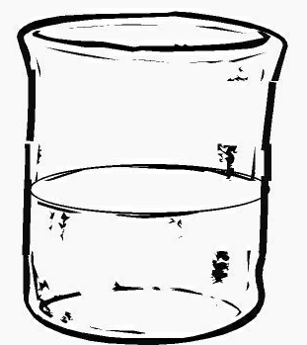
Activity 1.1. What do you understand about freezing?
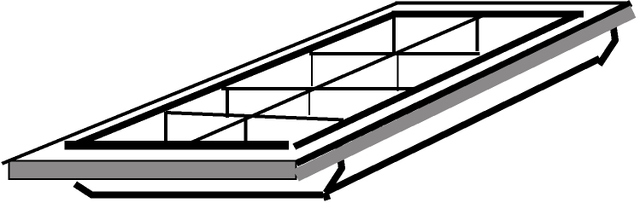
Equipment: Water, Ice Block Tray, and Freezer.

What to do:
Put water in an ice tray.
Get children to write down their observations about the water.
Predict: Get children to write down their predictions about what will happen to the water if placed in the freezer overnight.
(What will it look like? What will it feel like? Does it become larger or smaller?………..)
Observe: Next day write down all their observations.
Compare these with their predictions.

Write up a wall chart with their predictions and observations.
Explain: What happevened to the water? Why did this happen> Can you reverse the process?

What we want the children to learn:
That water changing into ice is called freezing.
That the process is reversible.
Ice warmed up turns into liquid water.
This process is melting.

Question: Does it matter how many times this is done? Will the water become any different other than ice or liquid water?

Teacher Activity Sheet

Activity 1.2. What do you understand about evaporation?
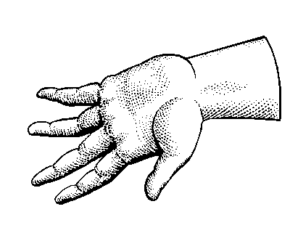

Equipment: Water, Paper towels, or Cotton material, Pen.

What to do:
Get the children to draw a line around their hand to make a handprint on the paper towel or cloth. Crayons work best for this.
Wet the hand.
Place the wet hand on the towel (or cloth) inside the outline.

Observe: What do they see on the paper towel (or cloth).
How do they think the handprint was formed?

Predict: What do they think will happen to it? Write down all the possibilities. – changes in size, shape and colour

Observe: Leave the handprint for a period of time. Test this first as 5, 10 and 20 minutes will probably work but may be too far apart if it iws really hot.

Explain: What happens to the handprint? Write down all the possibilities.
Why is the towel no longer wet? Where did the water go?

What we want the children to learn:
Children understood that the water has changed into gas form.
The process is called evaporation.

Teacher Activity Sheet

Activity 1.3: What do you understand about condensation?
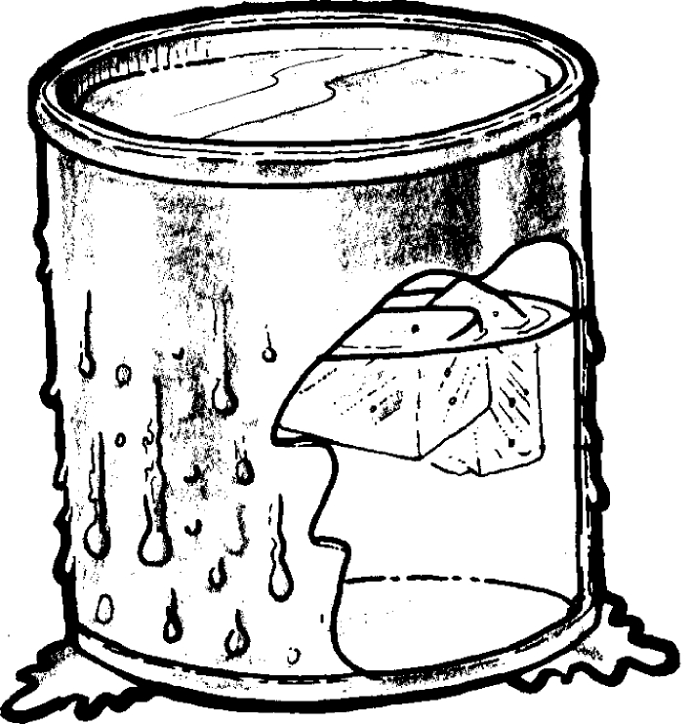
Equipment: A metal can with lid, cold water and ice cubes.
ice
What to do:
Get the children to feel the outside of the can. It should be dry.
Put some cold water and ice cubes into the can. Put the lid on the can.

Predict: What do they think will happen to the outside of the can? Give reasons.

Observe: Leave the can for a while at room temperature. Get the children to have a look at the outside of the can. Is it wet or dry?

Explain: Compare the results with predictions. How can they explain what has happened.
Draw a wall chart to share ideas.
Where did the water come from?
Where was it before it appeared on the surface of the can?

What we want the children to learn:
That the water was in a gas form in the air around them.
It is often called water vapour.
Cooling turns the gas into liquid water.
This is called condensation.

Teacher Activity Sheet

Activity 2.1: Does ice lose weight when it melts?

Equipment: A large block of ice or several ice cubes, a large jar and lid to hold the block of ice, a set of kitchen scales.

What to do:
- Place a block of ice in the jar, put the lid on it.
- Put the jar on the scales. Weigh it.

Predict: Write down what the children think will happen?
  - What do they think they will see happen to the ice block?
  - What will happen to the weight measurement on the scales?

Observe: Allow the ice to melt.
- What happens?
- What is the reading on the scales?

Explain: Compare the observations with the predictions. What explanations can they give?

What we want the children to learn:
We do not lose water when it changes from one form to another.

Teacher Activity Sheet

Activity 2.2: Puddles.

Equipment: Water, chalk. a concrete surface. (or somewhere where water will not soak through).

What to do.
Create a puddle of water.
Draw a chalk line around it.

Predict: Ask the children what they think might happen. Make some predictions that include time.

Observe: Observe what happens over a period of time. Each time the puddle is checked, draw a new chalk line around it. Observations will probably need to be made every 10 minutes, depending on the time of day and whether the puddle is in direct sunlight. You will need to try this first.

Explain: Get children to draw pictures of what happened and write their explanations about what they think happened and why.

What we want the children to learn:
They can use the words liquid and gas or vapour.
They use the word evaporation for the change from liquid to gas.

Extend to different conditions: e.g. cloudy, windy.
Does the speed the water disappears at, ever change?
What do the children think happens out in the ocean?
Where does the rain come from that makes the puddle?

Teacher Activity Sheet

Activity 2.3: Where does the water go?
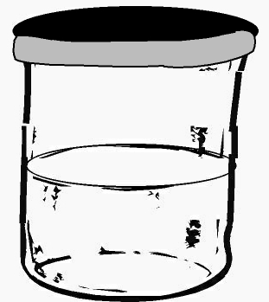
Equipment: 2 glass jars, (one with a lid,) some water, and a marker pen.

What to do:
- Put the glass jars in a sunny place.
- Put the same amount of water in each. Put the lid on one of the containers.

Predict: What do the children think will happen over the next few days?
  - What effect will the lid have, if any?

Observe: Get the children to mark on the sides off the jars the level of the water.

Explain: Get the children to answer the questions:
  - Where has the water in the open jar gone?
  - Where has the water in the closed jar gone?
  - Why is there a difference?

What we want the children to learn:
The children can draw out pictures to explain, “Where does all the water go when evaporation happens.”

Teacher Activity Sheet

Activity 2.4: Is there water in the air?

Equipment: 2 dry glass jars. A puddle. Access to a fridge.

What to do:
- Put a glass jar upside down over a puddle of water.
- Put the other empty glass jar with the lid on it in the fridge.
- Leave them in place for a few hours.

Predict: What do the children think will happen over the next few hours?

Observe: What happens to the inside of the jars?

Explain: Why do they think this has happened?

What we want the children to learn:
The children can explain what they think happened using pictures.
Introduce the word condensation for water vapour changing to liquid water.
The children can draw pictures to explain, “Where does water come from when condensation happens.”

Teacher Activity Sheet
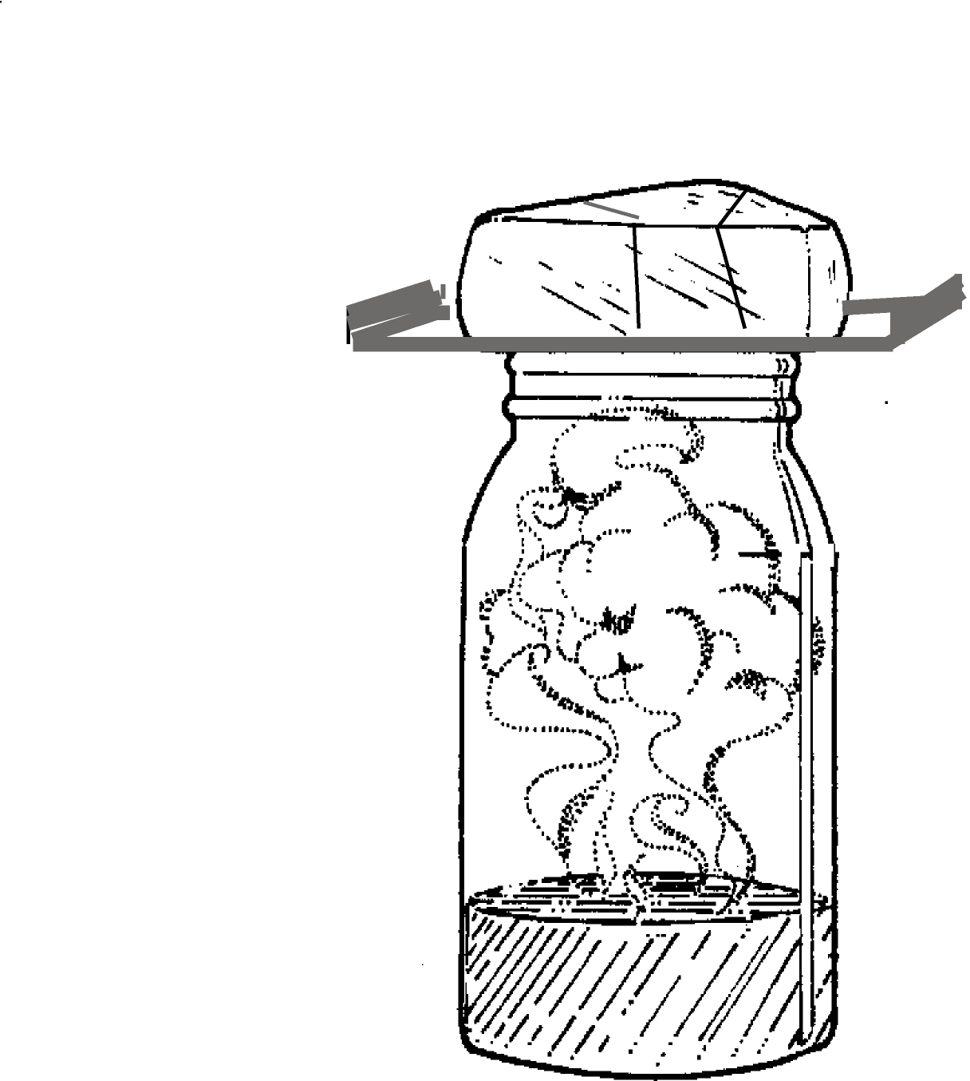

Activity 3.1. Making Clouds

Equipment: Ice cubes, metal tray, large glass jar, and warm water.

What to do:
- Pour about 2 cm of warm water into the glass jar. (Do not use boiling water, as this will crack the glass jar.)
- Put some ice cubes on the metal tray and put this on top of the jar of warm water.

Predict: Get the children to predict what is likely to happen.

Observe: Watch what happens as the moist warm air in the glass jar rises and reaches the cold metal tray.

Explain: Get the children to draw their observations and write an explanation.
What we want the children to learn: Use the words evaporation and condensation.
This activity can be linked to water evaporating off the sea and cooling high in the atmosphere.
When the water vapour cools, small drops of liquid water form. These collect together to form clouds.

Activity 3.2 The Water Cycle.

Equipment: Large sheets of paper and plenty of colouring pencils, pens etc.

What to do: Relate this as a story or even get the children to write a story of a water drop, after they have been through ideas about the water cycle, and become familiar with the terms.
Step 4:
clouds rise and cool
Step 5:
water drops combine and fall as rain
Step 1:
Sun provides heat heat energy
Step 3:
water vapour condenses into droplets to form clouds
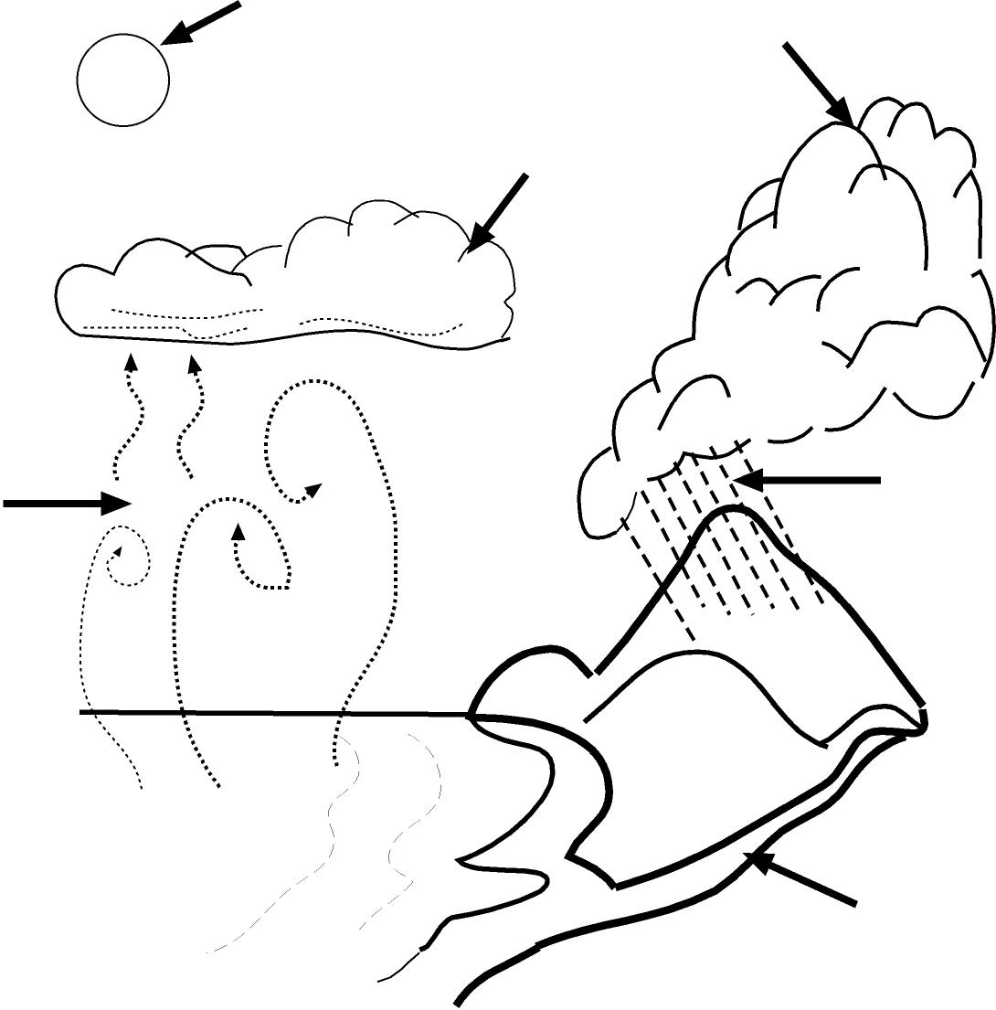
Step 1:
sun provides heat energy
Step 6:
water soaks into the ground, flow into streams and rivers
Step 2:
water evaporates from the surface of the ocean
Step 3:
water vapour condenses into droplets to form clouds

The Story
Step 2:
water evaporates and vapour rises
The story of the water cycle is all about how water changes state due to heat energy from the sun then changes again when it loses energy
STEP 1.
Heat from the sun evaporates some of the liquid water that is on the earth’s surface. Two thirds of the earth is covered in ocean so the sun evaporates o lot of water from the sea.
The liquid water is turned into an invisible gas, which we call water vapour.

STEP 2
The water vapour rises into the air. As it gets higher the water vapour cools. It changes back into tiny drops of liquid water.

STEP 3
Slowly the tiny droplets of liquid water start to crowd together. This is when they form a cloud.

STEP 4
The clouds are blown over the ocean by wind. When they reach land they are forced higher into the sky. The higher the clouds go the colder it gets.

STEP 5
As the cloud gets colder the tiny droplets of water join together. They become so heavy that they cannot stay up there. They fall down to the ground as rain.

STEP 6
When the water reaches the ground, it soaks into the soil. Plants get some of the water. Some of the water ends up in puddles. A lot of the water ends up in streams, which flow into rivers. The rivers then flow into the oceans.

STEP 7
The sun warms up the water in the oceans again. It changes into water vapour and floats up to make a cloud.
Student Activity Sheet
Fill in the words to tell the story of the water cycle.
- Heat from the ……………….…… evaporates ………………….…………… from the oceans.
- The invisible …………………….… vapour rises into the air.
- The cool air changes the water vapour into tiny droplets of floating ….……….
- The tiny droplets join together to form a ……………………………..………….
- The wind blows the ……………………………….…… towards the land.
- The rain soaks into the ground and ……………………………………………..……….
- The rivers flow into the ………………………………….
- The water …………………………………… has started all over again.
- It never …………………………….
Use the information to complete the diagram of the water cycle. Use the words condensation, precipitation and evaporation in the boxes A, B and C.

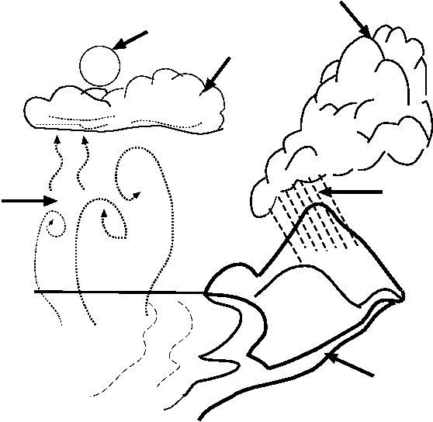
1
2
3
4
6
7
A_________________________
B_________________________
C________________________

Teacher Activity Sheet
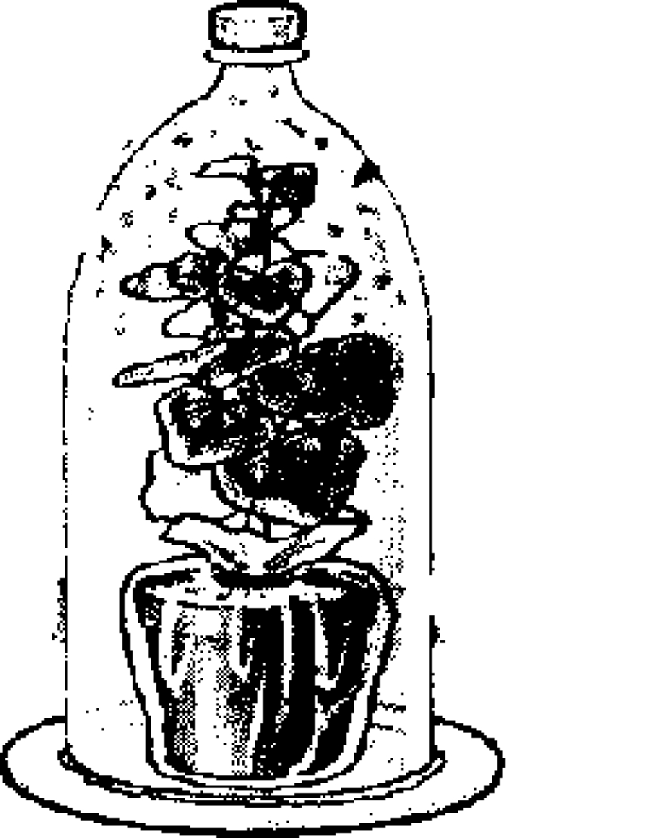

Activity 3.3: Do plants give us water?

Equipment: Plastic drink bottle with lid, pot plant, Blu-Tack.

What to do:
- Water the plant in its pot and tie a plastic bag over the pot and around the base of the plant to stop water evaporating from the pot soil.
- Carefully cut the bottom off a large drink bottle. Keep the lid on the top of the drink bottle.
- Put the plant on a flat plate.
- Put the drink bottle over the plant and seal around where the bottom of the bottle and plate meet. (Use something like Blu-Tack).
- Leave the plant for three days

Predict: Have the children write about what they think will happen.

Observe: and look at the inside of the drink bottle.

Explain: Where has the water come from?

What we want the children to learn:
Children can draw the plant experiment and write their explanations. They can use the words evaporation and condensation.

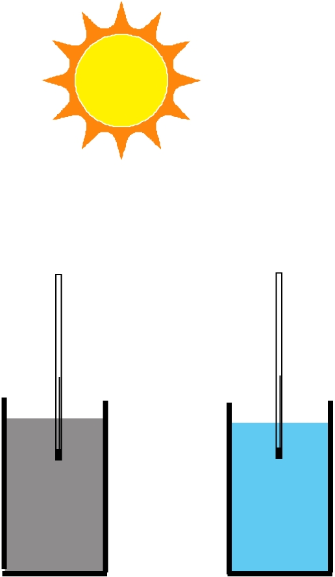
Teacher Activity Sheet

Activity 3.4 Heating Land and Sea

Equipment:, A jar three quarters full of sand, a jar three quarters full of water, two thermometers, a sunny spot

What to do:

- Set up the jars with water and sand.
water
- Put one thermometer into the sand and the other
thermometer into the water. Make sure the thermometer is not touching the sides or bottom of the jars
- Place in a sunny spot sheltered from the wind and record the temperatures each 15 minutes for 1 hour.
- Place the jars in the shade and record the temperatures each 15 minutes for 1 hour.
sand
Predict: Which jar will heat up the fastest? Which jar will cool down the quickest?
Observe: Which jar heats up the fastest over a period of 60 minutes?

Explain: Ask the children if they can explain why this has happened? Get them to write down their ideas and compare with other groups.

What we want the children to learn: The land heats up quicker in the sun than the water.
Extension:
Put an umbrella over the jars. Take the temperature every 15 minutes.
Can you think of an explanation for what you have seen happen.

Section 4: Weather Watch

Starter: What makes weather?

An activity that children can do in groups and then come together as a class. Make up a wall chart of their opinions.

- Give five reasons why weather is so important.
- Name and explain four things that make up weather.

Some information for the children:
  - The weather can change from day to day.
  - We go through wet seasons and dry seasons.
  - The weather changes because the air is moving, we call this wind.
  - To get an idea of the weather patterns (climate), we build up observations of day to day weather and make measurements
  - We can use this information about weather to make predictions.

Question: What sort of things do you think we need to record? Write down your ideas.

Teacher notes:
Hopefully the children will come up with some of the following ideas;

Sun
Cloud
Showers
Rain
Wind
Thunderstorms
Hot or Cold
Amount of rain
cyclone

- Do they need to consider what time of day they make their observations?

- Does it have to be the same each day?

- Allow the children to design their own wall chart to record their observations.

- Have the children design their own pictures for each of the things they want to measure.

What we want the children to learn;
That building up a picture of the weather requires regular observations.

This information can help tell us if the weather is changing on a year to year basis.

Scientists use this information along with information from satellites and Argo to help explain why the changes are happening.

Some suggestions for the weather monitoring:

Some symbols that are used:
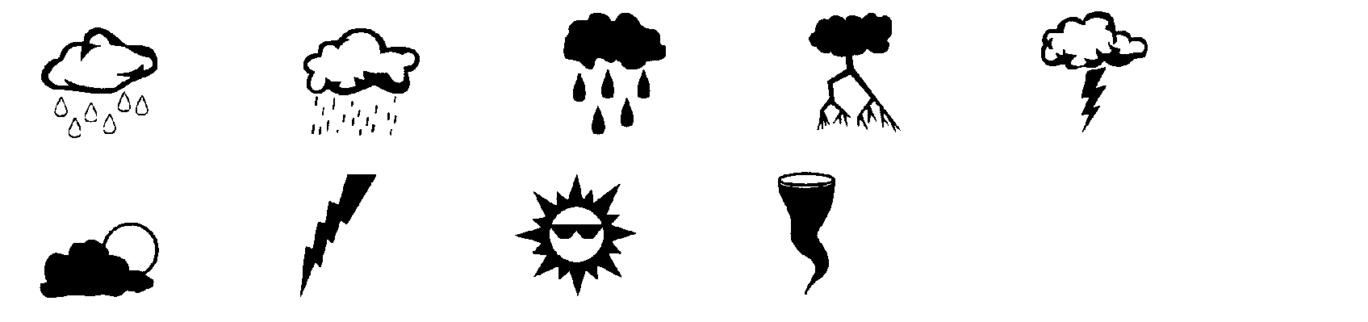

Design for a Rain Gauge.

Equipment: Requires one plastic drink bottle and a knife or scissors.

What to do:
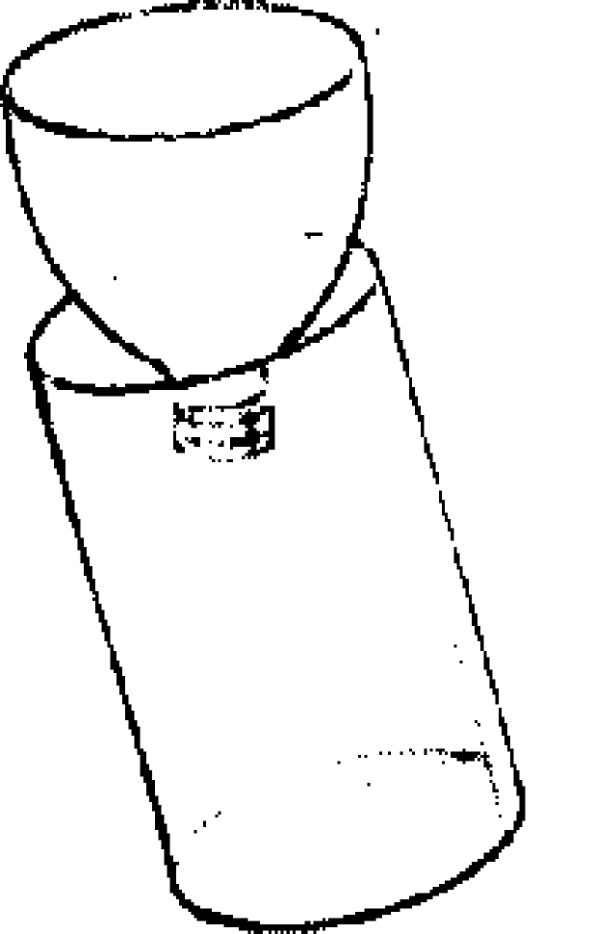
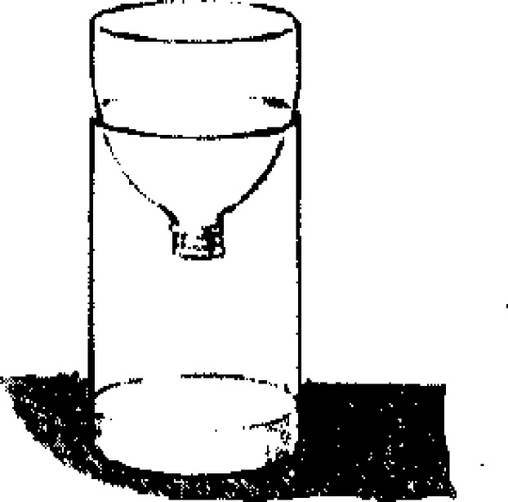
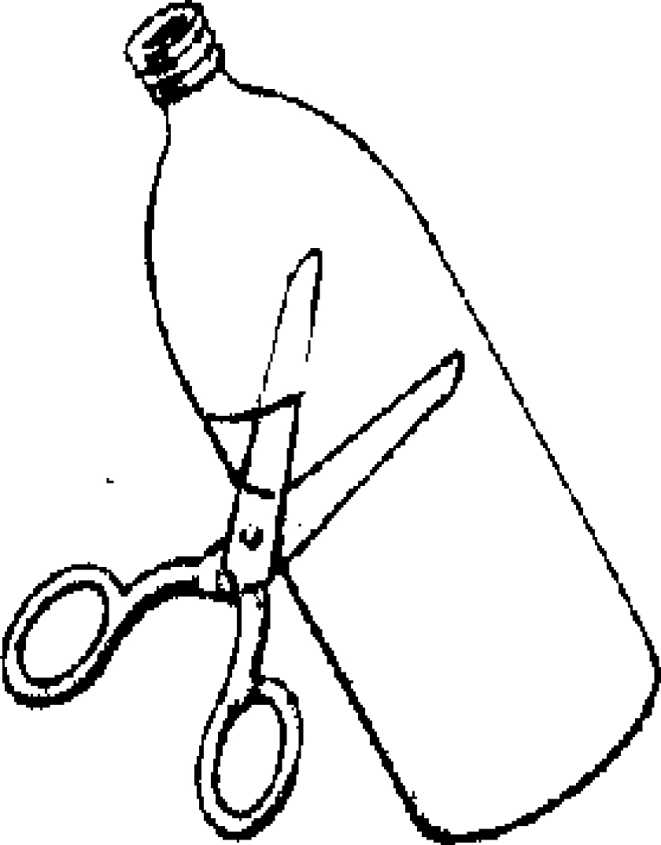

Set the rain gauge on a post or on the ground out in the open away from trees and buildings.

Thermometer: Put the thermometer in a open place, but not in the direct sun. On the sunny side but under a veranda will do fine. It should be in a place where it is open to breezes and weather. Courtyards can be a problem as the air can be quite still in these areas.

