SSD211: PLANET EARTH AND ITS RESOURCES

PART III

NATURAL RESOURCES

Definitions

STOCK RESOURCES •

FLOW RESOURCES •

CONTINUOUS RESOURCES •

RESOURCE UTILISATION •

RESOURCE EXPLOITATION •

SUSTAINABLE RESOURCE USE •

ECONOMIC DEVELOPMENT •

* Providing goods and services to customers on a continuous basis
* Any natural resource that can be increased, sustained or depleted by the actions of humans
* Using natural resources to generate wealth or income
* Using up a resource at a faster rate than it can be replaced
* Any way in which humans make use of a natural resource
* Transforming raw materials into products of higher value
* Any non-renewable resource that may be metallic, a fossil fuel, or non-metallic
* Any resource that is always available, independently of human actions
* Using a resource in such a way that the resource is not depleted

### DISTRIBUTION OF NATURAL RESOURCES IN THE PACIFIC

## *ACTIVITIES*

1. *Complete this diagram (Fig. 73) to show a classification of natural resources:*

***Fig. 73***

RENEWABLE

NON-RENEWABLE

(FINITE OR STOCK)

METALLIC

FOSSIL FUELS

NON-METALLIC

FLOW

CONTINUOUS

gold, iron, uranium

coal, oil natural gas

sand, limestone, clay, salt

fresh water, soil, flora, fauna, scenery

1. *State whether each of the following is a FLOW (F), CONTINUOUS (C ) or STOCK (S) resource:*

|  |  |  |  |
| --- | --- | --- | --- |
| *air* |  | *cockroaches* |  |
| *nambilak* |  | *the river Nile* |  |
| *clay soils at Wusi, Santo* |  | *the Indian tiger* |  |
| *a fresh-water lake* |  | *natural wheat plants in the Middle East* |  |
| *the hot springs at Port Resolution, Tanna* |  | *tidal energy* |  |
| *uranium 235* |  | *petroleum from Iraq* |  |
| *kauri trees on Erromango* |  | *hydro-power* |  |
| *phosphate on Nauru* |  | *the Big Bay National Park* |  |
| *the Pacific Ocean* |  | *limestone from the quarry at Erakor* |  |
| *solar energy received at the South Pole* |  | *the Great Barrier Reef* |  |
| *pozzolana on Efate* |  | *the moon* |  |
| *soils around Kilauea, Hawaii* |  | *bluefin tuna* |  |
| *soils in the Teouma valley, Efate* |  | *shell money in the Solomons* |  |
| *wild pigs in Santo Bush* |  | *wind* |  |

1. *Name one flow resource and say how it can be increased, sustained or depleted by the actions of humans.*
2. *In pairs, refer to the table and maps on pages 67-70 (Figs. 74-78), then answer these questions:*
3. *Which island type has the most abundant natural resources, and why?*
4. *Make a generalization about the distribution of fresh-water resources in the Pacific.*
5. *What are the 3 most significant mineral resources of the Pacific islands?*
6. *Suggest two natural resources that remain largely unused in the Pacific islands*
7. *On which type of island is there the greatest pressure of population on natural resources?*
8. *Suggest two flow resources that are rapidly being exploited in the Pacific islands.*
9. *Make a eneralization about the distribution of all natural resources in the Pacific.*
10. *When is a resource no longer a resource?*

##### SIGNIFICANT NATURAL RESOURCES OF THE SOUTH AND CENTRAL PACIFIC

***Fig. 74***

|  |  |  |  |  |  |  |  |  |  |  |  |  |  |  |  |  |  |
| --- | --- | --- | --- | --- | --- | --- | --- | --- | --- | --- | --- | --- | --- | --- | --- | --- | --- |
| Nation / Territory | Area(km2) | Population (mid-2009 estimate) | Island type (**C**ontinental, **V**olcanic, **R**aised reef, **A**toll) | Biogeo-graphical province (IUCN) | Rain forest (lowland and/or montane) | Man-groves | Wildlife (terr.) | Coral reefs | Inshore fisheries | Pelagic fisheries | Soils with good agric.Potential | Scenic land-scapes | Fresh water | HEP | Other energy resources (**O**il, **W**ind, **G**eoth.) | Mineral resources(Gold, Copper, Silver, Bauxite, Phosphate, Other) | **S**and &  **C**oral for buil-ding |
| AMERICAN SAMOA | 200 | 65,000 | V | 9 | * | * | * | * | * | * | * | * | * | - | W | - | * |
| COOK IS. | 237 | 16,000 | V,R,A | 16 | * | - | * | * | - | * | * | * | * | - | W | - | * |
| EASTER IS. | 166 | 2,000 | V | 20 | - | - | - | - | - | - | - | * | * | - | W | - | * |
| FIJI | 18,333 | 844,000 | V,R,A | 7 | * | * | * | * | ** | * | * | * | ** | * | W | G | * |
| FED. ST. OF MICRONESIA | 701 | 111,00 | C,V,R,A | 13 | * | * | * | * | ** | ** | * | * | ** | * | W | - | * |
| FRENCH POLYNESIA | 3,521 | 266,000 | V,R,A | 18 | * | - | * | * | * | ** | * | ** | * | * | W | - | * |
| GUAM | 541 | 182,000 | V | 12 | * | * | * | * | * | * | * | * | * | - | W | - | * |
| HAWAII | 16,636 | 1,288,000 | V |  | * | * | * | * | * | * | ** | ** | ** | * | W.G | - | * |
| KIRIBATI | 811 | 99,000 | A | 11 | - | * | - | * | ** | ** | - | - | - | - | - | Mn | * |
| MARSHALL IS | 181 | 54,000 | A | 14 | - | * | - | * | ** | ** | - | - | - | - | - | - | * |
| NAURU | 21 | 10,000 | R | 11 | - | - | - | * | - | * | - | - | - | - | - | Ph | * |
| NEW CAL. & LOYALTIES | 19,103 | 251,000 | C,V,R,A | 4 | * | * | * | * | * | * | * | * | * | * | W | Ni | * |
| NIUE | 259 | 1,500 | R | 8 | * | * | - | * | * | * | * | * | * | - | W | - | * |
| N. MARIANA ISLANDS | 471 | 63,000 | V,R | 12 | * | * | * | * | * | * | * | * | * | - | W | - | * |
| PALAU | 488 | 20,000 | R | 13 | * | * | - | * | * | * | * | * | * | - | W | - | * |
| PAPUA NEW GUINEA | 462,243 | 6,610,000 | C,V,R,A | 1,2 | ** | ** | ** | * | ** | * | ** | * | ** | ** | 0,W,G | C,G,S, Mb | ** |
| PITCAIRN IS. | 39 | 66 | V | 20 | * | - | - | - | - | * | - | - | - | - | W | - | - |
| SAMOA | 2,935 | 183,000 | V | 9 | * | * | * | * | * | * | * | * | * | * | W | - | * |
| SOLOMON ISLANDS | 28,370 | 535,000 | V,R | 3,5 | ** | ** | ** | * | ** | ** | * | * | ** | * | W | G,C, B, Ph | * |
| TOKELAU | 12 | 1,100 | A | 10 | - | * | - | * | - | * | - | - | - | - | W | - | * |
| TONGA | 747 | 103,000 | V,R | 8 | * | * | * | * | * | * | * | * | * | - | 0,W | - | * |
| TUVALU | 26 | 11,000 | A | 10 | - | * | - | * | * | * | - | - | - | - | W | - | * |
| VANUATU | 12,190 | 239,000 | V,R,A | 5 | ** | * | * | * | ** | * | * | ** | ** | * | W,G | Mn,G,C, Pozz | * |
| WALLIS & FU. | 255 | 14,200 | V,A | 9 | * | * | * | * | - | * | * | - | * | - | W | - | * |

** abundant * some - none

***Fig. 75***

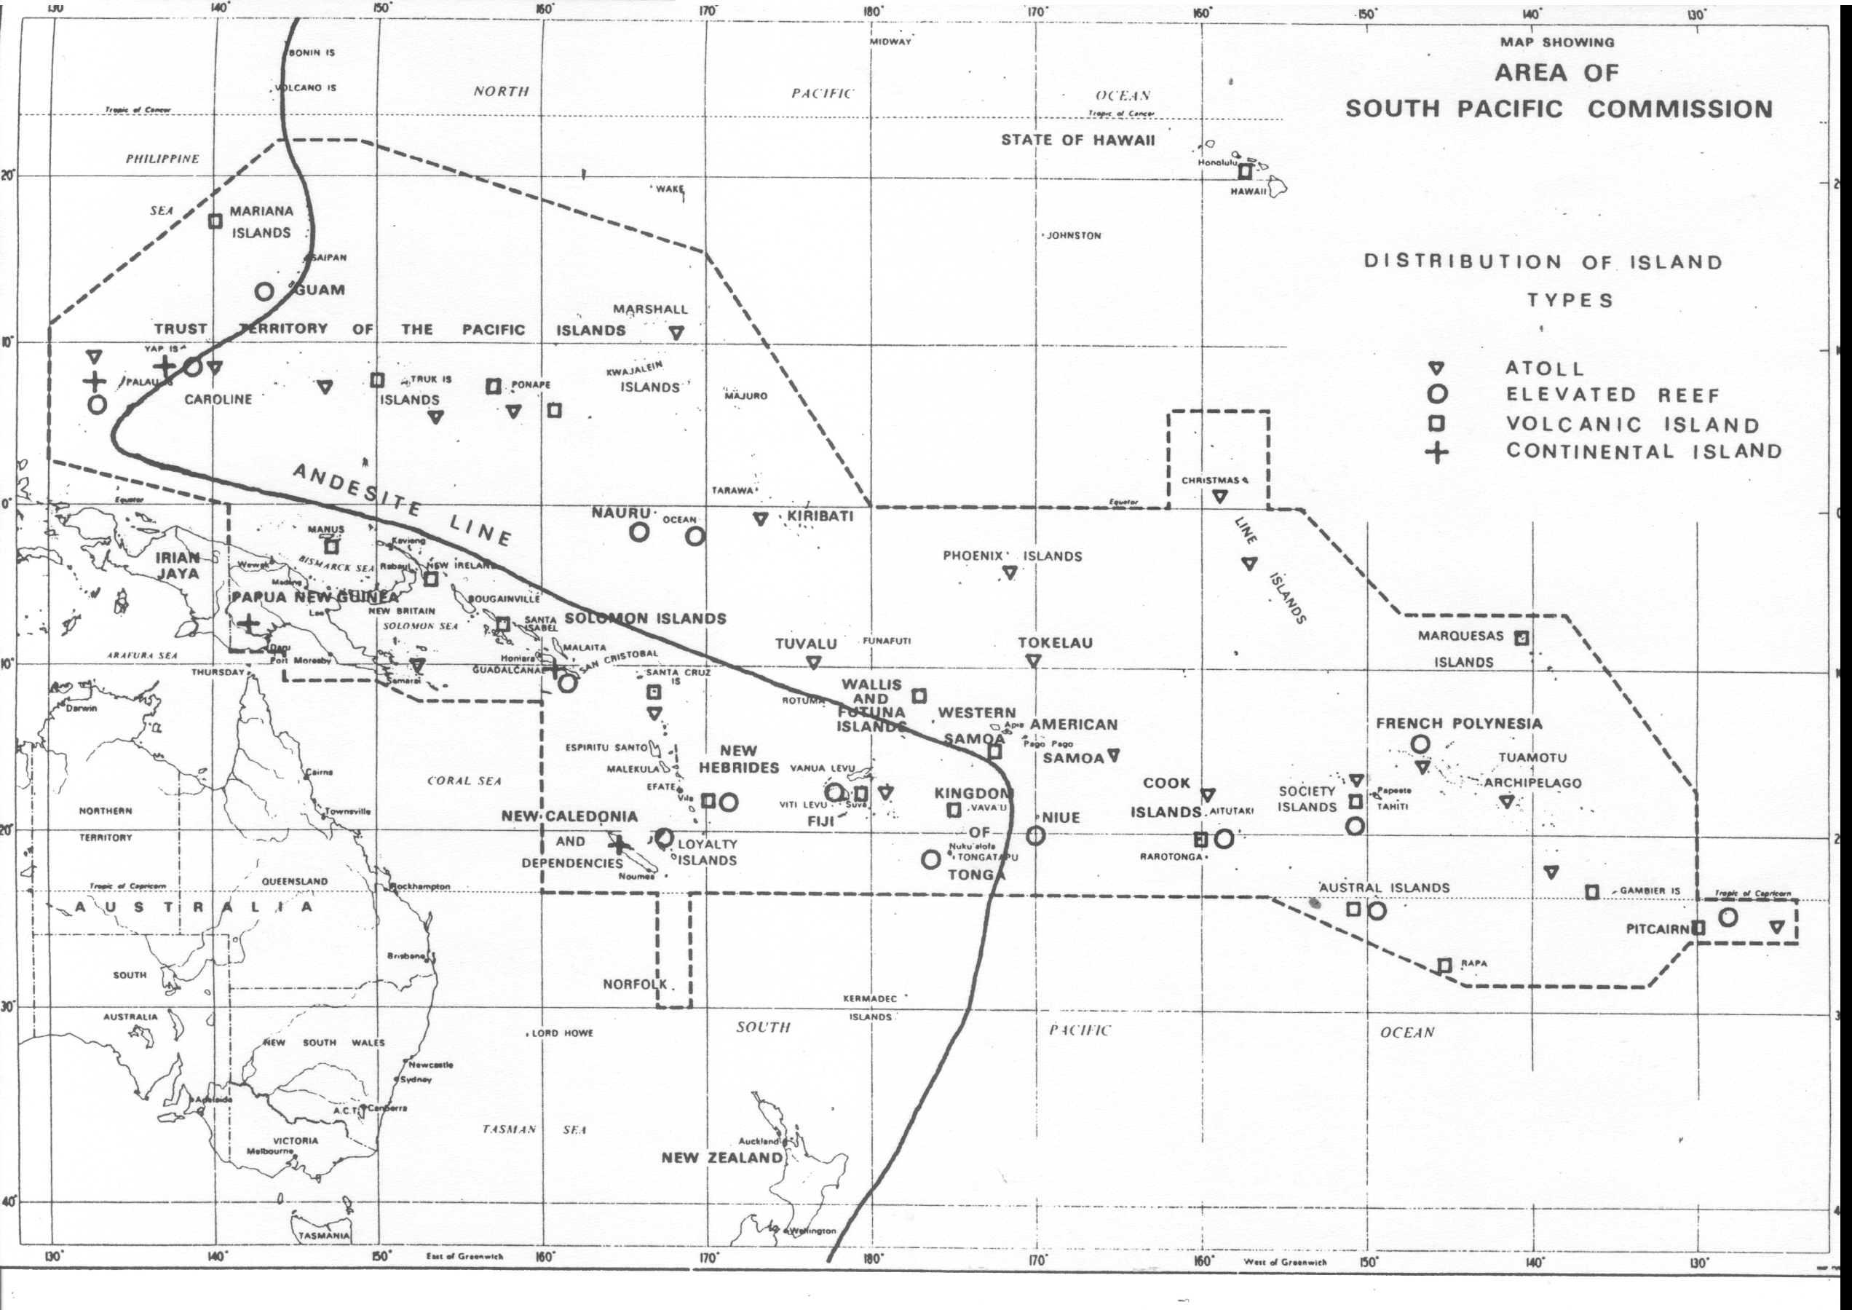

***Fig. 76:***

***Island types in the South Pacific***

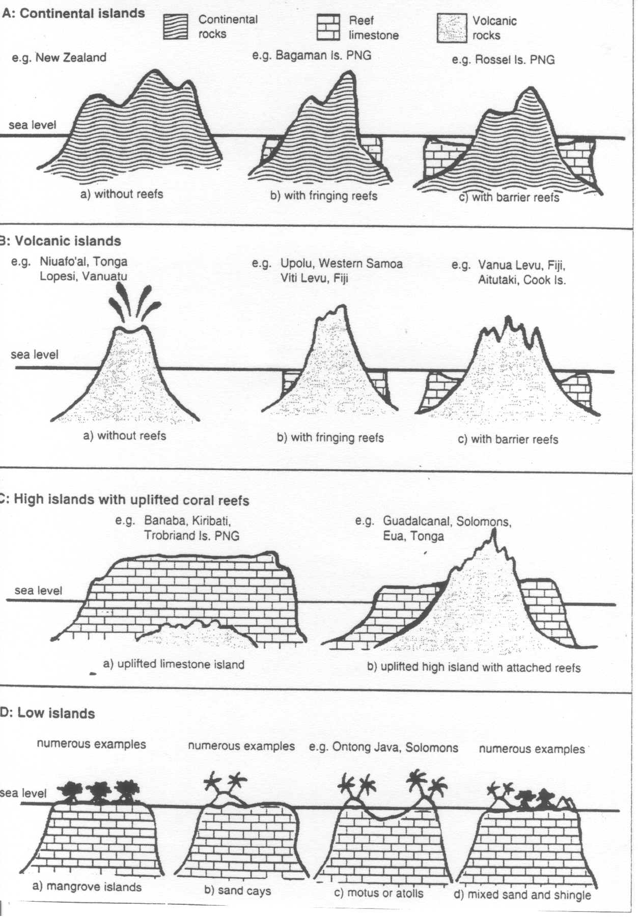

***Fig. 77:***

***Mineral resources in the South Pacific***

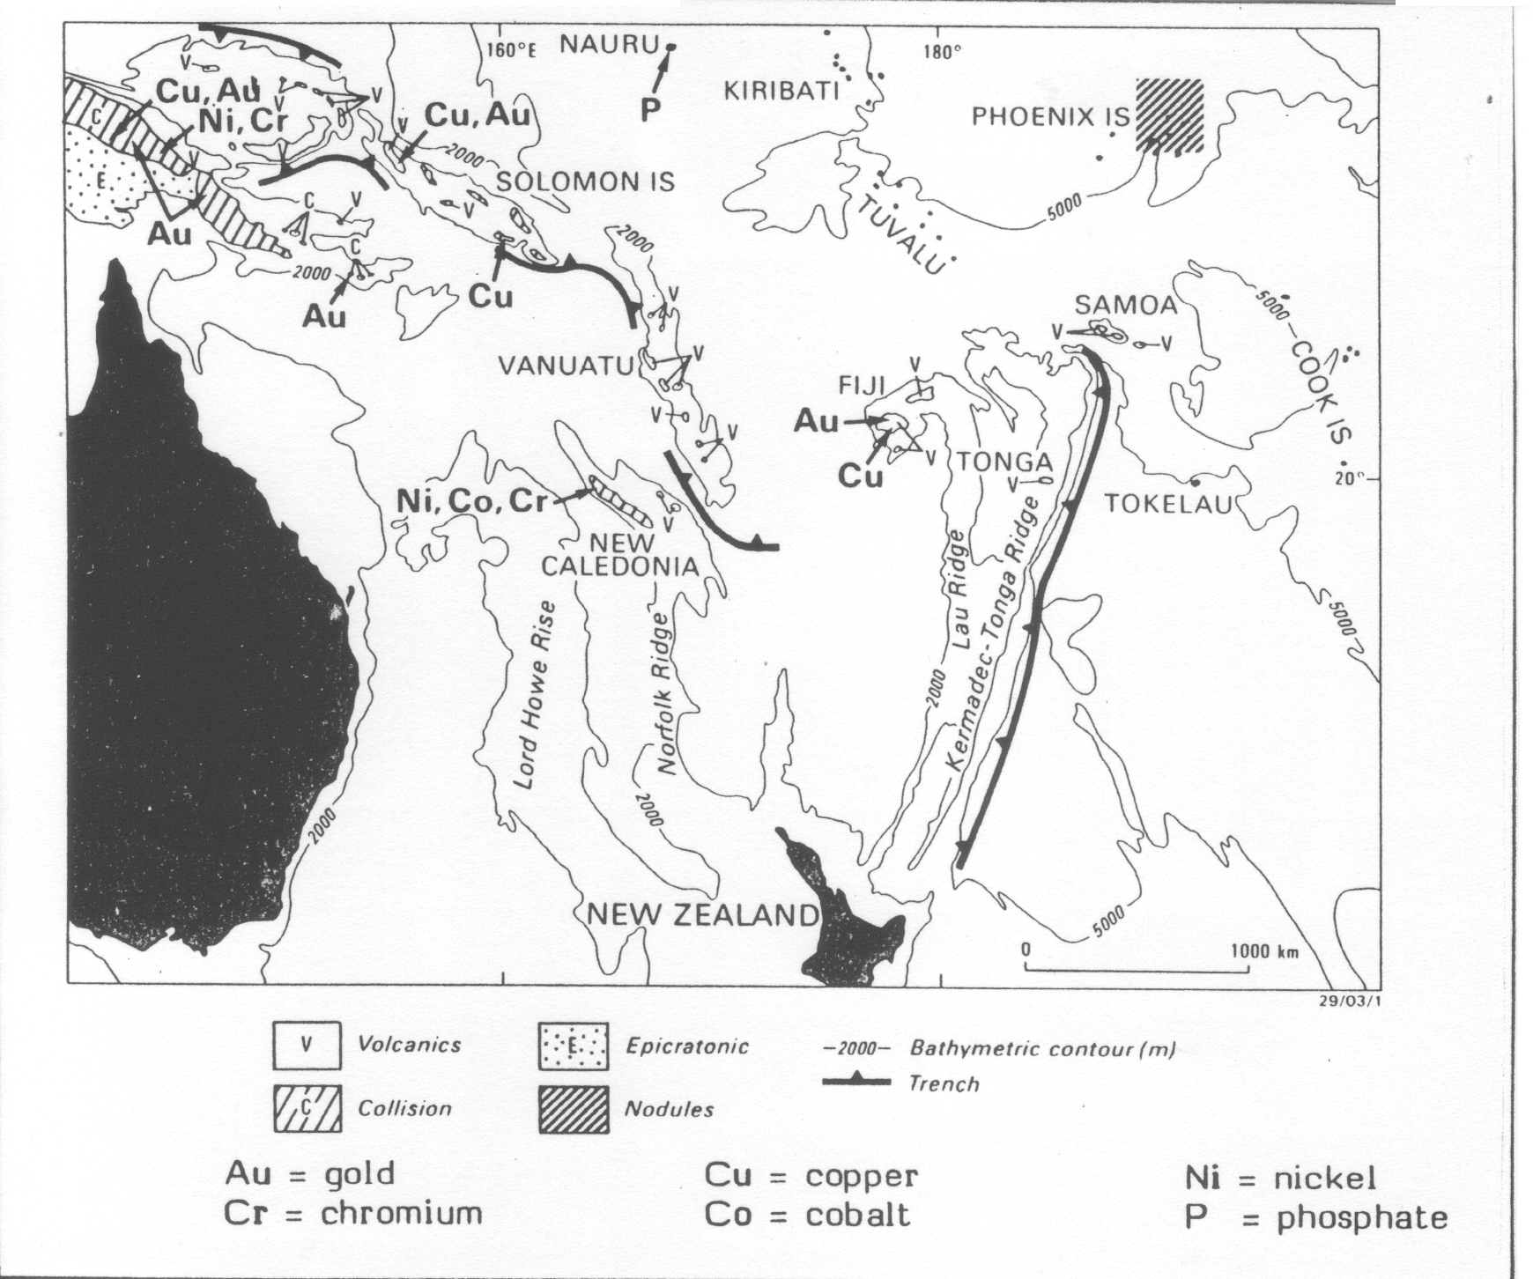

***Fig. 78:***

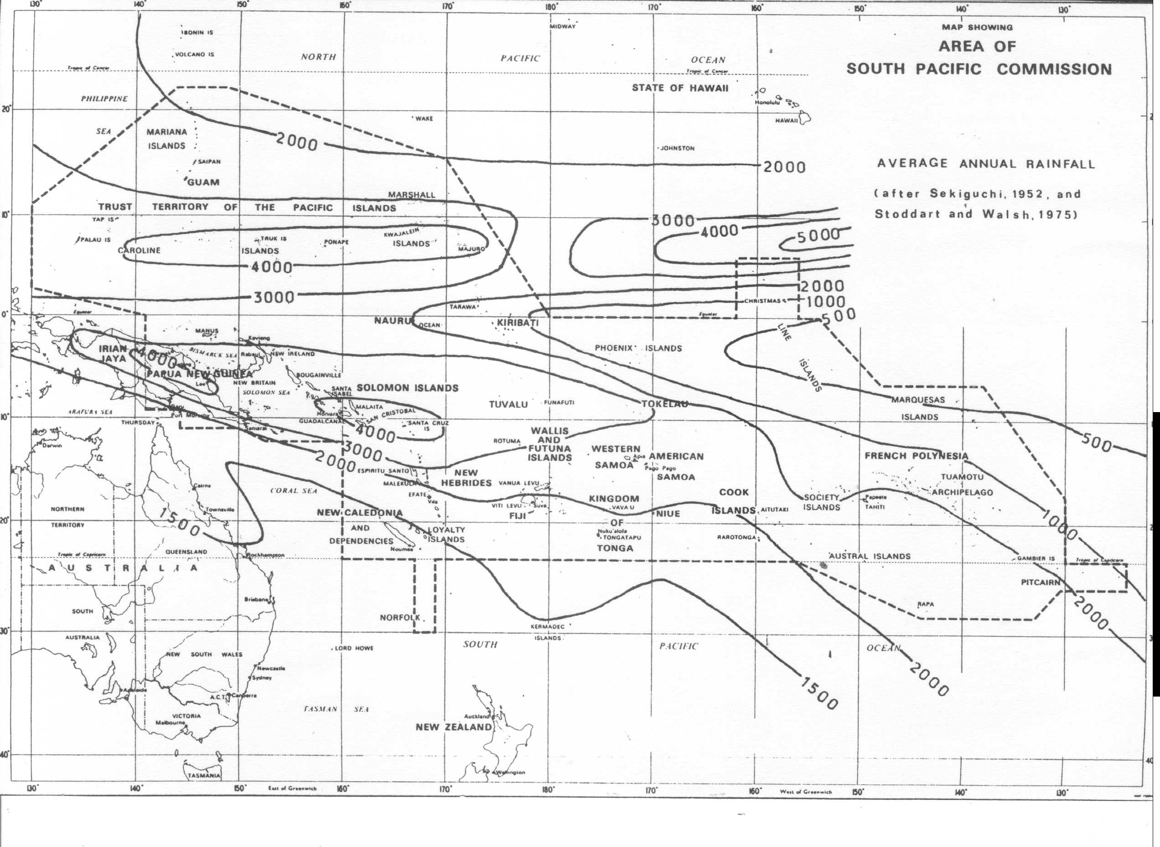

**RESOURCE EXPLOITATION**

*ACTIVITIES*

* 1. *Brainstorm: What factors determine whether a resource is exploited or whether it is used sustainably?*
  2. *Read through the following case studies and answer the questions that follow:*

**CASE STUDY 1: THE GOGOL TIMBER PROJECT[1]**

**Aims of the project**

In 1971, a woodchipping industry was established based on the forest resources of the Gogol Valley, near Madang. At the time, this was a new form of forest utilisation - harvesting all species of plant in an area in order to provide pulpwood. This is called “clear felling”. Four separate Timber Rights Purchase areas (TRPs) were established, as shown in Fig. 79. Together, they make up the Gogol Timber Project (GTP).

***Fig. 79***

The Madang area has a tropical rain forest climate, with mean monthly temperatures ranging from 23°C to 30°C, and an annual rainfall of 3,518 mm. Before the project began, most land in the district was covered by tall forest or forest regrowth resulting from shifting cultivation. Forests are rich in species.

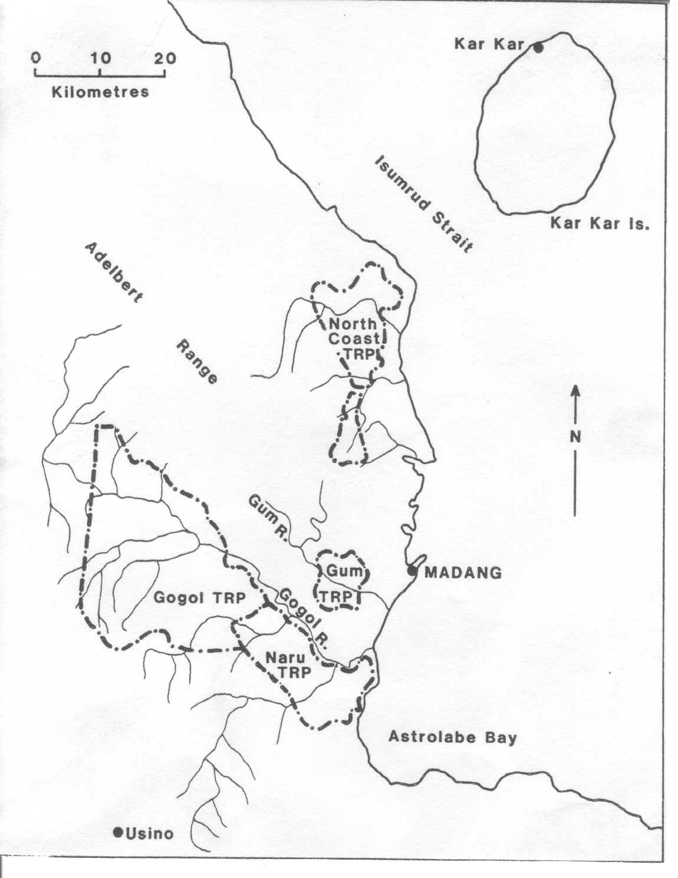

In 1969, just before the project started, the human population of the GTP area was 4,398, with a density of 5 persons per km2. The population lived as shifting cultivators, and relied on the forest to provide virtually all their needs. There was just one road in the area.

In August 1971, an agreement was signed between the PNG Administration and a Japanese company known as Japan and New Guinea Timber Co. (“Jant”) allowing Jant to harvest timber from the area. The aim was to use the smaller logs for pulp and the larger logs for sawn timber. Clear felling

in logging “coupes” (Fig. 81) would be carried out in all four TRP areas for 20 years. The Administration would make land available for reafforestation, in order to sustain the project after all natural forests had been exploited. There were no penalties for damage to the environment.

The PNG Administration supported the GTP because: a) it would diversify the country’s export base;

b) it would also demonstrate the viability of woodchipping, which could then be introduced elsewhere; and c) it would bring rural development to the Madang district, and stop emigration from the villages. The inhabitants of the area saw it as a chance for “development” - a way to acquire roads and to participate in the money economy.

**Summary: Advantages of the Gogol Valley Project**

1. Cash benefits to PNG, through the sale of woodchips, electricity purchased from the Electricity Commission, royalties received, etc.
2. Construction of a chip mill and a sawmill at Madang
3. Construction of new main and branch roads to serve the logging area. The new roads brought many benefits - cultivation of cash crops, access to markets in Madang, reduction in isolation, access to better health care, use of imported items such as kerosene lamps and aluminium cooking pots, etc.
4. Some control of forest-based enterprises by indigenous people in PNG.
5. Out-migration from the Gogol valley was halted, and reversed.

**Disadvantages of the Gogol Valley Project**

1. It has only brought short-term benefits. The initial plan was that the rain forest would provide woodchips for 20 years, and that the timber supply would then come from the plantations that had been established on the logged area. However, reafforestation has not been undertaken at the required rate, and when all the rain forest has been exhausted, the supply of plantation timber will be insufficient to sustain operations. By 1986, only 5,500 ha were under forestry plantations, approximately half of the area need to maintain operations at a sustainable level.
2. In the long-term, it is clear that clear-felling drastically affected two processes that sustain trees - a) the regeneration process through the production and dispersal of seed and the establishment of seedlings, and b) the nutrient cycle.
3. Financial compensation for landowners has been smaller than expected, and has led to unrest/disputes.
4. The natural environment has suffered - loss of trees, soil compaction, decline of wildlife, contamination of water supplies. By 1986, some 55% of the 73,000 ha of available forest in the Gogol, Naru and Gum TRPs had been logged. In 1986, regrowth in the logged areas appeared to be rapid, but the recovery process was being slowed down by several factors: many of the logging coupes were larger than before, and tended to form long continuous swathes; no buffer strips were being left along the streams; and logging debris was being allowed to fall into the water.
5. Changes in village life: Diets changed as more people ate imported foods such as tinned fish and meat. Many villagers worked for Jant: this brought cash into the villages, but also disrupted village work patterns since fewer men were available to do the heavy work.
6. A major beneficiary of the project has been the Honshu company (part of Jant), a multinational business based in one of the world’s richest countries, which received a 20-year supply of woodchips.

*STUDY QUESTIONS*

***Fig. 80***

1. *What is clear-felling (Fig. 80)? Why should it be avoided?*

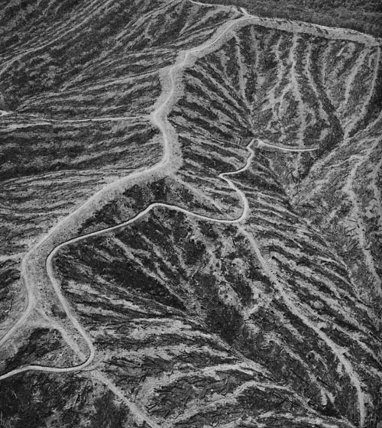

1. *What is a “logging coupe” (Fig. 81)? Why do you think an increase in size of logging coupes slows down the regeneration of forest in the logged areas?*
2. *Why can we say that the Gogol Timber Project is an example of “resource exploitation”?*

***Fig. 81***

**N**

**CASE STUDY 2: GOLD MINING AT PORGERA, PNG**

**General features of gold mining**

***Fig. 82: Block diagram to show how gold deposits are mined***

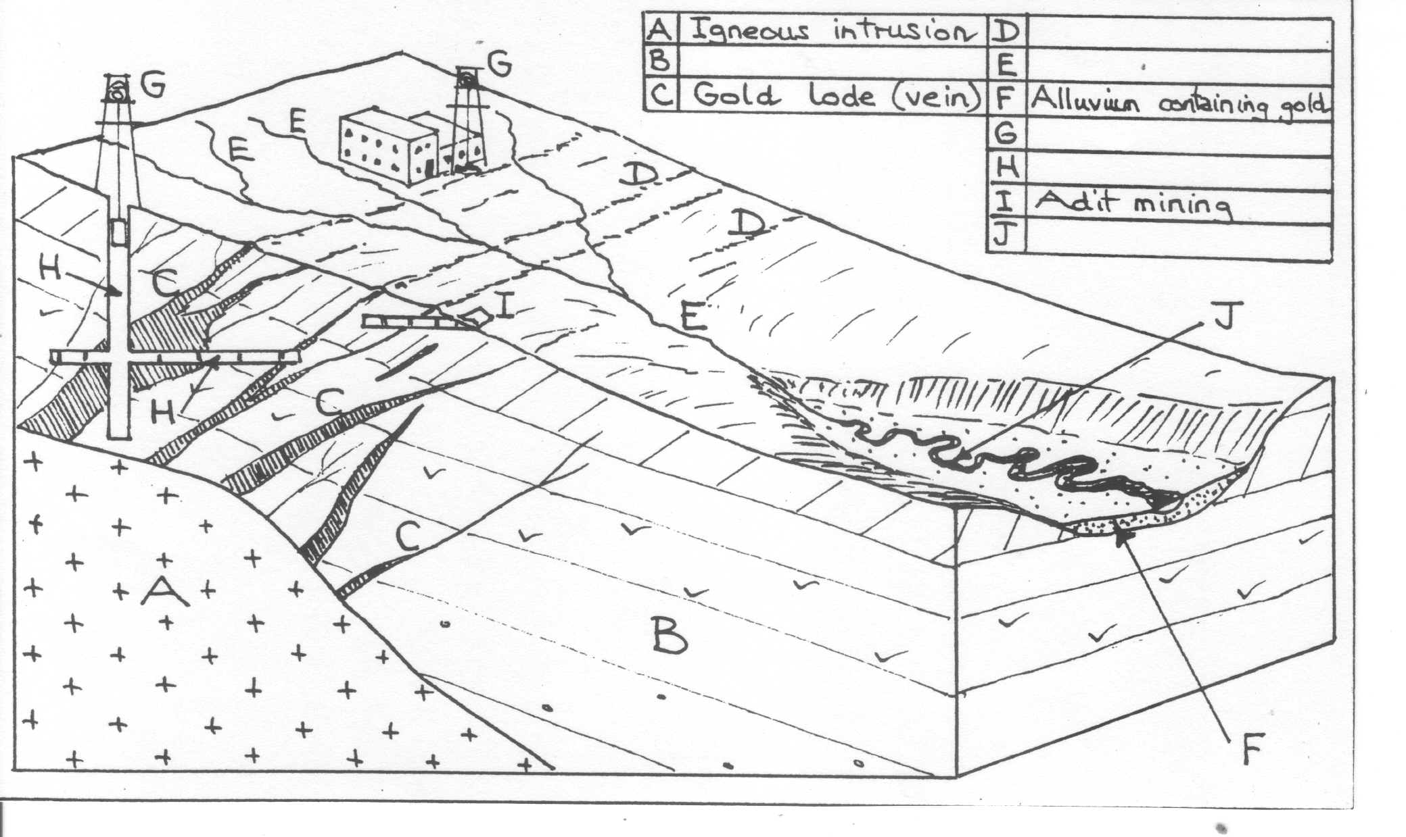

Gold is found in two types of location - igneous lodes and river alluvium. It is mined from lodes by surface digging, or by underground mining along shafts or adits. It is obtained from alluvium by “panning” the sand and silt, or by digging out the gold-bearing sediments with bulldozers or dredgers.

***Fig. 83: Location of Porgera***

Gold mining at Porgera

The Ipili people first came to live in the remote and rugged Porgera Valley about 300 years ago. They lived as scattered family groups in the forest, dependent on the land for all their needs. In 1938, gold was discovered in the alluvium of the valley. A few villagers began alluvial panning in the 1940s, but real interest in gold only began in the 1980s.

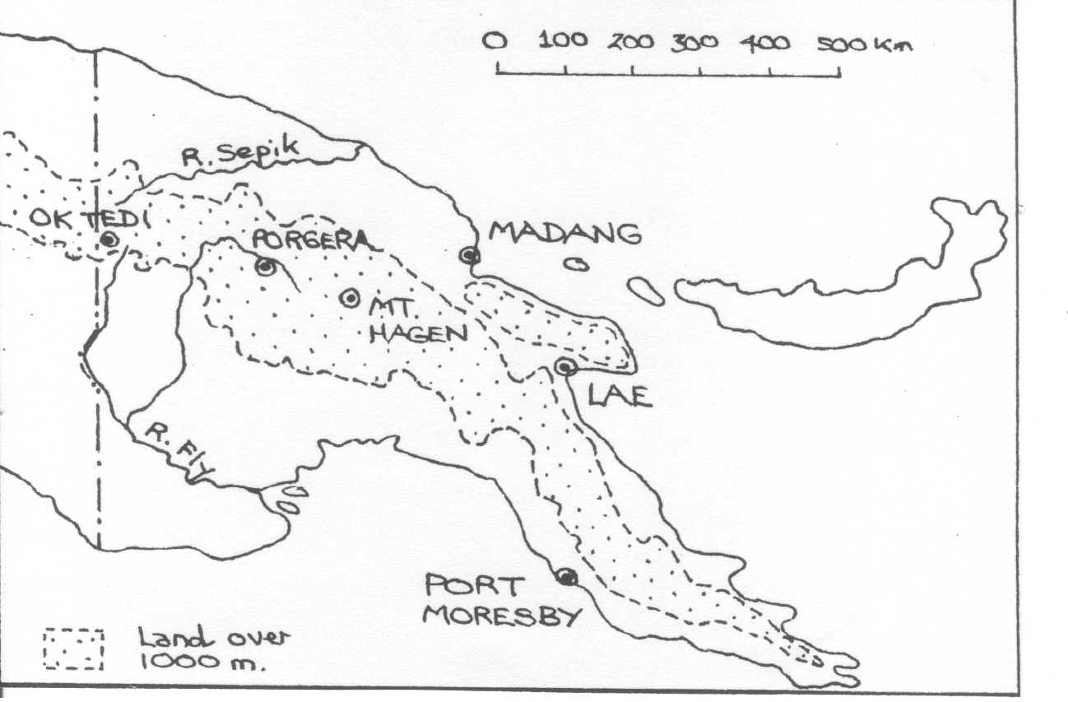

In 1984, one of the richest gold deposits in the world was discovered on Mount Waruwari. The Porgera Joint Venture company (PJV) was established.

Mining did not begin until 1989, since the company had to negotiate land rights and compensation with the landowners and the PNG Government. Three hundred families living in the mining area had to be re-located to new houses at the end of the valley in an area of very poor soils.

In 1988, gold was discovered in nearby Mount Kare, causing a “gold rush”. Thousands of people came in to pan and dig the alluvial gold resources, until nearly all accessible gold was removed. They then drifted back to Porgera to get work in the mine, or to claim compensation payments.

The Porgera gold mine has brought great wealth to the local people, and caused an increase of population from 3,000 to 15,000. Enormous social changes have occurred. Many new local businesses have been established and the Ipili Porgera Investment Co-operative now ensures that not all the wealth is lost. But bad feeling between land owners and the company remains, and incidents of violence are common. See the extract from the *Sydney Morning Herald* below:

The convoy of Landcruisers halted at the base of the hill overlooking the mine pit. Police tumbled out of the trucks and worked their way up the hill, burning every structure they found. Homes, shanties, pig stys and market gardens were torched. Violence is not new to the Porgera Valley in Papua New Guinea’s central highlands, but since the gold mine came it has changed. Now, rather than ritualised tribal warfare, there are reports of shootings by police, mine security and bandits, of rapes and beatings, of drug running and a lethal blackmarket in mercury, which is used to leach gold from stolen ore. There is prostitution and bootlegging, and an increase in domestic violence and sexually transmitted disease.

At the centre of it all is the Porgera mine, one of the 10 richest in the world, owned by the world’s biggest gold miner, Barrick Gold Corporation of Canada. The mine lies at the top of Porgera Valley, home of the Ipili people, and its open pit – the hole that used to be Mount Wari Wari – can be seen from space.

Barrick and the mine’s former owner, Placer Dome, have been accused of human rights abuses by a string of organisations and was recently criticised by Amnesty International. It has been reported to the United Nations. One group, MiningWatch Canada, has written to Australia’s Foreign Minister, Stephen Smith, calling on him to pressure the PNG Government to stop the burnings.

Nick O’Malley, Sydney Morning Herald, 10th June 2009

*STUDY QUESTIONS*

***Fig. 84***

1. *Using the information above and the photo on the right (Fig. 84), draw a concept map to show the environmental, economic and social impacts of the Porgera Gold Mine.*

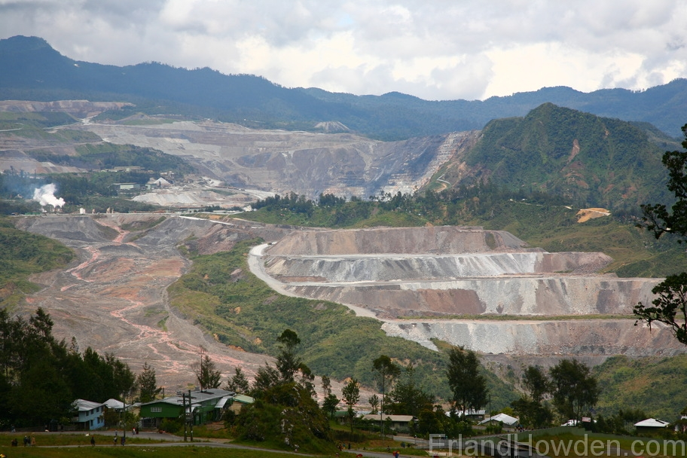

1. *Watch the DVD on Porgera, then compare the lives of the people of Porgera before and after gold mining began: Use these headings:*

* *Food and shelter*
* *Valuable mineral resources*
* *Distribution of wealth*
* *Health and education*

1. *Why can we say that this case study is an example of resource exploitation?*

**SUSTAINABLE USE OF RESOURCES**

**CASE STUDY 1: THE MONASAVU DAM, FIJI**

General features of a hydro-electric power station

“Hydro-power” refers to the generation of electricity from falling water. For medium and large hydro-power schemes, generating over 1000 kW of electricity, a concrete or earth dam is built across a constantly flowing stream, creating a large lake or reservoir. Water falls down from this lake through tunnels or penstocks to a power house, and then returns to the river. It is important to create a large “head” of water (difference in height between the level of water in the dam and the level of the turbines.)

***Fig. 85: Cross-section through a typical hydro-power scheme, showing its main features***

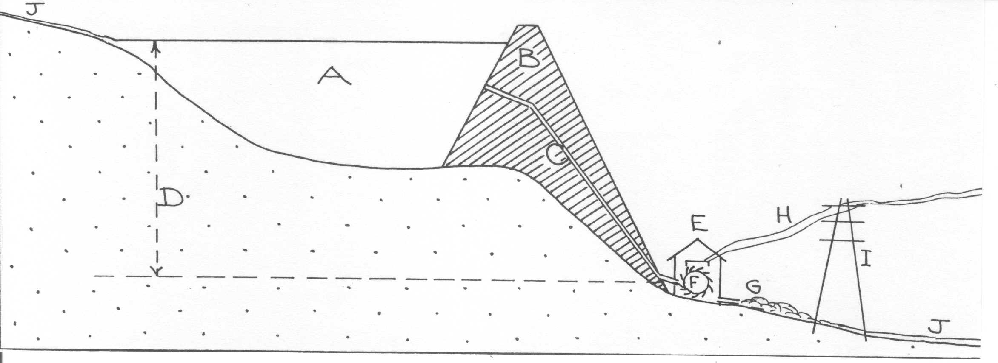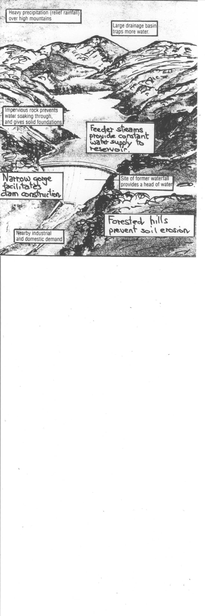

|  |  |
| --- | --- |
| A |  |
| B |  |
| C |  |
| D |  |
| E |  |
| F |  |
| G |  |
| H |  |
| I |  |
| J |  |

*CHOOSE FROM THIS LIST*

Power house Electricity cables

Pylon “Head”of water

Reservoir Turbines

River Tail race

Concrete or earth dam

Tunnel or penstocks

***Fig. 86:***

***Factors influencing the siting of a hydro-electric power station***

***Fig. 87: Viti Levu***

The Monasavu Project

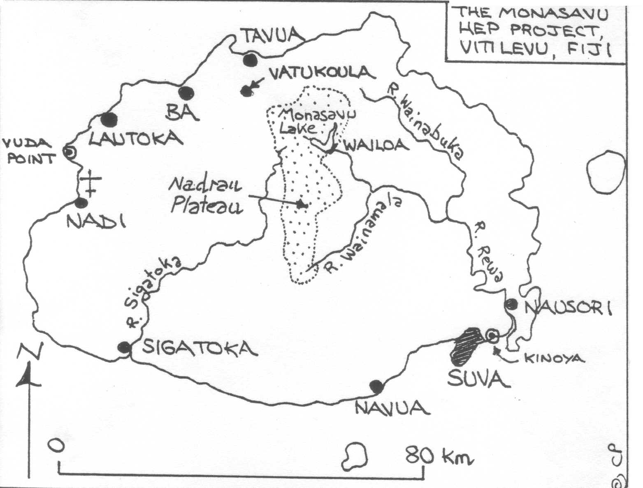

This hydro-project, the largest in the South Pacific, was constructed between 1981 and 1983. It was sited at the edge of the Nadrau Plateau, some 750 metres above sea level. The Monasavu Dam, built of a clay core with outer layers of sand and gravel, holds back a lake measuring 110 km2 in area that is fed by 7 streams. Water falls 80m to the power plant at Wailoa, in which 4 turbines generate a constant supply of electricity that is distributed within Viti Levu along a power line from Vuda Point to Kinoya.

0 km

20

The Monasavu project is the main hydro plant in Fiji. In 1998, it produced 83.5% of all power generated in the country; the remainder came from solar cells (0.0023%) and imported diesel fuel (16.4%). However, this percentage has gradually fallen, and there are concerns that the dam construction has upset the ecological balance and resulted in lower precipitation totals over central Viti Levu. By 2005-2006, Monasavu accounted for 60-65% of Viti Levu’s demand for power. In 2010, due to a long drought, the percentage had dropped to 25%, and the FEA warned that water levels in the dam were so low that operations might have to be temporarily closed.[2]

Although the landowners in the Monasavu area initially gave their consent for their land to be used for the project, they have become increasingly vociferous in their demands for compensation. The 19 landowning units argue that the catchment area is Native Reserve Land that can only be leased by the Fiji Electricity Authority in return for compensation of some 17.2 million USD. In 1998, the Fiji Gov. agreed to pay them 7.15 million USD.

*STUDY QUESTIONS*

1. *Watch the video-cassette “Monsavau - a new generation of power” and answer these questions:*
   1. *Why was the Monsasavu Project started?*
   2. *What was special about the Monasavu Dam when it was constructed?*
   3. *Why was the dam sited on the Nadrau Plateau?*
   4. *Who funded the project?*
   5. *Why did the landowners demand compensation?*
2. *State two advantages and one disadvantage of hydro-power as compared with electricity obtained from burning diesel fuel (i.e. thermal sources)*
3. *What problems is the FEA currently facing with the Monasavu Dam Project?*
4. *Is the Monasavu Project is a good example of the sustainable use of resources? Why/why not?*

**CASE STUDY 2: THE SARAKATA DAM, SANTO**

Site

***Fig. 88***

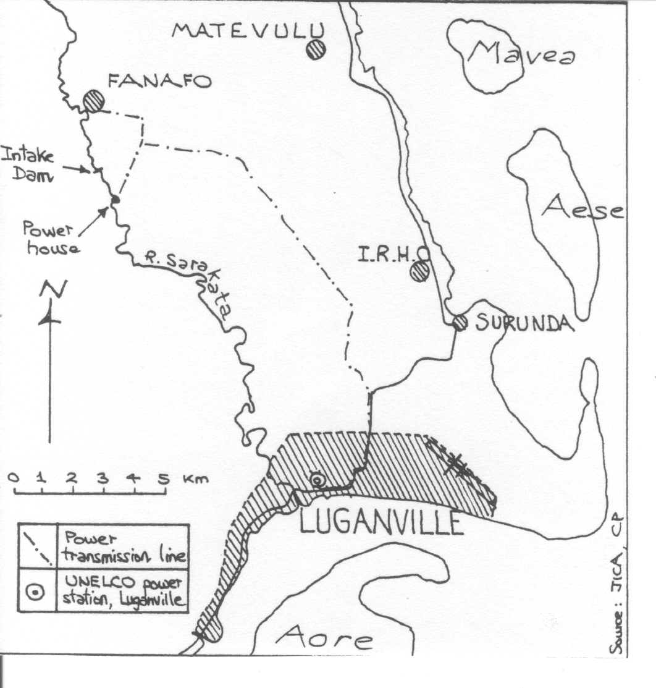

The project site is located in the middle section of the Sarakata River at an elevation of 114m above msl, approximately 15 km from the river mouth and 3 km south of the village of Fanafo. In this area, the river has eroded a narrow valley in the surrounding plateau, which is built of raised coral limestones. The annual rainfall in the Fanafo area is approximately 3,500mm. From the 8-metre high intake dam, an open canal carries water 850 metres downstream to a head-tank, from which water falls 28.5 metres through a penstock to two turbines in the power station. A transmission line 25 km long takes the electricity to Luganville, where it supplements power generated at UNELCO’s diesel plant.

Aims of the project

According to the project designers[3], the Sarakata HEP project is supposed to provide substantial savings in the cost of imported diesel oil, so enabling the production of electricity at a lower operating cost, and a reduction in price to consumers. Lower-income earners will have greater access to electricity than before. Another aim is to provide a more stable supply of electricity, with the hydro turbines providing continuous power that compensates for break-downs in supply from UNELCO’s diesel generators.

History and importance

The project was constructed during 1994-1995 with the help of grant aid supplied by the Government of Japan (funds, equipment and technical personnel). Electricity generated by the scheme (from 2 x 300 kw units) became available in Luganville from 1995 onwards, and in Fanafo since 1998. In August 2000, transmission was extended to Matevulu College. By 2001, hydro power from the Sarakata Dam supplied 51% of all electricity generated on Santo. The other 49% came from UNELCO's thermal power station in Luganville. The third phase of the project (an additional 600 kw unit) was completed in May 2009 with funding from Japan. In 2010, there are plans for the Sarakata Project to be managed by SANMA Provincial Council.

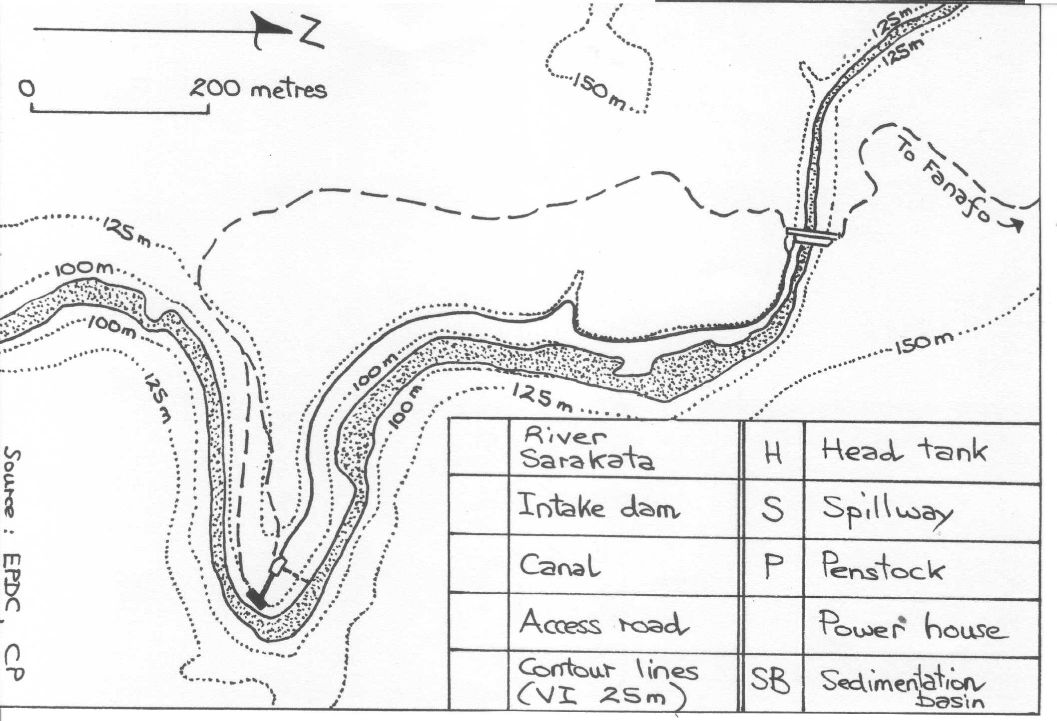

***Fig. 89: Site of Sarakata dam***

*STUDY QUESTIONS*

* + 1. *Complete the key to the plan of the Sarakata dam (Fig. 89)*
    2. *Why do you think the Sarakata project is more sustainable than the Monasavu project? (Think of size of dams, reservoirs created, etc.)*

**CASE STUDY 3: MICRO-HYDRO POWER IN THE SOLOMONS AND VANUATU**

Micro-hydropower means the generation of electricity from running water on a small scale. The equipment has a capacity of less than 100 kW, and there is only sufficient power for nearby villages with populations of 200 or less. A micro-hydro project is self-contained. It uses a local stream or river to generate enough electricity to meet the basic demands of a village for lighting, cooking and possibly refrigeration. People in the village learn how to install, maintain and repair the system.

One way of generating a sufficient “head” of water for micro-hydropower is shown in Fig. 90:

***Fig. 90: Features of a micro-hydro project***

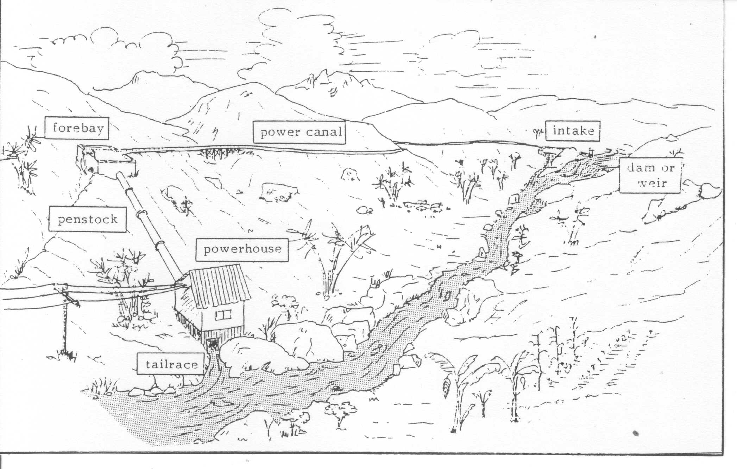

In the Solomons, several micro-hydro schemes have been established in remote villages with the help of an Australian NGO, APACE (Appropriate Technology for Community and Environment). Funding has come from AUSAID, although at Vavanga on Kolombangara, the local community financed one quarter of the costs when the scheme was completed in 1993. APACE tries to ensure that the local community is directly involved in the planning, operation and maintenance of the scheme, and particular emphasis is given to the training of village women. Fig. 91 shows the components of an APACE micro-hydro scheme.

The success of any micro-hydro scheme in Vanuatu will depend on the extent to which the local community is involved in building, operating, maintaining and repairing the equipment. The community must own the scheme, feel responsible for it, and have social structures in place for resolving any conflicts that arise. Skilled villagers must be identified and trained to maintain the equipment, and to know what to do when problems occur. Local industries that use the electricity should be established - for example, the manufacture of spare parts for the turbines.[4]

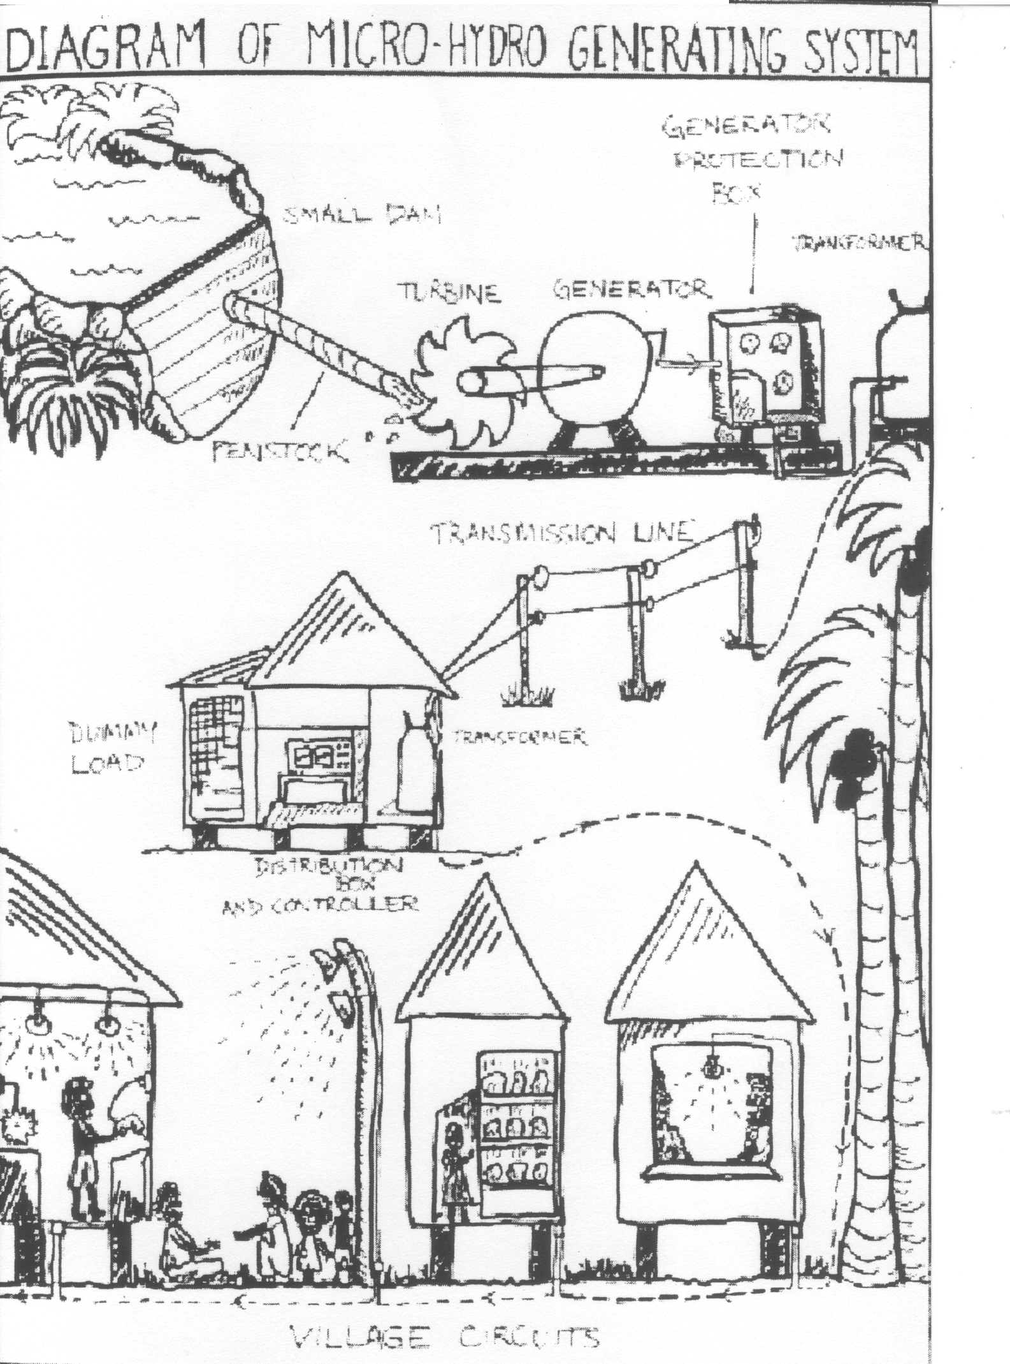

***Fig. 91:***

***Components of a micro-hydro generating system***

*STUDY QUESTIONS*

1. *In a micro-hydro scheme, why is it important that the community owns the project?*
2. *Draw a simple sketch map to show how a micro-hydro scheme works.*
3. *What are the advantages of a micro-hydro scheme?*
4. *Which is more appropriate for Vanuatu - the installation of one or two large dam projects such as Monasavu, or the introduction of a number of micro-hydro schemes? Give reasons for your answer.*

**TRADITIONAL METHODS OF RESOURCE CONSERVATION**

**Traditional systems of resource management in the Pacific**

The ancestors of today’s Pacific Islanders began migrating into Australia and Papua New Guinea about 25,000 years ago, towards the end of the Pleistocene period. By about 5,000 years ago, people were moving into the islands of Melanesia and Micronesia, while Polynesia received its first known settlements in Tonga and Samoa approximately 3,000 years ago (1000 BC). These sea-faring migrants brought along their domesticated plants and animals, together with techniques of slash and burn cultivation and sedentary agriculture. The most important plants introduced were taro, breadfruit, yam, coconuts and bananas. The most important domesticated animals were dogs, chickens and pigs. As the migrants settled down, they adapted their agricultural techniques to a new environment. On the atolls, for example, “pit cultivation”, or “water-table excavation” became essential for survival. On the high, wet islands, shifting cultivation (the “bush fallow” system) was necessary. [5] In the sea, traditional conservation practices ensured the maintenance of marine resources found in reefs, lagoons and the open ocean.

**Summary of traditional methods of resource conservation found in Oceania [6]**

***Fig. 92***

|  |  |  |  |
| --- | --- | --- | --- |
| **Form of resource management** | | **Example from ancient times** | **Present-day example** |
| **MARINE RESOURCES** | | | |
| Advice from traditional fisheries ecologists (master fishermen” | | Lau Group (Fiji) | Kiribati |
| Marine tenure systems | Restriction of fishing rights in certain areas | Society Islands | Hawaii |
| Restriction on certain species | Society Islands | Yap |
| Fixed seasons for fishing | Fiji | Palau |
| Some fish species could only be eaten by chiefs or priests | Marquesas | Yap |
| Conservation of sea food through fish ponds, sun-drying,.. | Hawaii | Palau, Tokelau |
| Magico-religious taboos | | New Zealand |  |
| Fines and punishments | | Marshall Islands |  |
| **SOIL AND FRESH WATER RESOURCES** | | | |
| Terracing of steep slopes | | Fiji | Vanuatu, PNG |
| Mulching | | All islands | PNG, Kiribati |
| Leaving tree seedlings and shrub stumps after initial forest clearing | | All islands | PNG, Vanuatu |
| Planting trees within food gardens | |  | PNG, Vanuatu |
| Arranging felled trees or rubbish in transverse rows on hillside | | High islands | PNG, Vanuatu |
| Burning to release nutrients into the soil | | New Zealand | PNG, Vanuatu |
| Using human wastes to enrich fields | |  | PNG |
| Leaving land in fallow | | PNG, Samoa | PNG, Vanuatu |
| Shelter belts | | New Zealand | Loyalty Islands |
| Pit cultivation | | Polynesia | Kiribati, Tuvalu |
| **FOREST AND WILDLIFE RESOURCES** | | | |
| Advice from traditional “forestry ecologists” | | Fiji |  |
| Closed seasons for harvesting fruits | | Samoa |  |
| Taboos to protect certain species (e.g. mangrove) | |  | Truk, Vanuatu |

|  |  |  |  |
| --- | --- | --- | --- |
| **Form of resource management** | | **Example from ancient times** | **Present-day example** |
| Fines and punishment | | Samoa |  |
| Game reserves | | Marshalls | PNG |
| Magico-religious taboos | | Australia |  |
| Game laws | Restrictions on hunting season |  | Tokelau |
| Limits on catch | All Pacific islands |  |
| Prohibitions on sacred animals | Tonga |  |
| **MAINTAINING A BALANCE BETWEEN POPULATION & FOOD SUPPLIES** | | | |
| Prevention of conception (moral restraint, withdrawal, celibacy) | | All Pacific islands |  |
| Abortion | | Melanesian islands |  |
| Infanticide | | Society Islands |  |
| Out-migration or in-migration of peoples | | All Pacific islands |  |
| Food preferences (e.g. for taro) | | All Pacific islands |  |
| Warfare | | PNG |  |

**Traditional food crop gardens in Vanuatu**

Traditionally, a clan or group of families held an area of land, with individual members having rights to use, but not own, sections of that land. New gardens were cleared each year from the forest or bush using stone axes and fire. Once cleared, a variety of crops were planted, with yam or taro as the main staple. The ground was not tilled, but carefully swept and weeded, with individual planting holes made with a digging stick. The garden was maintained until the yams or taro had been harvested, then allowed to revert to bush. As secondary forest developed, fertility was gradually restored on the old garden plot, and after 10 years or so, it could be used again.

According to Weightman (1989), this system of bush fallowing allowed great stability:

“It maintained soil fertility, and prevented erosion and the build-up of plant pests and diseases. It allowed man to farm the land indefinitely and develop his intimate and indissoluble identity with it. The staple foods were taro and yam, and bananas, sugarcane and leaf vegetables were also grown. Fences were built around the gardens to protect them from the pigs and fowls that scavenged at liberty. Large surpluses of food were produced and used in exchanges with neighbouring groups to cement alliances or for barter. In a few places, ample water resources and the terrain allowed the development of intensive, irrigated taro systems. The hunting and gathering of pigeon, flying fox, wild fowl, wild pig, edible ferns, termites and many kinds of wild nuts and fruit, or prawns from streams and shellfish from the reef, inshore fishing and the harvesting of breadfruit and coconuts, provided security against famine following the severe hurricanes and drought which periodically destroyed the food gardens or decimated their yields.” [7]

Traditional gardening in this manner continued almost unchanged for centuries. The pivotal crop was the yam, cultivated for ceremonial purposes and food. After European contact, manioc and citrus fruits were introduced, the planting of coconuts and cacao became important, and the rearing of cattle and goats began.

On most of the larger islands of Vanuatu (e.g. Ambae, Pentecost, Tanna), traditional gardens in coastal areas (0 – 200m) differed from those at higher altitudes.

**In the coastal zone**, people planted yam gardens surrounded by fences. They had extensive knowledge of how the different varieties of yam should be planted. In North Malakula, the “long” yam was planted in a

hole 1 – 2 metres deep, which was then filled with soft, crumbled topsoil until a mound 1 metre high was created; short yams (for food) were planted in this mound; the vines from the yams were trained along sticks of wild cane, with the vine from the “mama” yam following a bamboo stick and then a large tree (Fig. 93).[8]

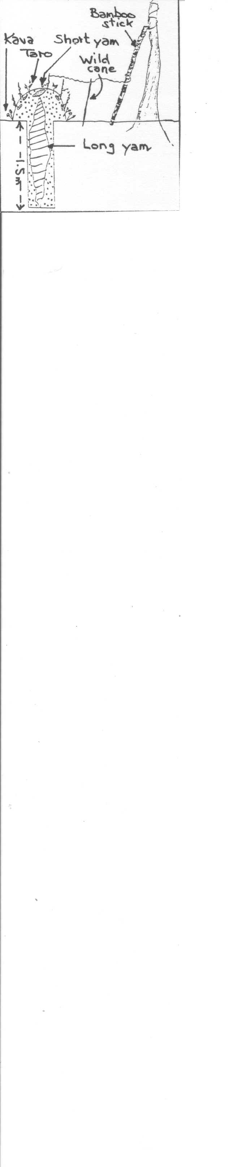

***Fig. 93***

***Traditional yam garden in North Malakula***

On Ambae, yam gardens were cleared during July, at the start of the dry season. Women and children cleared undergrowth and secondary vegetation, while the men cut down the larger trees. After a month, the cleared vegetation was burnt, and the ground prepared for planting by careful weeding and use of the mineral-

rich ashes. Yam heads were planted in deep holes and covered in topsoil and compost. Considerable energy would be spent on preparing the garden and caring for the yams during the period of growth. After harvesting the yams the following April, the farmer let his garden revert to forest, although he would return from time to time to harvest the bananas, kava or wild yams. After some 10 – 15 years, the land could be cleared again for gardening.[9]



Yams have by far the best storing qualities of all food crops cultivated in Vanuatu. On Malakula, the traditional names of the months indicate that yams could be stored for up to 6 months without going bad or being consumed by rats. They could be eaten during the period from April to September, and were available for re-planting as “seed” yams or yam heads. Fig. 94 shows a remarkable example of outdoor yam storage that was seen at Pongkil Bay, Erromango, in 1850. [10]

***Fig. 94***

***Traditional yam store in Erromango, 1850***

**At altitudes of over 300 metres**, in the zone known as *“aute”* on Ambae, *“kut”* on Pentecost and “*mananapi”* on Tanna, the pivotal crop becomes taro rather than yam. Traditional taro cultivation was very similar to yam cultivation, in that it involved clearing of the forest and bush-fallowing. However, taro can be planted and harvested at any time of year, unlike the yam, and is impossible to preserve for long periods. This meant that taro cultivation had to be continuous throughout the year, so that there would always be plants for harvesting. Several types of taro were cultivated - giant taro (for feasts and ceremonies), normal “island” taro or *taro colocasia*, and “taro Fiji”, which was introduced in the early 1900s. [11]

### Traditional agroforestry

In Vanuatu and other islands of Melanesia, where population densities were low, traditional gardening practices always ensured that some tree species were conserved during forest clearance. Such species were slow-growth forest trees, fruit and nut trees, and trees of cultural or medicinal importance. As gardens aged, other domesticated tree species were planted, such as coconuts, bananas, breadfruit, mango and burao (for fences). This practice of combining crop production with forest planting on the same unit of land is known as “agroforestry”. There are many advantages in such forest management and re-planting: trees provide shade; protect soil from leaching and erosion; ensure the preservation of animal habitats; provide timber for housing and furniture; supply food, spices, medicines, wrapping materials and perfumes; and yield cultural resources (e.g. ferns for carving tamtams on Ambrym)

### Changes in traditional gardening practices

Two important factors have changed traditional gardening since European contact - the commercial cultivation of coconuts and cacao in coastal areas, and the rapid growth of population.

In West Ambae, for example, Bonnemaison (1973) reports that the conversion of people to Christianity led to widespread cultivation of coconuts in coastal areas, with no space left for yam gardens that needed long periods of fallow to recover. As people lost their traditional customs, so they lost their detailed knowledge of yam varieties and specialised methods of ground preparation, composting and yam cultivation. New crops such as manioc, kumala and maize gave greater yields of food with much less effort. As population densities increased to over 60 persons per km2, there was not enough land to be able to leave abandonned gardens in fallow for 10 years or more, so yam cultivation became less and less important. Today, food gardens make up less than 10% of all agricultural land in the Ndui Ndui area; each garden is used for approximately 3 years, then left in fallow for another 3 years; a wide variety of crops are grown. Manioc has become the staple root crop - it is the only one that can survive under conditions of declining soil fertility.

*ACTIVITIES*

1. *Describe three traditional gardening techniques in Vanuatu that helped to ensure that people lived in balance with their environment and did not over-exploit resources.*
2. *Which of these gardening gardening techniques are traditional, i.e. practised before European contact in the 1840s?*

* *use of metal yam spades*
* *fencing of yam gardens*
* *cultivation of taro Fiji*
* *clearing and burning of patches of rain forest*
* *cattle rearing*
* *rearing of fowls*
* *composting*
* *cultivation of manioc*
* *bush-fallowing*
* *small sized gardens (less than 900 m2)*

1. *Study the maps of the imaginary village of Sale in 1910 and 2010 (Fig. 97). On each map, identify the land belonging to the people of Sale village, the area under coconuts, primary forest and secondary forest. In 1910, there were just four households (1,2,3 and 4) in the village, with a total population of 41. Family 1 held land-use rights in a zone extending from the reef to the boundary of the village land some 1.1 km inland. By 2010, there were 31 households and 195 people. The descendants of family 1 now had land-use rights in just two small parcels of land, and all other areas were being used by other families:*
2. *Calculate the approximate density of population for the land belonging to Sale village in 1910 and in 2010.*
3. *On the map for 1910, shade in the section of family 1’s land where they grew coconuts, and shade in the section of their land over 500 metres high (unsuitable for any form of agriculture)*
4. *On the same map, clear three more gardens from the forest to show land that the family cultivated in 1911. Label them 1911. Now clear three more gardens for 1912, and label them. Continue doing this, clearing 3 plots per year, until all the forested land in their area has been cleared. The family must now go back again to the gardens they used in 1910. How many years has this taken? What then is the length of fallow?*
5. *Now repeat this exercise for the year 2010, and calculate the length of fallow.*
6. *Carefully explain why the length of fallow has decreased, and suggest the effects that this will have on the food gardens.*
7. *What solutions can you suggest to help family 1 in the year 2010?*

**Intensive pit cultivation in Kiribati**

Intensive pit cultivation, also known as “water-table excavation” was an agricultural system that developed in response to the harsh environment of Pacific island atolls, where soils are impoverished, salty and alkaline, and droughts are frequent.

An atoll is a string of islands, usually in the form of a circle or an arc, with a lagoon in the centre. The islands develop on top of reef-building coral polyps that have grown up over underwater volcanoes. During storms, waves break off fragments of coral from the reef and pile them up above high water mark to form low islands. Each island in an atoll is between 50m – 500 metres wide, and has a maximum height of only 5 metres above mean sea level. Whenever it rains, fresh water quickly soaks into the ground until it meets the upper surface of salt water. Because sea water is denser than fresh water (1/40 more dense), the fresh water floats on top of the sea water as a “fresh-water lens”.

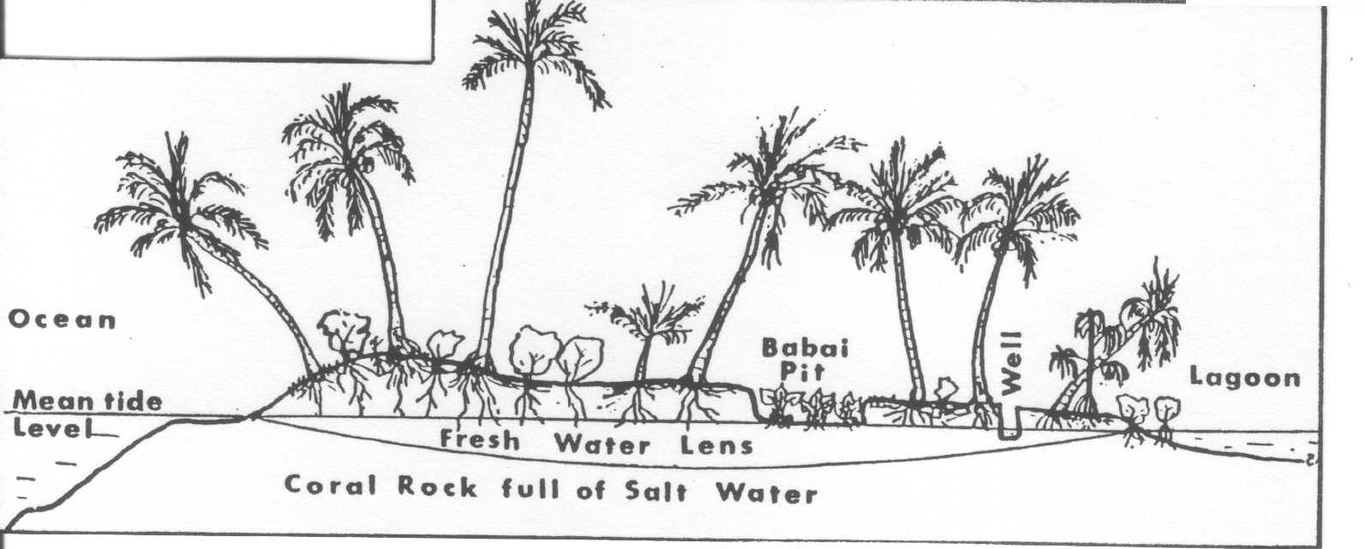

***Fig. 95***

***Cross-section through an atoll***

In such an environment, normal cultivation is impossible. From very early times, the i-Kiribati realized that food crops could only be grown by digging deep holes down to the top of the fresh water lens, and by the careful use of organic fertilisers. The principal tuber cultivated is the giant taro or babai (cyrtosperma chamissonis), which reaches 3 metres in height and lives for over 10 years. It therefore provides a constant reserve of food, unlike normal taro, which must be harvested within 6 – 8 months of planting.

Most babai pits were dug before modern tools came to the islands, using implements made from shells. A babai pit is about 10 – 20 m2 in area. Inside it, the plants are about 1 metre apart, in holes 60 cm deep. A basket of pandanus leaves is placed around the babai plant and filled with compost. Farmers do not use any crop rotation or fallow, since the same crop is grown continuously. Great care is lavished on the cultivation of babai, and farmers have their own secret methods.

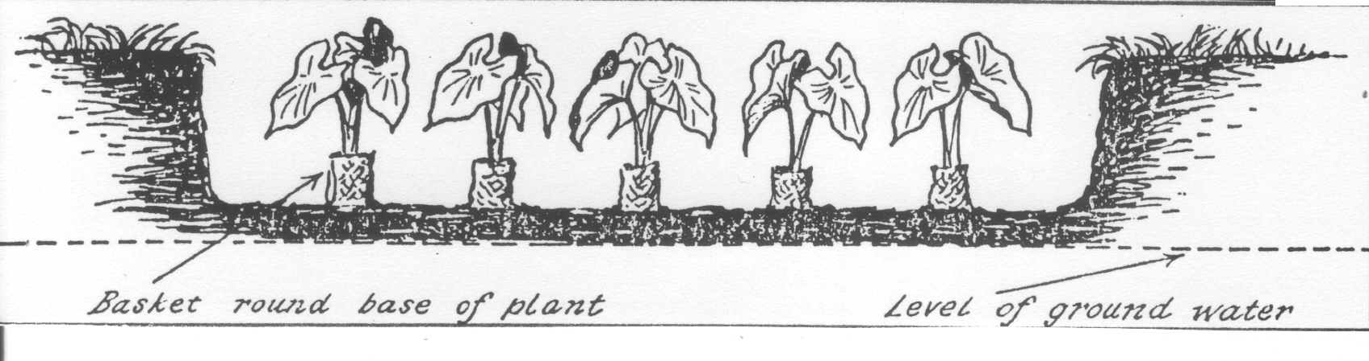

***Fig. 96***

***Cross-section through a babai pit***

## *ACTIVITIES*

1. *Why can we say that babai cultivation is an agricultural method that conserves resources?*
2. *In recent years, babai cultivation on Tarawa has come under threat. What do you think are some of the factors involved, and how exactly do they affect babai cultivation?*

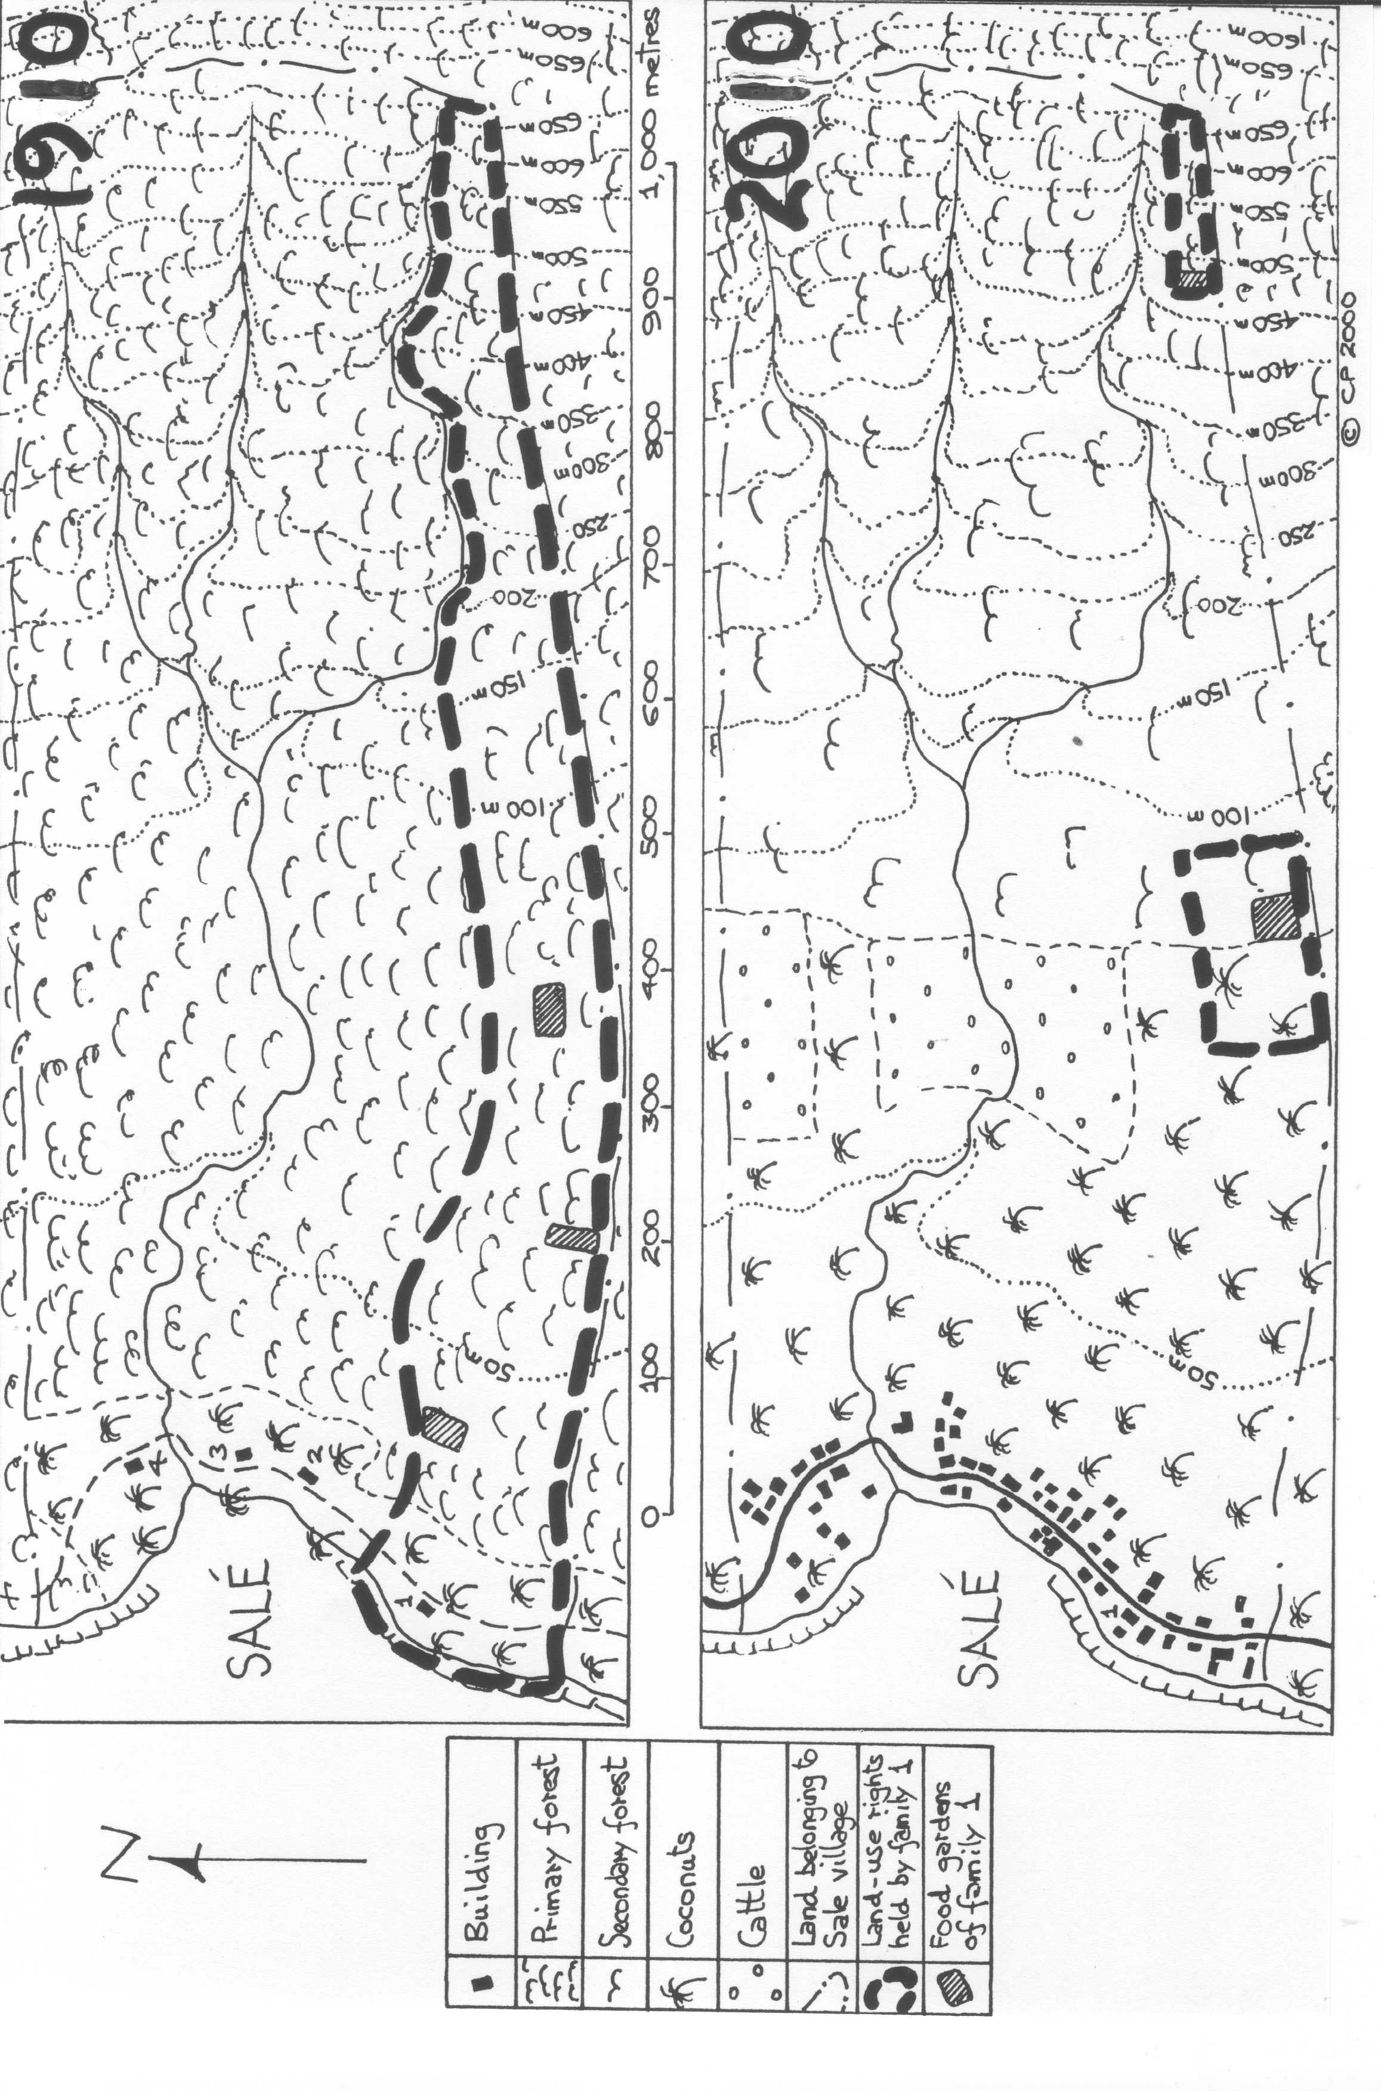

***Fig. 97***

**Summary of traditional resource conservation in the Pacific islands**

*ACTIVITIES*

1. *In small groups, discuss what is meant by the “physical fragility and cultural richness of Pacific island environments”. Can you give some specific examples?*
2. *Review questions (answers to be prepared in note form, ready for the end of semester test):*
   1. *Explain how the traditional agricultural systems of the Pacific islands were adapted to the natural environments, illustrating your answer with reference to specific farming methods and places. Why are these traditional systems now under threat?*
   2. *“Modern resource managers in the Pacific islands should start reviving some of the traditional conservation techniques that have largely been forgotten”. Do you agree with this statement? Justify your answer by referring to specific techniques and resource controls.*

**MODERN METHODS OF SUSTAINABLE DEVELOPMENT**

1. LAND USE PLANNING
2. BREEDING OF FISH AND SHELLFISH
3. RENEWABLE ENERGY RESOURCES

**WHAT IS SUSTAINABLE DEVELOPMENT?**

The most commonly used definition of sustainable development is that given by the World Commission on Environment and Development (WCED) in their report *Our Common Future:*

Sustainable development is development that meets the needs of the present without compromising the ability of future generations to meet their own needs. It contains within it two key concepts:

* the concept of “needs”, in particular the essential needs of the world’s poor, to which overriding priority should be given
* the idea of limitations imposed by the state of technology and social organization on the environment’s ability to meet present and future needs.[12]

More simply, sustainable development means that any economic activity carried out to meet our current needs should not degrade or deplete the environment in such a way that people will not be able to meet their needs in future. It must not endanger the earth’s life-support systems - the atmosphere, the waters, the soils, the flora and fauna.

***Fig. 98***

According to Nalial (1997), sustainable development in Vanuatu involves three aspects - social equity, economic growth and environmental protection (see Fig. 98).

ECONOMIC GROWTH

SOCIAL EQUITY

*Show sustainable development in Fig. 98.*

ENVIRONMENTAL PROTECTION

*Use the diagram to define sustainable development.*

**LAND-USE PLANNING**

“Land-use planning” means the systematic assessment of land and water potential so as to be able to select the kinds of land-use that will be of most benefit to land users, without degrading the environment or resources.

In Vanuatu, the Land-Use Planning Office (LUPO) was established in 1996. It collects information on land-use in all islands, enters it into a computer-held data base called VANRIS, and makes it available to government departments and the public. VANRIS holds data on natural vegetation, soils, rocks, climate and land use for each of thousands of RMUs (Resource Mapping Units) in the country.

Using VANRIS, LUPO can tell a farmer how he can develop his land sustainably - whether he can log it, grow kava, cacao, vanilla or other cash crops, use it for cattle, or leave it undisturbed. LUPO advises the national and provincial governments on policies regarding land-use development, and works at grass-roots level to help local communities manage their resources according to customs and environmental constraints.

VANRIS is an extremely useful tool for planning purposes. For example, maps can be generated to show four categories of land for agricultural use - prime agricultural land, other agricultural land, marginal agricultural land, and non-agricultural land (useless for agriculture).

# AQUACULTURE (BREEDING FISH AND SHELLFISH) IN VANUATU

The Department of Fisheries operates several aquaculture projects in the islands of Vanuatu, e.g. the breeding of trochus (*Trochus niloticus),* greensnail *(Turbo marmoratus)* and giant clam in its base at Nambatu. There are also commercial enterprises such as the prawn farm at Teouma and the aquarium fish company at Blacksands.

The trochus shell, heavily exploited for use as “mother of pearl” in the manufacture of buttons and jewellery, is found in a restricted and well-defined habitat (the inter-tidal and shallow sub-tidal zones on the seaward margin of coral reefs). All over Vanuatu, there is pressure to obtain the shell from known trochus grounds; this results in the collection of shells of under the legal minimum size (9cm diameter), and in a depletion of trochus stocks. For this reason the Fisheries Department has a re-stocking programme based upon two strategies: a) breeding juvenile trochus in hatcheries, then releasing them at suitable reef sites, e.g. Emae, Siviri and Erakor; and b) transplanting adult trochus from sites with adequate stocks to sites where stocks have disappeared. However, the Department has found that neither of these strategies will work unless there are also changes in people’s fishing practices. It encourages a "community-based management approach" that gives responsibility for managing trochus and other marine resources to the community that "owns" the reef, which must set up restrictions/taboos on harvesting.

**RENEWABLE ENERGY IN VANUATU**

In 2010, UNELCO aimed to produce 23% of its total electricity supply from renewable sources. These include the Sarakata hydro plant (9%), the wind farm on the Kawene plateau at Devil’s Point (9%), and biofuel production (coconut oil mixed with diesel oil) at the Tagabe power station (5%). The Devil’s Point wind farm has eleven masts, each 55m high, with a total capacity of 3.025 megawatts.

Other small-scale renewable energy projects currently planned, or already operating, in Vanuatu include:

* Projects run by VANREPA (Vanuatu Renewable Energy and Power Association), an NGO that is installing power systems in 5 secondary and 20 primary schools using wind, solar and micro-hydro technologies, e.g. wind-operated turbines at Eles Primary School, Nguna, and Vulumanu School, Pentecost.
* A solar energy plant at Fareavau, Nguna, installed by UNELCO.
* The Talise micro-hydro project serving three villages on Maewo.
* The installation of wind turbines at dispensaries and schools on Futuna and Aneityum, funded by EU-ACP under SPREP’s Pacific Islands Greenhouse Gas Abatement through Renewable Energy Project (PIGGAREP)
* Biofuel projects using locally produced coconut oil in villages in north-east Malakula (4), Ambae (3), and Vanua Lava (2), funded by UNELCO and the EU-ACP - also under PIGGAREP.

*FIELDWORK*

*Visit the following places to find out about some examples of sustainable development: UNELCO WIND FARM, BIOFUEL PLANT AT TAGABE, FISHERIES DEPARTMENT, TEOUMA PRAWN FARM. Use the questions to guide your research.*

BIOFUEL PLANT AT TAGABE

1. What is the percentage of coconut oil in biofuel?
2. Where does the copra come from?
3. What are the advantages of using coconut oil for generating electricity?
4. Are there any disadvantages of using biofuel?
5. What are the environmental impacts of using biofuel?

FISHERIES DEPARTMENT

1. Name some of the marine organisms being bred at the Fisheries Department?
2. Why are these organisms being bred?
3. What steps are involved in breeding trochus in captivity?
4. For how many months are trochus juveniles kept in captivity?
5. What are the problems when juvenile trochus are released back on to the reefs?
6. In what ways does the Fisheries Department help village people to manage their marine resources?

TEOUMA PRAWN FARM

1. Describe the site of this project, and draw a sketch map to show its lay-out.
2. What species is being reared?
3. Give some statistics to indicate production.
4. What difficulties are being faced?
5. What are the benefits of this project, and who is benefiting?
6. Could this kind of project be developed in other places in Vanuatu? If so, what conditions would be required?

**ASSESSMENT 4: PROPOSALS FOR RESOURCE MANAGEMENT ON ONE ISLAND OF VANUATU**

You will select a major island of Vanuatu that you know well, and prepare a report outlining your proposals for the future management of this island’s natural resources. The report should contain the following:

* A map (or maps) of your island, indicating the major resources of forest (mid-height and over), fresh water, land with good agricultural potential and any useful resources. You can also show any other significant resources that exist on the island. You may refer to VANRIS maps and *Atlas de Vanouatou*. Your map(s) should have a scale, key and title. *(5)*

* A list of the principal natural resources on your island, classified as stock, flow and continuous. *(5)*
* Any existing steps that are being taken on your island to manage or conserve its resources. Be sure to state who is doing the management, and exactly how it is being done. *(5)*
* Your own suggestions for future resource management, bearing in mind any techniques that have been used in other places in the world. *(5)*

1. Information in this section is adapted from Lamb, D. 1990, *Exploiting the Tropical Rain Forest,* UNESCO, Paris.
2. Riteshni Singh, 21/08/10, fijiboardexiles.yuku.com/topic/4390, accessed 19/10/2010
3. Japan International Cooperation Agency 1991, *Basic Design Study Report on the Project for Sarakata River Hydroelectric Power Development in the Republic of Vanuatu,* JICA, Tokyo, p. 4-1
4. Pierce, D. 1996,  *Micro-Hydro as an Appropriate Technology for Rural Areas in Vanuatu,* UWA, Perth., pp 7-8, 24-26
5. Klee, G. (ed) 1980, *World Systems of Traditional Resource Management,* John Wiley, New York, pp. 248-253
6. ibid, pp. 253 - 264
7. Weightman, B. 1989, *Agriculture in Vanuatu,* British Friends of Vanuatu, Cheam, UK, pp. xix-xx
8. Bonnemaison, J. 1978, *Man mo Garen: Olgeta Rod blong Presen long Fasin blong Kastom,* quoted in

   Brunton R. et al (eds) 1978, *Man, Langwis mo Kastom long Niu Hebridis,* ANU, Canberra, pp 31-39
9. Bonnemaison, J. 1973, *Espaces et Paysages Agraires dans le Nord des Nouvelles-Hébrides,* ORSTOM, Nouméa, pp. 39 – 41
10. Weightman, B. 1989, *Agriculture in Vanuatu,* British Friends of Vanuatu, Cheam, UK, pp. 82 - 83
11. Bonnemaison, J. 1973, *Espaces et Paysages Agraires dans le Nord des N.H.,* ORSTOM, pp. 47 - 53
12. Bruntland, H. 1987, *Our Common Future,* Oxford University Press, Oxford, p. 87