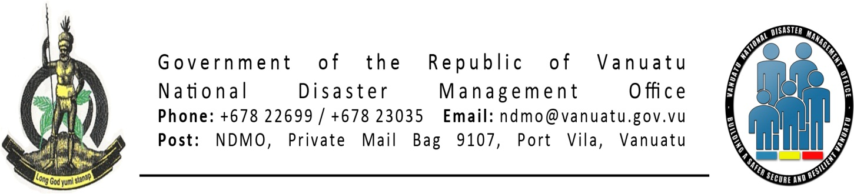

PDCC Final Roles & Responsibility

Preparation

Develop and collation of community profiles

Develop and review of logistic capacity assessments

Work with police and private sector to inform communities of specific disaster warnings

Participate in simulations and drills

Develop provincial contact lists and radio frequencies

Develop SOP and provincial disaster plans

Key communications person to liaise with NDMO

Regular meeting to ensure progress on DRR and CC preparedness

Response

Conduct provincial coordination meetings

Collate Initial Community Assessments

Update Logistic Capacity

Assist to coordinate relief distribution (including recording & beneficiary lists)

Provide updated information to NDMO

Recovery

Monitor recovery process and report back to NDMO

Advocate for planning for better preparedness

Communicate to community level on action of national governments