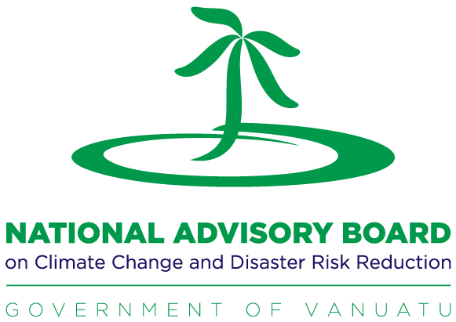


Ministry of Climate Change and Natural Disasters
National Validation Workshop for the
Vanuatu Climate Change and Disaster Risk Reduction Policy
The Minister for Climate Change and Natural Disasters, the Honourable James Bule, hosted a national validation workshop for the Vanuatu Climate Change and Disaster Risk Reduction Policy at the Holiday Inn in Port Vila on 17 February 2015. The workshop was attended by 85 representatives of government agencies, provincial governments, civil society organizations and the private sectors. The policy is supported by the United Nations Development Programme (UNDP), the Australian Government’s Department of Foreign Affairs and Trade (DFAT) and SPC GIZ through the Pacific Risk Resilience Programme (PRRP), working with the Vanuatu Meteorology and Geo-Hazards Department (VMGD). The draft policy was released for public consultation during late January to mid February 2015.
The vision of this Policy is for Vanuatu to be a nation whose community, environment and economy are resilient to the impacts of climate change and disaster risks. These risks cannot be completely eliminated and this policy provides a framework through which risks can be identified, assessed, reduced and managed.
Minister James Bule in his opening address encouraged workshop participants to share the policy priority areas throughout Vanuatu as it is in line with the integrated strategy on climate change and disaster risk reduction being drafted for the Pacific region. “I encourage you to take the outcomes from this workshop back to your communities and workplaces, and spread the word about this policy…. it will be up to all of us to play our roles in implementing this policy, since climate change and disaster risk reduction are everyone’s business.” He said.
The Director-General of the Ministry of Climate Change and Natural Disasters, Mr Jotham Napat, presented the policy at the workshop. Mr Napat said, “This policy identifies Vanuatu’s vision, principles, priorities and strategies to drive and integrate climate change and disaster risk reduction activities across all levels of government, industry sectors, civil society and donor partners into the future. Climate change and disaster risk reduction are everyone’s business, which means we all need to contribute to implementing the policy.”
PRRP Programme Manager, Moortaza Jiwanji, said: “The development of this policy is an exciting and essential stepping-stone to ensure future national planning for development, budgets and needs assessments properly consider Climate Change and Disaster Risk Management, or CCDRM."
“PRRP is very pleased to be able to support the Government of Vanuatu in its work to develop the nation’s CCDRM policy, and we look forward to continuing the partnership and to use ‘risk governance’ as a means to strengthen the resilience of rural and urban communities in Vanuatu.”
The policy was developed following an extensive consultation processes, including an inception workshop in Port Vila and workshops in all provinces during late 2014 and will be implemented by a range of government agencies and stakeholders by applying the six principles of accountability, equity, community focus, collaboration and innovation.
The draft policy aligns with policy direction at the regional level to integrate climate change and disaster risk reduction into one policy, rather than addressing each separately. This aims to deliver efficiencies and reduce duplication. The policy takes into account global level frameworks, as well as national plans implemented across a wide range of sectors. Vanuatu will be at the forefront of innovation in this field as the first nation to endorse this integrated approach in the policy.
The Australian High Commissioner to Vanuatu Jeremy Bruer and his delegation also attended the workshop.

Following the national validation workshop, final drafting of the policy will be undertaken before submission to the Council of Ministers for approval, expected in March 2015.
END
For further information:
Please contact the Project Management Unit (PMU) at the Vanuatu Meteorology and Geo-hazards Department on phone: 24686 or email: commp@meteo.gov.vu for further information on the National Climate Change and Disaster risk Reduction Policy.
Further information
PRRP works with Pacific Island nations and their people to think about the risks they may face from climate change and disasters when they are making their usual plans for development. Communities can become more resilient to climate change and disasters if routine government, community and other planning takes these risks into account. This Risk Governance approach is supported by the Australian Government’s Department of Foreign Affairs and Trade (DFAT), and implemented by the United Nations Development Programme (UNDP) and international Non-Government Organisation Live and Learn Environmental Education (LLEE) and the Mainstreaming of Rural Development Initiative (MORDI TT). PRRP is being delivered in four countries: Solomon Islands, Vanuatu, Tonga and Fiji.

