Reaching the Last Mile through Integration of Local Climate and Weather Indicators with Modern Forecasting Techniques in Vanuatu:
Pilot Program for the Climate and Oceans Support Program in the Pacific (COSPPac)

Contents

Contents 2
Glossary 3
Executive Summary 4
1. Introduction 5
2. Goals and objectives 5
3. Program coordination and participation 6
4. Proposed activities and timelines 9
5. Key outcomes and products 12
6. Potential Legacy from the Program 12
7. Coordination and staffing 12
8. Funding and expected costs 13
Appendices 15

Glossary

CCA Climate Change Adaptation
COSPPac Climate and Oceans Support Program in the Pacific
DARD Department of Agriculture and Rural Development
DDR Disaster Risk Reduction
GIZ
GFCS Global Framework for Climate Services
IPR Intellectual Property Rights
MOA Memorandum of Agreement
NAB National Advisory Board
NDMO National Disaster Management Office
PMU Project Management Unit
PICPP Pacific islands Climate Prediction Project
TK Traditional Knowledge
TEK Traditional Ecological Knowledge
VMGD Vanuatu Meteorological and Geo-Hazard Department
VRN Vanuatu Rainfall Network
VKS Vanuatu Kaljural Senta

Executive Summary
The Vanuatu Meteorological and Geo-Hazard Department (VMGD) and its partners will actively collect local weather and climate indicators from at least 4 sites around Vanuatu and a database will be created to host the data collected. The process will be divided into 5 parts.
- Collection of traditional climate and weather indicators
Different mechanisms will be adopted for collecting local indicators, be it workshops or face-to-face meetings, participatory approach, camera and voice recording and use of historical collections, including the VKS archives. A methodology will be finalized to guide and coordinate future collection.
- Management of the information collected and storage
Collection, management, storage (database) and use of the data will be agreed in advance by way of a formal Memorandum of Understanding between the Bureau of Meteorology, and the Vanuatu Meteorological and Geo-Hazard Department on the use of data for collaborative research including validation of forecasts, development of forecast systems and publication of scientific papers and reports.
- Monitoring and Evaluation of the local indicators as part of a validation process
Local indicators will be monitored and their effectiveness as seasonal forecast tools tested using conventional forecast methods and systems.
- Integration of traditional indicators and conventional seasonal forecasts
The partners will work with COSPPac, and consult with local communities, to determine the best methods for integrating the traditional and modern seasonal forecast systems.
- Dissemination of information
The information collected and the tools developed will be given to the communities for their use and knowledge. The mechanisms for disseminating the integrated forecast information back to the community will be agreed on by the partners as the project progresses.
The collection process will be the most costly component and will require several interventions. Funding should be provided to cater for the costs of field work and at least 3 workshops for stakeholders and site managers of the Vanuatu Rainfall Network. In this proposal we provide an overview of the project, estimates and sources of costs involved and possible collaborations.

1. Introduction
The Global Framework for Climate Services (GFCS) is based on the philosophy that efficient management of the climatic risks today is the foundation for managing the changed climatic risks of tomorrow. Sound scientific knowledge underpins this foundation. Where they exist, climate services are extremely effective. Prominent user sectors are agriculture, water management, health, disaster risk reduction, planning and energy. But there is a wide gap between the needs for climate services and their current provision in climate-vulnerable developing countries and especially in their communities.
Communities in Vanuatu have always related to the climate and weather in their own context. Being highly exposed to risks of extreme events such as tropical cyclones, flooding and droughts, communities have naturally adapted in their own ways. They are able to use their surroundings to indicate in advance the different weather extremes they are likely to face. These careful observations of their surrounding have allowed them to come up with their own traditional forecasting methods which have been tested and proven to be very reliable.
In parts of the country where communication is still a challenge, communities continue to rely on their knowledge of the environment to guide their preparedness for extreme events. While there is promise in the use of this traditional based science, there are also challenges.
The first challenge comes as a result of modernization and increased emphasis for the use of western science over traditional methods. Modern school systems, urbanization, the growing interest in the cash economy and western goods have left the traditional based knowledge, such as the knowledge to be able to forecast weather and climate using indicators, a thing of the past. It seems to have not yet found its place in the modern society and thus slowly fading away. In some communities, there may be less than a handful of elders left who still hold this wealth of knowledge. This program will hope to document some of the remaining knowledge so they can be reintroduced to the younger generations through vernacular programs in primary schools or preserved in archives.
The second challenge often confronted by the VMGD is to reach out to remote communities to document traditional knowledge. This knowledge in some communities have been used and relied upon for centuries and it formed a vital part of the societal structure. For example, on Tanna Island, the chiefly system setup would have different tupunas who have their own role in the governance structure of a community. In that governance structure, it is a tupunas whose role is to provide weather information to the chief and the people. He would be a weatherman of the community and his role has been predefined over centuries.
The tupunas have found their own niche in these communities and therefore have more authority and effect on people’s decision than a foreign advice that comes from outside institutions such as the VMGD. Communities over the years have naturally followed the advice from tupunas. However, tupunas lack the understanding of the broader science and often in circumstance what they think they know as dictated by century old practice would be contradictory to advice from VMGD.
The century old knowledge has been observed over many years. To communities, the indicators they use from plants and animals are reliable and have guided their activities for many years. Modern forecasting systems on the other hand is based on complex mathematical calculations and proven theories which are also tested and verified. There is a real opportunity to integrate both the centuries old traditional weather and climate forecast system and modern scientific methods in Vanuatu for improved decision making.

2. Goals and objectives
Local communities in Vanuatu have a good understanding of traditional knowledge systems for environmental management and coping strategies. They are able to make their own predictions for weather and climate variables based on traditional knowledge that has evolved through observation and experience over a considerable period of time. However, this knowledge of forecasting weather and climate through historical experiences and intuitions is fast disappearing due to a growing Western influence. The primary goal of this project is therefore to document traditional knowledge on weather and climate forecasting, set up mechanisms to coordinate the collection of TK in Vanuatu, examine the reliability of that knowledge, incorporate it with conventional scientific methods, and develop mechanisms to disseminate the integrated product back to the community.
More specifically, this project will have the following key objectives:
- Identify local communities that use traditional knowledge for environmental forecast applications, particularly at the seasonal timescale.
- Determine and document the traditional indicators used by these communities; indicators may be based on the behaviour of plants and animals, meteorological indicators such as wind direction and strength or astronomical indicators such as stars.
- Document where possible historical information on the traditional indicators, i.e. past dates/timing of the traditional indicator.
- Train personnel in each community/province for continuous monitoring and archiving of the indicators.
- Compare the traditional knowledge forecasts with that provided by conventional scientific methods (e.g., SCOPIC).
- Disseminate the integrated forecast back to the community.
The project also aims to bring together different scientific and cultural groups that are involved in climate related projects in Vanuatu. This collaboration can help open avenues towards better disaster prevention, preparedness, response and mitigation.

3. Program coordination and participation
The VMGD will work closely with COSPPac to coordinate the arrangements with local institutions such as the Vanuatu Kaljural Senta (VKS) for documenting and integrating traditional knowledge of weather and climate forecasts with ‘modern’ scientific methods. Traditional knowledge on weather and climate indicators is fast becoming a popular topic in the region and there is a need for better coordination at this early stage. Coordination and collaboration will ensure no duplication of effort and will allow an environment for the pooling of resources to implement the program. It will also ensure that future efforts will use the same methodologies and build on information that is collected as part of this collaboration.
This program already has the support from the VKS as one of the main partners. The GIZ project and the Red Cross have both indicated strong interest in collaboration. The GIZ program in Vanuatu has gone a step further to establish foundations for this project.
The VMGD, during its Agro-Met Summit held in March 2012, established a Memorandum of Agreement (MOA) with the Department of Agriculture and Rural Development (DARD). It is a network we can work around and utilize under the program and exploit the linkages to traditional cropping calendars.
Another network established by the VMGD that can be utilized by the program is the Community based rainfall monitoring network known as the Vanuatu Rainfall Network (VRN, Figures 1 and 2). This is voluntary network established for 5 years and continues to grow. It is made up of about 80 community individuals whose role is to monitor rainfall and other aspects of the climate. They are avenues which the VMGD utilizes to disseminate information and also collect information on weather and climate impact in communities. Individuals in the network are well connected with their elders and can be part of the network for collecting TK and also part of the verification component where potential indicators for integration are identified.
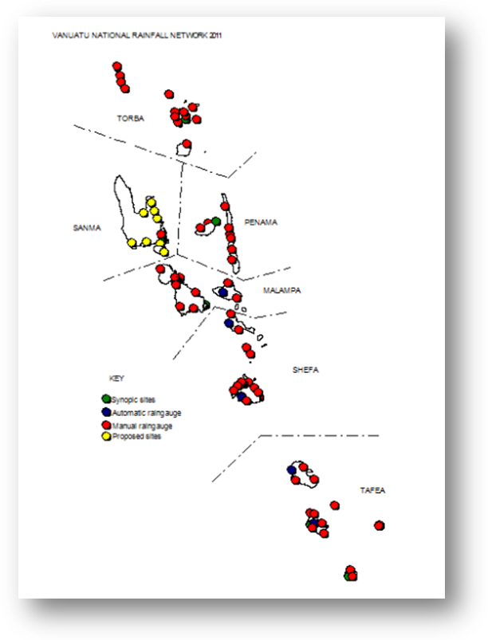

Figure 1: The Vanuatu National Rainfall Network (VRN).

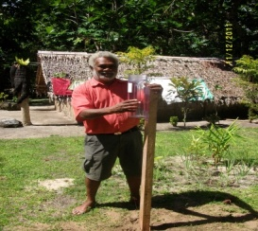 | 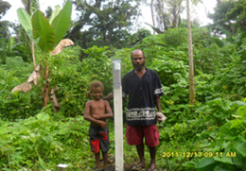 | 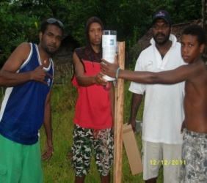 | 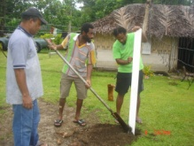
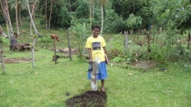 | 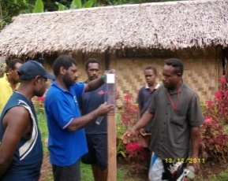 | 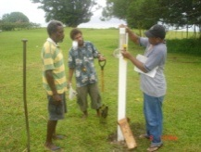 | 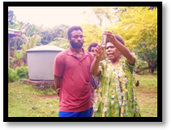
Figure 2: Some pictures of Vanuatu Rainfall Network (VRN) showing potential participants in the COSPPAC TK collection and monitoring. This is a network set up by the VMGD.

The participants in this program must be as broad as possible to allow effective coordination with those programs that have funding to carry out similar activities. It is therefore anticipated the program will be coordinated by the VMGD (Climate Division) under the auspices of the National Advisory Board (NAB) on Climate Change Adaptation and Disaster Risk Reduction to allow further integration of the information collected for activities pertaining to strengthening community resilience. The program in Vanuatu can therefore involve the following partners.

Table 1: List of collaborators for the TK project.
Partner stakeholder (Sector) | Role
Climate and Oceans Support Program in the Pacific (COSPPac) | COSPPac will offer technical and scientific support throughout all phases of the project. It will also provide some funding for the initial implementation of the program.
The Secretariat (PMU) of the National Advisory Board (NAB) for Climate Change Adaptation (CCA) and Disaster Risk Reduction (DDR) | Overall coordination of CCA and DDR and can assist to align future programs to the mechanisms established in this project to avoid duplication
VMGD (Climate Division) | Management of the project – including coordination of partners, collection of TK indicators, hosting and managing the TK database, and working with COSPPac to integrate TK with modern seasonal forecasting. VMGD will build this role into a Job Description of its staff to ensure continuity and give confidence to the partners of their commitment to the initiative.
Vanuatu Kaljural Senta (VKS) | VKS is the overall guardian of all TK in Vanuatu and will provide advice on the best way forward on issues regarding Intellectual Property Rights (IPR), archiving of the information, etc. They also have a well-established network that the program can utilize.
GIZ-Vanuatu Program | A coordinating partner for the program and can provide co-funding to support the gaps in the program. They can also provide technical advice to guide the program.
Red Cross Vanuatu | Red Cross Vanuatu has carried some work in Vanuatu on documenting traditional knowledge related to weather, climate and also related to food preservation techniques (associated with extreme weather) and cropping calendars. They acknowledge the need for better coordination and can work with their own networks imbedded in communities to collect the knowledge.
Civil Society Organizations | The Climate Change Consortium would be an ideal inclusion into the coordination team so they can provide advice to their NGO groups.
National Disaster Management Office (NDMO) | The information on TK is very useful for DRR activities and so the inclusion of the NDMO would be strategic.

4. Proposed activities and timelines
The activities under the COSPPac program on TK in Vanuatu will be guided by the framework developed from the Agro-Met Summit on “National Summit to Improve Understanding on Climate, Climate Change and its Impacts on Agriculture and Land-based Sectors” funded by the PICPP in March 2012. The framework developed in the Agro-Met Summit outlined the four main areas which the project can focus on. These areas of interest are data collection, management, sharing and monitoring (see Table A1 in appendix).
This project will be implemented in different stages (Figure 3) in order to achieve the overall goals. Desired activities within the project and approximate timeframe for each activity are summarized in Table A2 (see appendix).
To meet the objectives of COSPPac, the following calendar is additionally developed to provide objective guidance and formal reporting during the course of the project (Table 2). Note that is will form part of the MOU between COSPPac and VMGD. Funding for each year will be dependent on satisfactory and timely reporting.
Table 2: Proposed calendar for COSPPac monitoring and reporting of the project.
Objective | Timeframe | Monitoring and reporting to COSPPac
TK questionnaire developed and trialed in a workshop. | Nov 2012 | - Workshop report to be submitted by VMGD.
MOU finalized and signed | Jan 2013 | - This MOU will enable COSPPac and VMGD to both have access to TK information for research purposes (e.g. validation of TK forecasts and development of forecast integration products).  - Job description of a VMGD staff allocated for TK work to be included here as well.
TK indicator information from the VKS archive collected and compiled. Also preliminary set of TK indicators identified by VMGD for the VRN to use in the upcoming workshop. | April 2013 | - Formal report to be submitted to COSPPac on the availability of TK indicators in the VKS archive, and on those obtained through VRN.
Training workshop | April 2013 | - Detailed workshop report needs to be submitted to COSPPac.  - Four pilot communities need to be identified for validation of TK indicators.
Pilot site visits | Dec 2013  June 2014  Dec 2014  June 2015  Dec 2015  June 2016 | - A formal report must be submitted to COSPPac for each visit. Every six months beginning Dec 2013; main purpose is to validate TK indicators, and obtain feedback from the participating communities.
Database for storage of TK information developed. | June 2013  June 2014  June 2015 | Report on the database and information contained within it. The database needs to be constantly updated as the TK indicator information becomes available.
Completion of the project | June 2016 | Final report

5. Collection of TK through the VRN for the Workshop
1. Cataloging of information in the VKS archives
2. Engage officers to research and extract TK information in the archives
3. Development of Standard Questionnaires
6. “First National Workshop on TEK relating to Weather and Climate Indicators”
Effectively reaching the Last Mile through an integrated information system

7. Visits to pilot sites to collect detail information to validate TK indicators
8. Further collection of TK and validation through the VRN and other networks
9. Development of a National Database for TK forecast indicators
Process for Integrating TK for Weather and Climate Indicators

10. Integration into Seasonal Forecasting
11. Integration into Weather Forecasting
12. Second workshop to launch the final product and determine dissemination processes
These stages are aligned to the COSSPac and the overall program objectives.
Integration of all the information collected into the Vernacular Programs in Relevant Primary Schools (This can be carried out later by other programs building on the information collected).
4. Development of IPR guidelines on the use of TK. This will include a formal agreement between COSPPac and VMGD for use of data by the COSPPac scientists

Figure 3: A Flow of proposed activities for the Traditional Knowledge Project in Vanuatu.

5. Key outcomes and products
The following are the primary outcomes that are expected to be achieved by the end of the project:
- Local information of Weather and Climate (WC) indicators will be collected and entered into the TK database.
- Some TK indicators currently used in different communities for weather and climate forecast applications will be identified and documented.
- An infrastructure for continuous monitoring of TK indicators will be set-up. This will involve training individuals within VRN structure on the monitoring of TK indicators in their respective areas
- A database will be developed for recording of TK indicators.
- Forecasts using TK indicators will be verified against scientific methods, and a mechanism for disseminating consensus forecast based will be determined.
In addition to the aforementioned key outcomes, this project is also likely to advance the scientific understanding of participating communities on key drivers of weather and climate and how this understanding can be incorporated into their traditional cognitive views of weather and climate. It is also likely to strengthen ties between different scientific and cultural groups in Vanuatu. This bridge is necessary for climate change adaptation and disaster risk management purposes.

6. Potential Legacy from the Program
- Development of a framework and procedures for the collection of climate and weather indicators in Vanuatu.
- Development of a database of TK on weather and climate indicators.
- Integration of Science and TK knowledge systems for effective communication.
- Lessons learned will lead and guide the collection of TK in the region.
- Potential for further research to better understand the mechanisms behind the TK indicators, improve resilience of communities to weather and climate events, etc.

7. Coordination and staffing
Coordination in-country will be carried out by the VMGD through its National Advisory Board of CCA and DRR with support from the GIZ Program
The VMGD will dedicate a staff member in the Climate Division to work full time on this initiative for the period of the program. The officer will coordinate and draw support with the VMGD and NAB, the Forecasting Division, PMU on DRR and CCA, etc.
The program will be supported by staff in COSPPac – ecological expertise, research and modeling expertise, IT and database expertise.

8. Funding and expected costs
Total cost for implementing the TK program in Vanuatu over 3 years is estimated at 294,000 (Tables 3-6). COSPPac is co-funding this project as specified below (Table 4).
Table 3: Total Cost
Estimated Total Cost for implementing Activities under the program to achieve the desired outputs and outcomes | 2013 (AUD) | 2014 (AUD) | 2015 (AUD) | Total Cost  (AUD)
Total for each year (AUD) | 161,000 | 95,000 | 98,000 | 294,000

Table 4: COSPPac costs – full acquittal will be required
Activities | 2013 (AUD) | 2014 (AUD) | 2015 (AUD) | Total Cost (AUD)
Engage officers to research and extract TK information in the archives | 5,000 |  |  | 5,000
“First National Workshop on TEK relating to Weather and Climate Indicators”  Effectively reaching the Last Mile through an integrated information system | 40,000 |  |  | 40,000
Visits to Pilot sites to collect detail information to validate TK Indicators | 15,000 | 14,000 (flexible funds) | 10,000 (flexible funds) | 39,000
Development of the database | 50,000 (in kind)
TOTAL | 110,000 | 14,000 | 10,000 | 134,000 (50k in kind) (24k flex fund)

Table 5: Other costs from collaborating partners
Activities | 2013 (AUD) | 2014 (AUD) | 2015 (AUD) | Total Cost (AUD)
Cataloging information in the VKS Archives | 3,000 |  |  | 3,000
Engage officers to research and extract TK information in the archives (for their own purpose but can contribute to the program) | 3,000 | 3,000 | 3,000 | 9,000
“First National Workshop on TEK relating to Weather and Climate Indicators”  Effectively reaching the Last Mile through an integrated information system | 10,000 |  |  | 10,000
Visits to Pilot sites to collect detail information to validate TK Indicators | 5,000 | 5,000 | 5,000 | 15,000
Launch of the TK Database and the integration on TK and Science |  |  | 2,000 | 2,000
TOTAL | 26,000 | 13,000 | 8,000 | 47,000

Table 6: Cost incurred by government (VMGD) through in-kind contribution and direct costs
Activities | 2013 (AUD) | 2014 (AUD) | 2015 (AUD) | Total Cost (AUD)
Dedication of a full time staff on TK for 3 years by VMGD  Engage an officer to research and extract TK information in the archives | 20,000 | 20,000 | 20,000 | 60,000
“First National Workshop on TEK relating to Weather and Climate Indicators”  Effectively reaching the Last Mile through an integrated information system | 5,000 |  |  | 5,000
Visits to Pilot sites to collect detail information to validate TK Indicators | 5,000 | 5,000 | 5,000 | 15,000
Hosting of the National Database for TEK (Weather and Climate) |  | 2,000 |  | 2,000
Maintenance of the VRN through the provision of the basic allowances | 30,000 | 30,000 | 30,000 | 30,000
Integration of TK and Science  Development of Procedures (incurred through overtime, etc) | 5,000 | 5,000 | 5,000 | 15,000
Launch of the TK Database and the integration on TK and Science |  |  | 5,000 | 5,000
Ongoing maintenance of database | ?? | ???? | ???? | ????
Miscellaneous Cost (Logistics) | 5,000 | 5,000 | 5,000 | 15,000
In-kind contribution by the VKS | 5,000 | 5,000 | 5,000 | 15,000
TOTAL | 75,000 | 72,000 | 75,000 | 162,000

Appendices
Table A1: Framework developed during the Agro-met Summit in March 2012 by Sectors for the effective collection/management/dissemination/monitoring of TEK.
Focus Areas | How it can be collected? | Who all are involved? | When do we start?
Collection  - Local indicators for forecasting  - Short-term (weather)  - Long-term (climate)  - Traditional Calendars  - TK on Mitigation & Adaptation Methods  - Disasters  - Traditional Knowledge (Rain Man) | - From the archives at VKS  - Face to Face interview  - Survey Forms  - Voice records  - Video camera  - Nakamal Group Technic  - Participatory Approach  - Training & documentation | - Productive Sectors  - NGOs (eg. RC, WSB Vanua Tai Resource Monitors)  - VKS Field Workers  - VMGD Staff and partners  Use of existing networks to have a far-reaching impact (such as the VRN) | As soon as Possible  (2012-2013)
Management | - Create Database  - Documentation  - Archiving | - VKS  - VMGD (New Act)
Sharing and Communication | - Guidance when Sharing: Permission/Acknowledge Source  - Video Documentary  - Publish in Website  - Exhibition  - Booklets to Complement modern forecasting  - Need to have a MOU | Public Domain | As soon as data is validated
Monitoring  Monitor and validate the traditional and local indicators collected.  (This is where the VRN can be used to monitor and validate) | Workshop to train on:  - Rainfall collection tools  - Common climate variability/extreme and change  - monitoring tools  - validate the information collected | - VKS volunteers  - NGO volunteers (eg. RC)  - Rainfall Collectors

Table A2: A summary of the proposed activities and suggestions of how, who and when it will be implemented.
Aim | Objectives | Timeframe | Participating Groups
1. Literature survey and preliminary investigation of TK indicators. | Undertake a stock assessment of climate and disaster related information held within the data repositories in the Vanuatu Cultural Center. | Nov 2012 | SPC/GIZ
 | Engage volunteers for 3 months to research the materials in the VKS archive and extract TK information, with a particular focus on traditional seasonal indicators. VMGD, GIZ/SPC and other programs may also provide additional support. | Mar 2013 | COSPPac, SPC/GIZ, VKS
 | VMGD will engage the Vanuatu Rainfall Network to carry out initial TK research and data collection in their communities. | Nov 2012 – April 2013 | VMGD
2. Develop guidelines and MOUs governing collection, access and use of TK information. | Develop a draft framework agreement/MOU between the VKS the VMGD and the NAB in regards to the future collection, stewardship and dissemination of climate and disaster traditional knowledge.  Also develop a formal agreement between VMGD and COSPPac for the use of data for research purposes (including joint publications). | Nov 2012 | SPC/GIZ, VKS, VMGD, COSPPac
 | Develop guidelines for TK and linkages to Policy and Legislations in VKS.  NAB/PMU and VMGD linkages in their policy and legislations. | June 2013 | GIZ, VMGD
 | Develop clear procedures for the operation and access of the National database (so other groups can input into it). | April 2013 | GIZ, VMGD
3.TK data collection and storage | Develop questionnaires that can be used to collect TK information in Vanuatu and in the region | Nov 2012 | COSPPacVMGD  GIZ
3.TK data collection and storage | Develop a database to store information collected. The database will be hosted by the VMGD and duplicated for other partners to access. A backup copy of the database will be made available to the VKS for long term storage and other use. | June 2013 | COSPPac
3.TK data collection and storage | VRN to continue to monitor and report on the TK indicators agreed upon. | Ongoing | VMGD
3.TK data collection and storage | VMGD to archive the data sent in from the VRN and other data collectors with COSPPac assisting with analyses. | Ongoing | VMGD, COSPPac
4. Raising awareness, reporting progress and determining steps forward. | Hold a workshop inviting key partners including VKS, DARD and VRN. The workshop will focus on:  - Understanding climate drivers in Vanuatu.  - Promotion of VMGD products (such as the seasonal forecast).  - Training on improvement of the rainfall and TK monitoring using the new forms developed.  - Discuss framework for collection, storage, validation and integration.  - Discuss the TK collected from the islands and the VKS archives. | April 2013 | VMGD, DARD, GIZ, COSPPac
 | Develop methods and materials to disseminate the captured information and integrated product back into the communities. | June 2016 | VMGD
5. Validation of TK Indicators | VMGD staff to visit the 4 pilot sites to validate the indicators that have been collected by VRN and others. This will be coordinated with other partners to avoid duplication. | June 2016 | VMGD, VKS, GIZ, RC, NGO’s
6. Integration of TK and ‘modern’ science | VMGD in partnership with COSPPac will develop processes for the integration of the two strands. | June 2014 | VMGD, COSPPac

